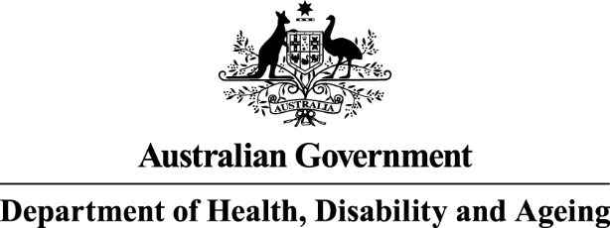

Surgical prophylaxis prescribing in Australian hospitals




Results of the 2023 Surgical National Antimicrobial Prescribing Survey

Published by the Australian Government Department of Health, Disability and Ageing For issues regarding the content of the report:
Email: support@naps.org.au
Website: https://www.naps.org.au ISBN: 978-1-74186-105-1
© Australian Government Department of Health, Disability and Ageing
All material and work produced by the Australian Government Department of Health, Disability and Ageing is protected by copyright.
The Department reserves the right to set out the terms and conditions for the use of such material.
Enquiries about the licence and any use of this publication are welcome and can be sent to AMR@health.gov.au
Preferred citation
Royal Melbourne Hospital and the National Centre for Antimicrobial Stewardship. Surgical prophylaxis prescribing in Australian hospitals. Results of the 2023 Surgical National Antimicrobial Prescribing Survey. Canberra: Australian Government Department of Health, Disability and Ageing; 2025.
Disclaimer
This document is not intended to provide guidance on particular healthcare choices. You should contact your healthcare provider for advice on particular healthcare choices.
This document includes the views or recommendations of its authors and third parties. Royal Melbourne Hospital, the National Centre for Antimicrobial Stewardship and the Australian Government Department of Health, Disability and Ageing do not accept any legal liability for any injury, loss or damage incurred by the use of, or reliance on, this document.

Table of Contents
Acknowledgements 4
Contributing facilities 4
Abbreviations 5
Summary 6
Results of key indicators 6
Implications for clinical practice 6
Suboptimal documentation 6
Compliance with guidelines and appropriateness of prescribing 6
1. Introduction 7
2. Results 8
2.1 Participation 8
2.2 Surgical episodes 9
2.3 Key indicators 11
Documentation 11
Overall appropriateness 12
2.4. Procedural prophylaxis prescribing 14
Reasons for inappropriate procedural prophylaxis prescribing 15
Guideline compliance 15
Antimicrobial choice 17
Procedure groups 18
2.5. Post-procedural prescribing 19
Reasons for inappropriate post-procedural prophylaxis prescribing 20
Guideline compliance 22
Antimicrobial choice 23
Procedure groups 24
3. Conclusion 25
Appendix 26
References 36

Preface
This report is best interpreted when read in conjunction with the National Antimicrobial Prescribing Survey: technical supplement 2023.⁵

Acknowledgements

Contributing facilities
On behalf of the National Centre for Antimicrobial Stewardship and the Royal Melbourne Hospital Guidance Group, we would like to thank all contributing facilities and auditors for their time and effort in collecting and entering the data, in contributing data to this report, to the Antimicrobial Use and Resistance in Australia (AURA) surveillance program and for their continued commitment to improving safety and quality across
the Australian healthcare system.
National Centre for Antimicrobial Stewardship and the Royal Melbourne Hospital Guidance Group
Professor Karin Thursky
Dr Rodney James
Dr Courtney Ierano
Ms Caroline Chen
Ms Josephine Wen
Associate Professor Noleen Bennett
Professor Lisa Hall
Mr Pramode Varghese
Mr Logesh Palani
Mr Abukari Yakubu
Mr Simon Burrell

Abbreviations
Abbreviation | Term
ABS | Australian Bureau of Statistics
AIHW | Australian Institute of Health and Welfare
AMS | Antimicrobial stewardship
AURA | Antimicrobial Use and Resistance in Australia
EMM | Electronic medication management
NAPS | National Antimicrobial Prescribing Survey

Summary
The Surgical National Antimicrobial Prescribing Survey (Surgical NAPS) is key contributor towards Australia’s National Antimicrobial Resistance Strategy1 and the Antimicrobial Use and Resistance in Australia (AURA) surveillance program.2
The Surgical NAPS program continues to be a widely adopted and valued tool to assess the quality of antimicrobial prescribing across Australian facilities. Its focus on providing meaningful data for action with clear data visualisation for contributing facilities has led to the continued high participation from Australian facilities, representing a wide variety of funding types, peer groups and remoteness classifications.
During 2023, 201 facilities (93 public and 108 private) submitted data on 11,516 surgical episodes with
9,620 procedural doses and 4,320 post-procedural prescriptions to the Surgical NAPS database.

Results of key indicators
- There was a slightly lower documentation of incision time and time of antimicrobial administration (72.5% and 89.9% respectively) than in 2022.
- There was a continued low overall rate of appropriateness per surgical episode (57.3%).
- There was a continued noticeable difference between overall prophylactic procedural and post-procedural dose appropriateness (61.5% and 42.7% respectively).
- Procedure groups with the lowest prophylactic procedural appropriateness were dentoalveolar (13.6%), head and neck (33.0%) and plastic and reconstructive surgery (44.2%).
- Procedure groups with the lowest prophylactic post-procedural appropriateness were head and neck (1.8%), dentoalveolar (2.7%) and breast surgery (10.3%).
- Duration remains the most pertinent issue for post-procedural prophylaxis appropriateness. Of all such prescriptions, 34.2% had a duration greater than 48 hours.

Implications for clinical practice

Suboptimal documentation
Documentation is important for comprehensive medical care, as it allows timely and accurate communication between members of the clinical care team and contributes to effective safety and quality of patient care. Failure to document important components of surgical care was reported for 1 in 4 surgical procedures for incision time; and 1 in 10 surgical procedures for the time of antimicrobial administration. This is consistent with the previous 2022 report.9

Compliance with guidelines and appropriateness of prescribing
Compliance with guidelines for surgical antimicrobial prophylaxis and, consequently, appropriateness of prescribing continues to be poor overall but even more so for prophylactic post-procedural prescriptions.
This relates to prescription of antimicrobials that are not required and prolonged duration of antimicrobial
use. Procedurally, inappropriate antimicrobial use is primarily due to suboptimal timing of administration.
For many procedures, there is no evidence that prophylactic antimicrobial use, either procedurally or post- procedurally, reduces post-operative infections. Reducing inappropriate surgical antimicrobial prophylaxis balances the unintended harms of antimicrobial use with the benefits of evidence-based care.

Introduction
The judicious use of antimicrobials is a key component of good patient care across all health settings. Australia’s National Antimicrobial Resistance Strategy – 2020 and beyond 1 has recommended the adoption of antimicrobial stewardship (AMS) programs, with the aim of enhancing patient healthcare outcomes while reducing the emergence and spread of antimicrobial resistance.
Now in its eighth year, the Surgical National Antimicrobial Prescribing Survey (Surgical NAPS) has been adopted as an important platform to support the AMS programs in facilities by allowing for the meaningful measurement, reporting and benchmarking of the quality of antimicrobial prescribing. NAPS program staff also continue to provide clinical program support and training for participants. Internationally, it remains the only tool to measure appropriateness of antimicrobial prescribing.
Furthermore, participation in the Surgical NAPS assists health service organisations to demonstrate
that they meet the AMS action requirements of the National Safety and Quality Health Service Standards3 and the Antimicrobial Stewardship Clinical Care Standard.4
The Australian Government Department of Health, Disability and Ageing provides funding for the Royal Melbourne Hospital Guidance Group and the National Centre for Antimicrobial Stewardship to conduct
the Hospital, Surgical and Aged Care NAPS and contribute data to the Antimicrobial Use and Resistance
in Australia (AURA) surveillance program.2
For details on survey methodology, analyses of methodology and considerations for data interpretation, please refer to the National Antimicrobial Prescribing Survey: technical supplement 2023.5

Results

Participation
The Surgical NAPS remains a voluntary program; nonetheless, there has been consistent participation by acute care facilities across all Australian states and territories, remoteness areas and funding types since the program’s initiation.
This report analyses the data submitted by 201 facilities (93 public and 108 private) that met the Surgical NAPS inclusion criteria. Participation has remained steady the last few years, with 197 facilities (110 public and 87 private) in 2022 and 188 facilities (96 public and 92 private) in 2021. The 2023 cohort included public and private facilities from most states and territories, covering a range of Australian Institute of Health and Welfare hospital peer groups6 and Australian Bureau of Statistics remoteness classifications7 (Figure 1).
Northern Territory did not contribute any data for 2023. For further information regarding inclusion criteria and definitions, refer to the National Antimicrobial Prescribing Survey: technical supplement 2023.5
Figure 1. Facilities that contributed to the Surgical National Antimicrobial Prescribing Survey by state and territory, 2023
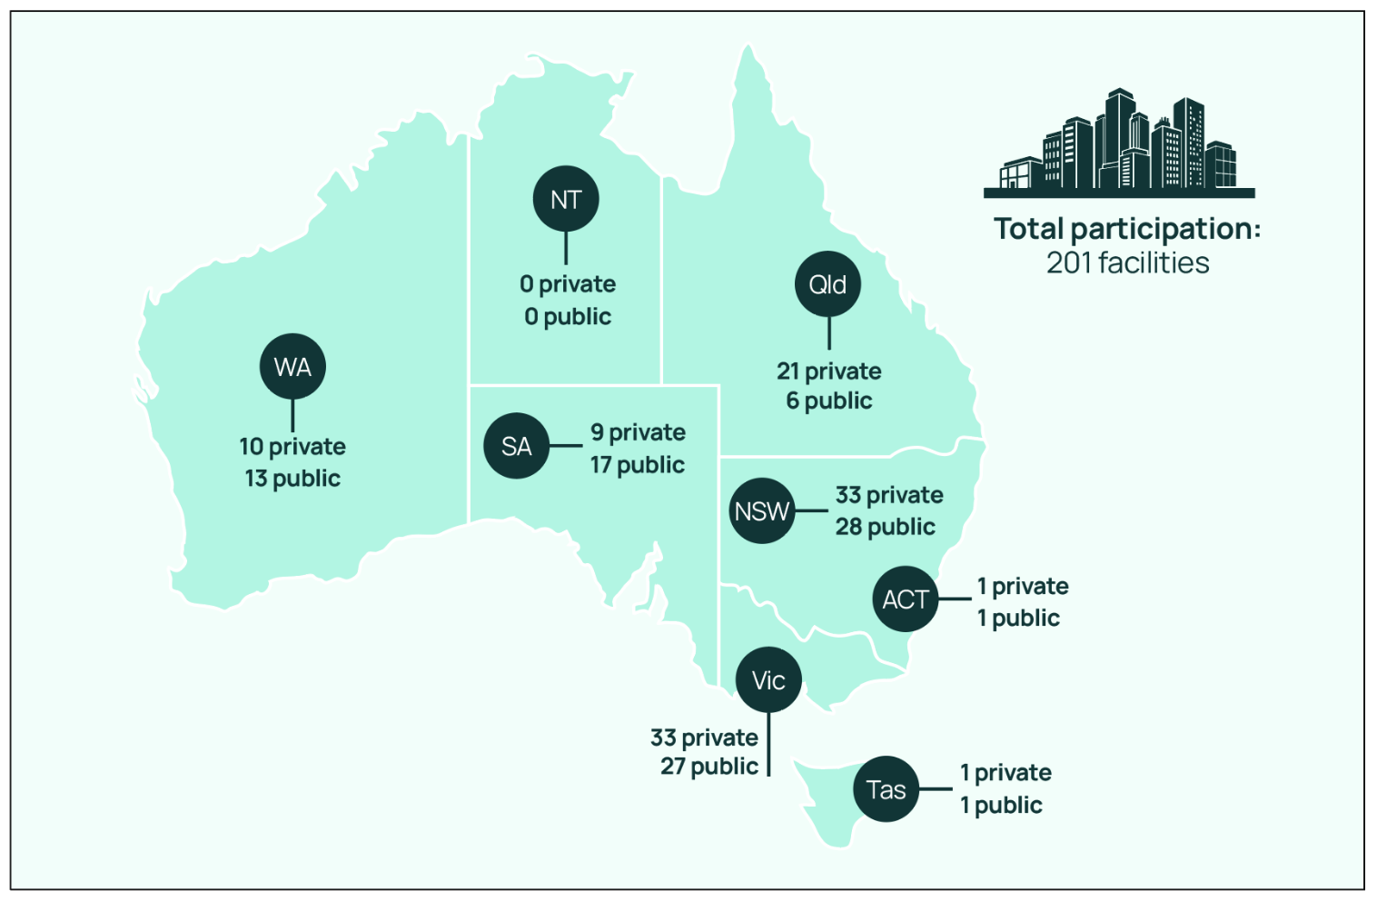
ACT = Australian Capital Territory; NSW = New South Wales; NT = Northern Territory; Qld = Queensland; SA = South Australia; Tas = Tasmania; Vic = Victoria; WA = Western Australia.

Surgical episodes
A total of 11,516 surgical episodes were included in the 2023 Surgical NAPS analyses. The majority of surgical episodes were for initial surgeries (97.4%) compared with subsequent procedures (2.6%), and this did not differ significantly when comparing public and private funded facilities (96.7% and 98.0% initial surgeries respectively). Elective surgical procedures remained the most common type for all episodes (86.8%), with a greater proportion in private facilities compared with public (97.5% and 73.8% respectively).
Procedures as a result of trauma remain low (3.9%), with a higher proportion in public facilities (7.0%) compared with private facilities (1.3%). Conversely, the removal or insertion of prosthetic material accounted for approximately one-third of all surgical episodes (32.4%), with a higher proportion in private facilities (40.4%) compared with public facilities (22.7%).
For a full breakdown of the characteristics of surgical episodes, procedural doses and prophylactic post- procedural prescriptions by funding type, state and territory, peer group and remoteness classification,
refer to Table 1A in the Appendix.
Figure 2 shows the breakdown of antimicrobial prescribing for surgical episodes reported to the 2023 Surgical NAPS, by procedural and prophylactic post-procedural characteristics, to assist with understanding the analyses presented.

Figure 2. Surgical episodes by procedural and post-procedural prescribing characteristics, Surgical National Antimicrobial Prescribing Survey, 2023
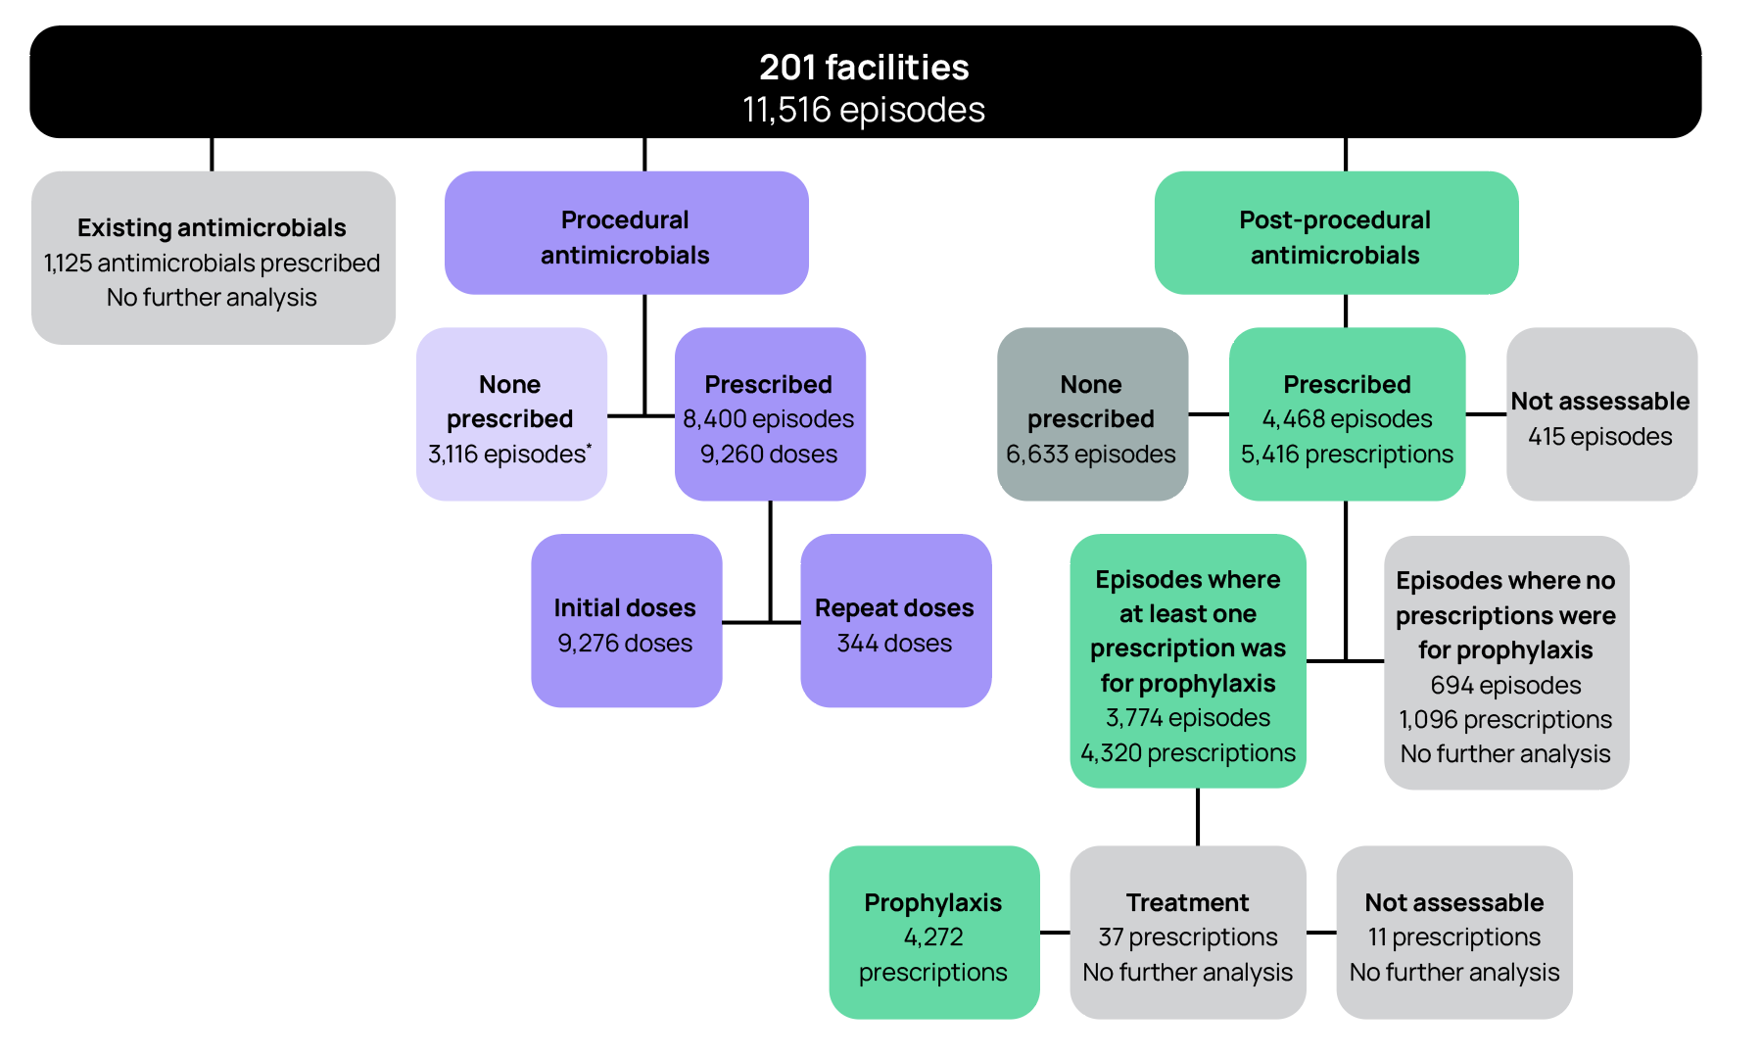
* There were 29 repeat doses indicated but not prescribed.
Notes:
Episode: An individual procedure or set of procedures performed together during one surgical session and the subsequent post-procedural care (i.e. antimicrobials prescribed) associated with the procedure(s).
Dose: An individual antimicrobial dose administered either immediately prior to or during or after the surgical procedure.
Prescription: Any antimicrobial prescribed either as a single dose or as a course following the surgical procedure.
Existing antimicrobial: An antimicrobial prescribed for treatment or prophylaxis in the 24 hours prior (72 hours if on dialysis) to the procedure, used to determine the appropriateness of whether procedural antimicrobials were given or not given.
Procedural antimicrobial: An antimicrobial administered either immediately prior to or during the surgical procedure for the purpose of prophylaxis; each initial and repeat dose of the antimicrobial administered is recorded individually.
Post-procedural antimicrobial: An antimicrobial prescribed following, but directly relating to, the procedure; each prescription of the antimicrobial is recorded, including any inpatient or discharge scripts.
Initial dose: The first dose of an antimicrobial administered either immediately prior to or during the surgical procedure for the purpose of prophylaxis.
Repeat dose: Any subsequent dose of an antimicrobial administered during the surgical procedure for the purpose of prophylaxis.
Prophylaxis: An antimicrobial prescribed for the prevention of surgery-related infection. Treatment: An antimicrobial prescribed for the treatment of infection related to the procedure.
Episodes where no prescriptions were for prophylaxis: Any episode where all prescribed antimicrobials are recorded as for ‘treatment’ and/or ‘not assessable’.

Key indicators
Results of the indicators are summarised below (Table 1).
Table 1. Surgical National Antimicrobial Prescribing Survey key indicators, for assessable prescriptions, 2023
Key indicator | Result
Incision time documented | 72.5%
Administration time documented* | 89.9%
Overall appropriateness† of prescribing for surgical episodes | 57.3%
Overall procedural dose appropriateness† | 61.5%
Overall post-procedural prescription appropriateness† | 42.7%
Post-procedural prescription duration >48 hours | 34.2%
* Calculation includes both ‘exact’ and to the ‘nearest 15 minutes’ documentation.
† Refer to National Antimicrobial Prescribing Survey: technical supplement 2023 for definitions.5

Documentation
A consistent theme over the last 8 years is the suboptimal documentation of surgical incision and antimicrobial administration times.
Of the 10,802 incisional procedures reported, approximately three-quarters had a time of incision documented (n=7,832, 72.5%).
Of the 9,276 initial procedural doses prescribed, 26.3% were recorded to the exact minute and 63.6%
to the nearest 15 minutes. The remainder (10.1%) did not have a documented administration time.
Documentation of incision time was similar in both private facilities (77.5%) and public facilities, (76.3%). Comparatively, exact documentation of administration time was reported less frequently in private
facilities (17.2%) than in public facilities (39.4%).
The timing of surgical prophylaxis is important to ensure high concentrations of antimicrobials at the
time of surgical incision. Ensuring documentation of both incision and antimicrobial administration times may improve appropriateness of antimicrobial administration times and help prevent surgical siteinfections for those episodes in which antimicrobial prophylaxis is indicated.
As electronic medication management (EMM) systems are progressively implemented in Australia,
we anticipate that this may support improvements in the documentation of surgical incision and antimicrobial administration times. In comparison to paper-based systems, EMM systems have the capacity to prompt and require information that is otherwise routinely omitted (i.e. time of surgical incision and antimicrobial administration), as identified by the Surgical NAPS, to be entered.

Overall appropriateness
The overall appropriateness, inclusive of all procedural and post-procedural antimicrobial prescribing across a surgical episode, has not shown improvement from previous years. Of the 11,516 surgical episodes, 57.3% were deemed appropriate, similar to 2022 (55.3%). Overall appropriateness differed slightly when comparing public and private facilities separately (64.0% compared with 51.7% respectively).
The percentage of episodes deemed inappropriate varied by procedure group, ranging from 1.5% for gastrointestinal endoscopic procedures to 70.9% for dentoalveolar surgery. All procedure groups had an inappropriateness rate greater than 20%, apart from gastrointestinal endoscopic procedures (1.5%) and ophthalmology (16.7%).
High rates of appropriateness for gastrointestinal endoscopic procedures are consistent year on year (as evidenced through previous annual reports) and are expected, as surgical antimicrobial prophylaxis is not routinely required. Only 3.0% of all gastrointestinal endoscopic procedures included at least one procedural antimicrobial dose.
Ophthalmological procedures had the highest proportion of ‘not assessable’ episodes (16.9%), suggesting auditors may require further clarifications from guidelines and improvement in the clinical documentation to accurately assess these episodes. Dentoalveolar surgery has seen an improvement from 26.9% deemed not assessable in 2022 to 4.8% in 2023.
Figure 3. Percentage of episodes by appropriateness* of prescribing for each surgical procedure group, Surgical National Antimicrobial Prescribing Survey contributor facilities, 2023
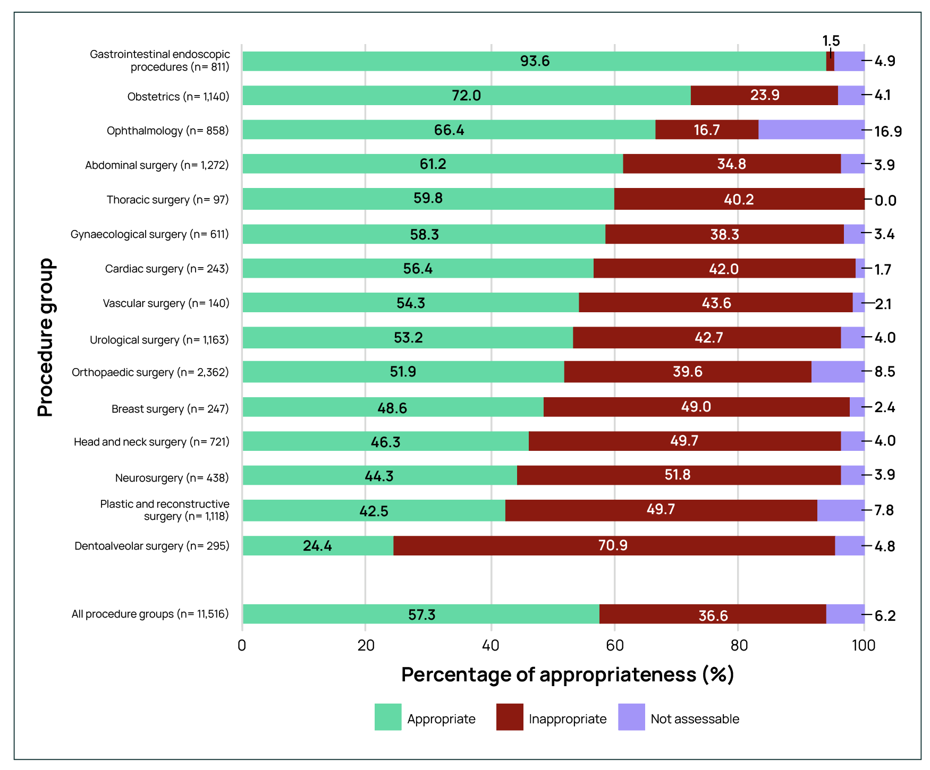
* For appropriateness definitions, refer to National Antimicrobial Prescribing Survey: technical supplement 2023.5
Note: n=11,516 total surgical episodes.
The measure of appropriateness differed greatly when comparing overall procedural doses and overall post-procedural prescriptions. Of the 9,620 prescribed procedural doses, 61.5% (n=5,914) were deemed appropriate. Comparatively, of the 4,272 prescribed post-procedural prophylaxis prescriptions, 42.7% (n=1,822) were deemed appropriate.
Prolonged durations remain an issue for post-procedural prophylaxis, with 34.2% (n=1,462) of these prescriptions having a duration greater than 48 hours. There are no recommendations in Australian guidelines recommending surgical antimicrobial prophylaxis for greater than 48 hours,8 with the exception
of ophthalmic procedures, where up to 7 days of prophylaxis may be administered.8

Procedural prophylaxis prescribing
Approximately one-quarter (25.1%) of all procedural prophylaxis prescribing episodes was assessed
as inappropriate (Table 2). The proportion of episodes deemed inappropriate was higher when antimicrobials were prescribed than when they were not prescribed (32.1% and 6.4% respectively). Antimicrobials were prescribed when not required in 10.6% of episodes.
When procedural antimicrobials were prescribed, appropriateness was similar for both initial and repeat
doses (66.3% and 69.5% respectively). Overall, 31.2% of all procedural dose prescribing was deemed inappropriate when non-assessable doses were excluded (n=2,894/9,281).
Table 2. Appropriateness* of procedural prophylaxis prescribing of antimicrobials for surgical episodes and antimicrobial doses, Surgical National Antimicrobial Prescribing Survey contributor facilities, 2023
Procedural prophylaxis | Total | Appropriate |  | Inappropriate |  | Not assessable
Procedural prophylaxis | (n) | (n) | (%) | (n) | (%) | (n) | (%)
Surgical episodes | 11,516 | 8,226 | 71.4 | 2,891 | 25.1 | 399 | 3.5
Antimicrobial prescribed | 8,400 | 5,832 | 64.1 | 2,692 | 32.1 | 326 | 3.9
- when required | 7,423 | 5,382 | 74.3 | 1,557 | 21.5 | 304 | 4.2
- when not required | 1,215 | 0 | 0 | 1,191 | 98.0 | 24 | 2.0
No antimicrobial prescribed | 3,116 | 2,844 | 91.3 | 199 | 6.4 | 73 | 2.3
- when required | 231 | 46 | 19.9 | 180 | 77.9 | 5 | 2.2
- when not required | 2,885 | 2,798 | 97.0 | 19 | 0.7 | 68 | 2.4
Antimicrobial doses | 9,620 | 6,387 | 66.4 | 2,894 | 30.1 | 339 | 3.5
Initial dose | 9,276 | 6,148 | 66.3 | 2,799 | 30.2 | 329 | 3.5
- when required | 8,047 | 6,148 | 76.4 | 1,592 | 19.8 | 307 | 3.8
- when not required | 1,229 | 0 | 0 | 1,207 | 98.2 | 22 | 1.8
Repeat dose | 344 | 239 | 69.5 | 95 | 27.6 | 10 | 2.9
- when required | 319 | 239 | 74.9 | 71 | 22.3 | 9 | 2.8
- when not required | 25 | 0 | 0 | 24 | 96.0 | 1 | 4.0
- not given when required† | 29 | 0 | 0 | 28 | 96.6 | 1 | 3.4
* The overall appropriateness of prescribing for a surgical episode was determined by taking the lowest ranked assessment of the individual doses/prescriptions, including all episodes where antimicrobials were prescribed and not prescribed.
† Excluded from total antimicrobial doses, as these are doses that were not given.

Reasons for inappropriate procedural prophylaxis prescribing
There were 2,894 procedural doses deemed inappropriate. Of these, 1,231 (42.5%) were deemed not required. For procedural doses, where antimicrobials were recommended by guidelines (n=8,366), 19.9% (n=1,663) were deemed inappropriate. A procedural prophylaxis dose can have more than one reason for inappropriateness. The most common reasons for inappropriate prescribing were incorrect timing and the prescribed antimicrobial’s spectrum being deemed too broad (38.7% and 24.2% respectively) (Figure 4).
Figure 4. Reasons for inappropriateness,* by percentage of required procedural prophylaxis antimicrobial doses,† Surgical National Antimicrobial Prescribing Survey contributor facilities, 2023
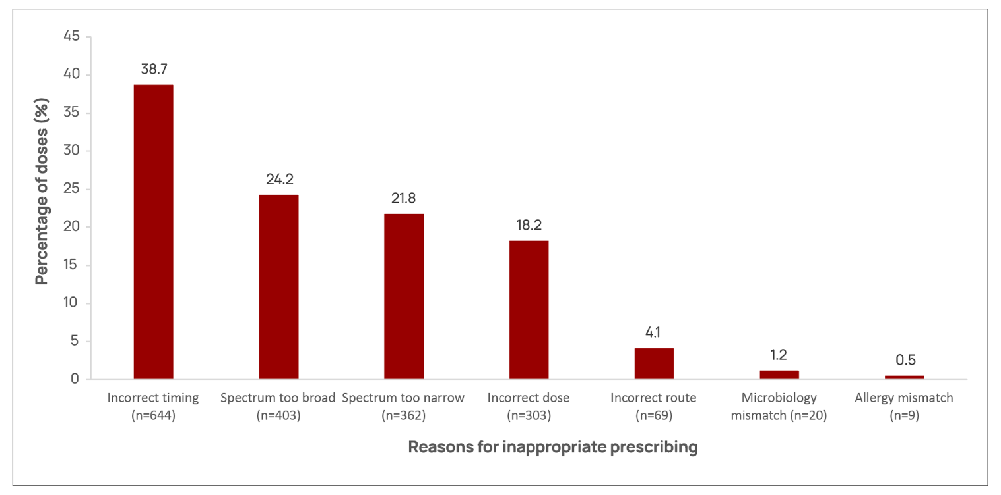
* Refer to National Antimicrobial Prescribing Survey: technical supplement 2023 for appropriateness definitions.5
† Each prescription is assessed against each quality indicator and thus can be represented in more than one category. There was a total of 1,663 inappropriate procedural prophylaxis doses (comprising of 1,810 reasons for inappropriateness).
Incorrect timing was the most common reason for inappropriateness of required procedural doses
(38.7% of 1,663 doses, comprising 1,810 reasons) (Figure 4). Comparatively, incorrect timing accounted
for 7.7% of all (8,335) required procedural doses (when omitting 941 doses that did not have a recorded administration time).
Cefazolin was the most commonly prescribed antimicrobial with an incorrect dose (61.4%), followed
by gentamicin (24.4%).

Guideline compliance
When no procedural antimicrobials were prescribed (n=3,116), guideline compliance (either with the Therapeutic guidelines: antibiotic8 or with local guidelines) was high (91.0%). Compliance with
prescribing guidelines was lower when antimicrobials were prescribed (66.4%) (Figure 5). Compliance increased to 69.3% when ‘directed therapy’, ‘no guidelines available’ and ‘not assessable’ doses were excluded (n=9,214).

Figure 5. Percentage of procedural prophylaxis antimicrobial doses* that were compliant with guidelines, Surgical National Antimicrobial Prescribing Survey contributor facilities, 2023
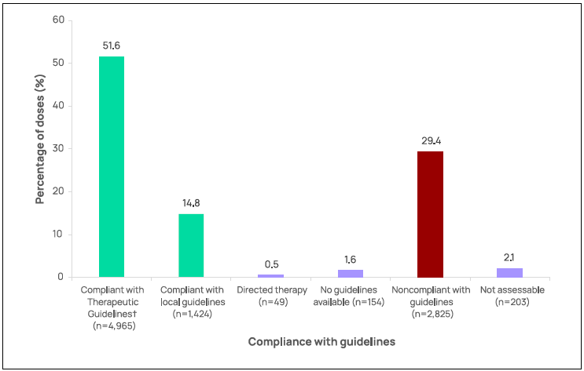
* n= 9,620 procedural antimicrobial doses.
† See the Therapeutic guidelines: antibiotic.8

Antimicrobial choice
Cefazolin was the most prescribed antimicrobial, accounting for 79.9% of prescriptions of procedural doses in 2023 (Table 3).
The top 5 procedural antimicrobials prescribed accounted for 93.2% of all antimicrobials: cefazolin (79.9%), metronidazole (5.3%), gentamicin (4.7%), vancomycin (2.1%) and clindamycin (1.1%), as shown in Table 3. Comparatively lower rates of inappropriateness were demonstrated for the most commonly prescribed antimicrobials, cefazolin and metronidazole (25.3% and 25.4% respectively). Rates of prescribing deemed inappropriate were greater than 70% for ampicillin, amoxicillin, cefoxitin, ceftriaxone and ciprofloxacin.
Table 3. Proportion and inappropriateness of procedural prophylaxis antimicrobial doses,* Surgical National Antimicrobial Prescribing Survey contributor facilities, 2023
Antimicrobial | Procedural doses prescribed |  | Inappropriate
Antimicrobial | (n) | (%) | (n) | (%)
Cefazolin | 7,690 | 79.9 | 1,947 | 25.3
Metronidazole | 507 | 5.3 | 129 | 25.4
Gentamicin | 455 | 4.7 | 222 | 48.8
Vancomycin | 203 | 2.1 | 113 | 55.7
Clindamycin | 108 | 1.1 | 64 | 59.3
Ceftriaxone | 106 | 1.1 | 85 | 80.2
Chloramphenicol | 75 | 0.8 | 19 | 25.3
Ampicillin | 68 | 0.7 | 65 | 95.6
Amoxicillin | 61 | 0.6 | 51 | 83.6
Ciprofloxacin | 54 | 0.6 | 49 | 90.7
Piperacillin–tazobactam | 41 | 0.4 | 25 | 61.0
Tobramycin | 39 | 0.4 | 4 | 10.3
Amoxicillin-clavulanic acid | 36 | 0.4 | 14 | 38.9
Teicoplanin | 33 | 0.3 | 14 | 42.4
Cefoxitin | 29 | 0.3 | 27 | 93.1
Lincomycin | 27 | 0.3 | 17 | 63.0
Benzylpenicillin | 17 | 0.2 | 7 | 41.2
Flucloxacillin | 17 | 0.2 | 9 | 52.9
Others† | 54 | 0.6 | 33 | 61.1
Total | 9,620 | 100 | 2,894 | 30.1
* Data are not shown for antimicrobials where n <10.
† ‘Others’ comprises 17 antimicrobials.

Procedure groups
The procedure groups with the highest rates of prescribing at least one procedural antimicrobial were orthopaedic surgery, breast surgery and neurosurgery (94.1%, 93.1% and 88.8% respectively), as shown in Table 4. Overall, the range of inappropriate prescribing varied across the procedure groups (10.1%–82.7%). The majority of prescriptions deemed inappropriate were for orthopaedic surgery (n=590 doses), urological surgery (n=501 doses), plastic and reconstructive surgery (n=403 doses) and abdominal surgery (n=386 doses). These 4 procedure groups accounted for 57.1% of all inappropriate procedural doses.
Table 4. Percentage of surgical episodes prescribed an antimicrobial, number of doses prescribed and inappropriateness of procedural prescribing by procedure group, Surgical National Antimicrobial Prescribing Survey contributor facilities, 2023
Procedure group | Surgical episodes | At least one antimicrobial prescribed |  | Total doses | Inappropriate doses
Procedure group | (n) | (n) | (%) | (n) | (n) | (%)
Orthopaedic surgery | 2,362 | 2,222 | 94.1 | 2,526 | 590 | 23.4
Abdominal surgery | 1,272 | 1,100 | 86.5 | 1,350 | 386 | 28.6
Urological surgery | 1,163 | 854 | 73.4 | 999 | 501 | 50.2
Obstetrics | 1,140 | 915 | 80.3 | 971 | 248 | 25.5
Plastic and reconstructive surgery | 1,118 | 763 | 68.2 | 801 | 403 | 50.3
Ophthalmology | 858 | 539 | 62.8 | 604 | 61 | 10.1
Gastrointestinal endoscopic procedures | 811 | 24 | 3.0 | 30 | 10 | 45.5
Gynaecological surgery | 611 | 392 | 64.2 | 539 | 245 | 33.0
Head and neck surgery | 721 | 367 | 50.9 | 391 | 250 | 63.9
Neurosurgery | 438 | 389 | 88.8 | 424 | 140 | 48.4
Cardiac surgery | 243 | 208 | 85.6 | 320 | 155 | 21.6
Dentoalveolar surgery | 295 | 211 | 71.5 | 214 | 177 | 82.7
Breast surgery | 247 | 230 | 93.1 | 255 | 55 | 43.5
Vascular surgery | 140 | 105 | 75.0 | 108 | 47 | 25.0
Thoracic surgery | 97 | 81 | 83.5 | 88 | 22 | 33.3
Total | 11,516 | 8,400 | 72.9 | 9,620 | 3,290 | 34.2

Post-procedural prescribing
Post-procedural prophylaxis was deemed inappropriate in 17.4% of the 11,516 surgical episodes audited (Table 5). The 57.6% of episodes where no post-procedural antimicrobials were prescribed were mostly deemed appropriate (98.0%). For the surgical episodes that had at least one post-
procedural antimicrobial prescribed for prophylaxis, 52.3% of prescriptions were deemed inappropriate. Antimicrobials were prescribed when not required for 10.3% (n=1,186) of episodes (Table 5). Post- procedural prophylaxis was deemed inappropriate for 56.2% of prescriptions, when the non-assessable prescriptions
were excluded.
Table 5. Appropriateness* of post-procedural prophylactic prescribing of antimicrobials for surgical episodes and antimicrobial prescriptions, Surgical National Antimicrobial Prescribing Survey contributor facilities, 2023
Post-procedural prophylaxis | Total | Appropriate |  | Inappropriate |  | Not assessable
Post-procedural prophylaxis | (n) | (n) | (%) | (n) | (%) | (n) | (%)
Surgical episodes# | 11,516 | 8,218 | 71.4 | 2,007 | 17.4 | 182 | 1.6
Antimicrobial prescribed | 3,774 | 1,719 | 45.5 | 1,973 | 52.3 | 82 | 2.2
- when required | - 2,588 | - 1,717 | - 66.3 | - 796 | - 30.8 | - 75 | - 2.9
- when not required | - 1,186 | - 2 | - 0.2 | - 1,177 | - 99.2 | - 7 | - 0.6
No antimicrobial prescribed | 6,633 | 6,499 | 98.0 | 34 | 0.5 | 100 | 1.5
- when required | - 53 | - 37 | - 69.8 | - 15 | - 28.3 | - 1 | - 1.9
- when not required | - 6,580 | - 6,462 | - 98.2 | - 19 | - 0.3 | - 99 | - 1.5
Antimicrobial prescriptions^ | 4,320 | 1,950 | 45.1 | 2,281 | 52.8 | 89 | 2.1
Prophylaxis | 4,272 | 1,922 | 45.0 | 2,261 | 52.9 | 89 | 2.1
- when required | 2,817 | 1,920 | 68.2 | 816 | 29.0 | 81 | 2.9
- when not required | 1,455 | 2 | 0.1 | 1,445 | 99.3 | 8 | 0.5
Treatment | 37 | 24 | 64.9 | 13 | 35.1 | 0 | 0.0
* The overall appropriateness of prescribing for a surgical episode was determined by taking the lowest ranked assessment of the individual post-procedural prescriptions.
# There were 694 surgical episodes that had only post-procedural antimicrobials prescribed for treatment of infection; auditors were unable to ascertain whether antimicrobials were prescribed in 415 surgical episodes and these were excluded from the analysis.
^ There were 11 antimicrobial prescriptions in which auditors were unable to ascertain whether these were for prophylaxis or treatment and these
were excluded from the analysis.

Reasons for inappropriate post-procedural prophylaxis prescribing
There were 2,261 post-procedural prophylaxis prescriptions deemed inappropriate. Of these,
1,445 (63.9%) were deemed not required. For post-procedural prophylactic prescriptions, where
prophylaxis was recommended by guidelines (n=2,817), 29.0% were deemed inappropriate (n=816).
A post-procedural prophylaxis prescription can have more than one reason for inappropriateness.
The majority of inappropriate prescriptions were due to incorrect duration (77.6%). Dose and frequency (18.3%) was the next most common reason (Figure 6).
Figure 6. Reasons for inappropriateness,* by percentage of required post-procedural prophylactic antimicrobial prescriptions,† Surgical National Antimicrobial Prescribing Survey contributor facilities, 2023
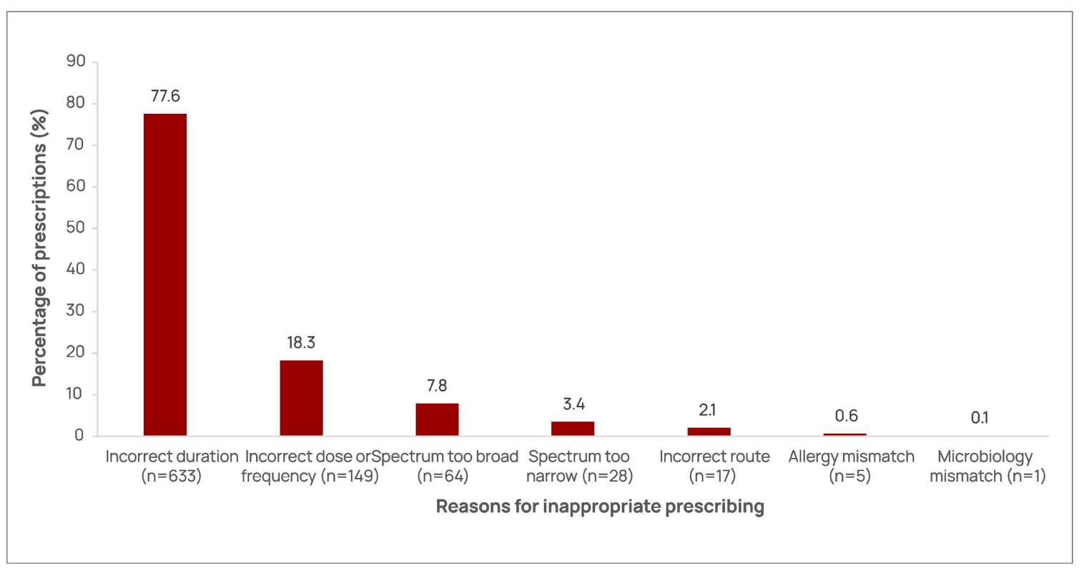
* Refer to the National Antimicrobial Prescribing Survey: technical supplement 2023 for appropriateness definitions.5
† Each prescription is assessed against each quality indicator and thus can be represented in more than one category. There was a total of 816 inappropriate post-procedural prophylaxis prescriptions (comprising 897 reasons for inappropriateness).
Of all post-procedural prescriptions, 51.5% involved prophylaxis for greater than or equal to 24 hours
(Table 6). Of those prescribed for greater than or equal to 48 hours (34.2%), 2 of the 15 procedural groups had prescribing rates greater than 80%. These were dentoalveolar surgery (95.5%) and head and neck surgery (87.6%).
When the volume of episodes audited is considered, 52.4% of all prescriptions greater than or equal to 48 hours are accounted for by 3 procedure groups: ophthalmology (n=318 prescriptions), plastic and reconstructive surgery (n=258 prescriptions) and head and neck surgery (n=190 prescriptions).
In comparison with reports over the years, there is noticeable improvement for orthopaedic surgery, in which post-procedural antimicrobial prescriptions with a duration greater than or equal to 48 hours reduced from 39.1% (2020) to now 7.8% in 2023. In contrast, plastic and reconstructive surgery prescriptions with a duration greater than or equal to 48 hours increased from 35.9% (2020) and 74.9% (2021) to 80.3% in 2022 and has now reduced to 69.4% in 2023. Dentoalveolar surgery prescriptions with
a duration greater than or equal to 48 hours increased from 39.7% (2020) to greater than 95% since 2021 and is currently 95.5% in 2023.
Table 6. Duration of surgical prophylaxis prescribed for greater than 24 and 48 hours, by procedure group, Surgical National Antimicrobial Prescribing Survey contributor facilities, 2023
Procedure group | Antimicrobial prescriptions | Duration range | Duration median | Duration  ≥24 hours |  | Duration  ≥48 hours
Procedure group | (n) | (days) | (days) | (n) | (%) | (n) | (%)
Orthopaedic surgery | 1,663 | 1-47 | 1 | 507 | 30.5 | 129 | 7.8
Ophthalmology | 651 | 1-29 | 1 | 369 | 56.7 | 318 | 48.8
Plastic and reconstructive surgery | 372 | 1-28 | 5 | 292 | 78.5 | 258 | 69.4
Neurosurgery | 236 | 1-14 | 1 | 99 | 41.9 | 33 | 14.0
Head and neck surgery | 217 | 1-15 | 5 | 202 | 93.1 | 190 | 87.6
Urological surgery | 201 | 1-35 | 4 | 145 | 72.1 | 108 | 53.7
Cardiac surgery | 192 | 1-8 | 1 | 109 | 56.8 | 79 | 41.1
Abdominal surgery | 181 | 1-17 | 2 | 117 | 64.6 | 80 | 44.2
Breast surgery | 156 | 1-20 | 4 | 103 | 66.0 | 92 | 59.0
Obstetrics | 112 | 1-19 | 1 | 42 | 37.5 | 23 | 20.5
Dentoalveolar surgery | 112 | 1-7 | 5 | 110 | 98.2 | 107 | 95.5
Gynaecological surgery | 83 | 1-8 | 1 | 50 | 60.2 | 29 | 34.9
Thoracic surgery | 61 | 1-6 | 1 | 35 | 57.4 | 7 | 11.5
Vascular surgery | 29 | 1-7 | 1 | 13 | 44.8 | 7 | 24.1
Gastrointestinal endoscopic procedures | 6 | 1–6 | n/a* | n/a* | n/a* | n/a* | n/a*
Total | 4,272 | - | - | 2,198 | 51.5 | 1,462 | 34.2
* Data are not shown for antimicrobial prescriptions where n <10. n/a = not applicable.

Guideline compliance
When no post-procedural antimicrobials were prescribed, noncompliance with guidelines was infrequent (0.5%). When they were prescribed, over half (51.7%) of post-procedural antimicrobial prophylaxis was noncompliant with guidelines (Figure 7). Noncompliance increased to 53.2% when ‘directed therapy’,
‘no guidelines available’ and ‘not assessable’ prescriptions were excluded.
Compliance with national prescribing guidelines8 continues to be poor, generally due to prolonged durations of oral, ocular and topical antimicrobials post-procedurally. These represent niche targeted areas for AMS and quality improvement intervention.
Of all post-procedural prophylactic prescriptions (n=4,272), 61.9% were administered via intravenous route, followed by 20.2% oral/enteral, 9.2% topical and 8.6% ocular routes. Noncompliance with guidelines was highest for antimicrobials administered via the oral/enteral route (90.2%), followed by intravenous route (48.1%) and topical route (32.5%).
Post-procedural extended use of prophylactic oral or topical antimicrobials is not recommended by Australian guidelines8 and should be discouraged. Antimicrobials should only be prescribed prophylactically when the evidence supports their use.
Figure 7. Percentage of post-procedural prophylactic antimicrobial prescriptions* that were compliant with guidelines, Surgical National Antimicrobial Prescribing Survey contributor facilities, 2023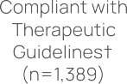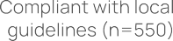
* n=4,272 prescriptions for post-procedural prophylaxis.
† See the Therapeutic guidelines: antibiotic.8

Antimicrobial choice
The 5 most commonly prescribed post-procedural antimicrobials accounted for 87.4% of all antimicrobials prescribed prophylactically: cefazolin (61.2%), cefalexin (12.1%), chloramphenicol (7.5%), amoxicillin–clavulanic acid (3.7%) and metronidazole (2.9%), as shown in Table 7.
All antimicrobials had relatively high rates of prescribing deemed inappropriate. Rates of prescribing deemed inappropriate were greater than 80% for cefalexin, amoxicillin–clavulanic acid, amoxicillin, trimethoprim, ceftriaxone, vancomycin, clindamycin and cefaclor.
Table 7. Post-procedural prophylactic prescribing of antimicrobials and percentage inappropriate,* Surgical National Antimicrobial Prescribing Survey contributor facilities, 2023
Antimicrobial | Total prescriptions |  | Inappropriate
Antimicrobial | (n) | (%) | (n) | (%)
Cefazolin | 2,615 | 61.2 | 1,066 | 40.8
Cefalexin | 517 | 12.1 | 482 | 93.2
Chloramphenicol | 319 | 7.5 | 87 | 27.3
Amoxicillin– clavulanic acid | 159 | 3.7 | 130 | 81.8
Metronidazole | 125 | 2.9 | 96 | 76.8
Amoxicillin | 82 | 1.9 | 76 | 92.7
Ciprofloxacin | 81 | 1.9 | 49 | 60.5
Trimethoprim | 53 | 1.2 | 51 | 96.2
Ceftriaxone | 52 | 1.2 | 46 | 88.5
Tobramycin | 51 | 1.2 | 31 | 60.8
Vancomycin | 50 | 1.2 | 41 | 82.0
Clindamycin | 33 | 0.8 | 28 | 84.8
Ofloxacin | 24 | 0.6 | 0 | 0.0
Mupirocin | 14 | 0.3 | 9 | 64.3
Gentamicin | 11 | 0.3 | 8 | 72.7
Cefaclor | 10 | 0.2 | 10 | 100.0
Others† | 76 | 1.8 | 51 | 67.1
Total | 4,272 | 100 | 2,261 | 52.9
* Data are not shown for antimicrobial prescriptions where n <10.
† ‘Others’ comprises 21 antimicrobials.

Procedure groups
The procedure groups with the highest rates of prescribing at least one post-procedural antimicrobial for prophylaxis were cardiac surgery, orthopaedic surgery and ophthalmology (72.4%, 67.3% and 63.9% respectively), as shown in Table 8. Three procedure groups – orthopaedic surgery (n=732 prescriptions), plastic and reconstructive surgery (n=315 prescriptions) and head and neck surgery (n=208 prescriptions) – accounted for over half (53.4%) of all inappropriate post-procedural prophylactic antimicrobial prescriptions.
Table 8. Post-procedural prophylactic prescribing and percentage inappropriate, by procedure group, Surgical National Antimicrobial Prescribing Survey contributor facilities, 2023
Procedure group | Surgical episodes | At least one antimicrobial prescribed |  | Total prescriptions | Inappropriate prescriptions
Procedure group | (n) | (n) | (%) | (n) | (n) | (%)
Orthopaedic surgery | 2,362 | 1,589 | 67.3 | 1,663 | 732 | 44.0
Abdominal surgery | 1,272 | 135 | 10.6 | 181 | 158 | 87.3
Urological surgery | 1,163 | 160 | 13.8 | 201 | 173 | 86.1
Obstetrics | 1,140 | 80 | 7.0 | 112 | 73 | 65.2
Plastic and reconstructive surgery | 1,118 | 315 | 28.2 | 372 | 315 | 84.7
Ophthalmology | 858 | 548 | 63.9 | 651 | 109 | 16.7
Gastrointestinal endoscopic procedures | 811 | 3 | n/a* | 6 | 3 | n/a*
Head and neck surgery | 721 | 185 | 25.7 | 217 | 208 | 95.9
Gynaecological surgery | 611 | 53 | 8.7 | 83 | 67 | 80.7
Neurosurgery | 438 | 220 | 50.2 | 236 | 165 | 69.9
Dentoalveolar surgery | 295 | 110 | 37.3 | 112 | 105 | 93.8
Breast surgery | 247 | 114 | 46.2 | 156 | 139 | 89.1
Cardiac surgery | 243 | 176 | 72.4 | 192 | 63 | 32.8
Vascular surgery | 140 | 26 | 18.6 | 29 | 17 | 58.6
Thoracic surgery | 97 | 60 | 61.9 | 61 | 25 | 41.0
Total | 11,516 | 3,774 | 32.8 | 4,272 | 2,352 | 55.1
* Percentages are not shown for antimicrobial prescriptions where n <10. n/a = not applicable.

Conclusion
Now in its eighth year, the Surgical NAPS continues to have strong adoption from both public and private facilities from around Australia. The number of contributing facilities has more than doubled since the inception of the Surgical NAPS in 2016 (201 in 2023 compared with 84 in 2016).
As the Surgical NAPS is voluntary and is resource intensive compared with other modules, such as the Hospital NAPS, this continual increase in participation rates suggests that the survey is regarded as a valuable tool to identify opportunities to improve surgical antimicrobial prophylaxis, with a notable steady uptake and proportion of private facilities undertaking Surgical NAPS.
Ongoing annual contributions to the Surgical NAPS continue to provide benefits to end users to support further improvements and assess the efficacy and impact of implemented interventions in terms of guideline compliance and appropriateness. Despite variation in participation rates and the specialty focus between contributors, consistent themes for quality improvement are evident.
There have been some encouraging signs of continued improvement, particularly in the areas of documentation of incision and antimicrobial administration time. Similarly, noncompliance with guidelines appears to have decreased over the last several years.
Targeted improvement is required to address the ongoing issue of duration – the most pertinent issue regarding post-procedural prophylaxis appropriateness. Over one-third of post-procedural prescriptions had
a duration greater than 48 hours. Procedure groups with the lowest prophylactic post-procedural appropriateness were head and neck surgery (1.8%), dentoalveolar surgery (2.7%) and breast surgery (10.3%), representative of key procedural targets for quality improvement.
In summary, and consistent with findings from previous surveys of surgical prophylaxis, the 2023 Surgical NAPS identified ongoing concerning inappropriate use of surgical prophylaxis in participating facilities. The issues involved require urgent attention from all stakeholders to improve AMS in the operative setting.

Appendix
Table 1A: Prescribing patterns of Surgical National Antimicrobial Prescribing Survey contributors, by state and territory, Remoteness Area,^ AIHW peer group^^ and funding type, 2023
 |  | Number of participating facilities  (n) | Percentage of participating facilities  (%) | Number of surgical episodes (n) | Percentage of surgical episodes (%) | Surgical episodes with procedural dose(s) prescribed  n (%) | Surgical episodes with post procedural prophylaxis prescription(s) prescribed  n (%)
State or territory* | ACT | 2 | 1.0 | 43 | 0.4 | 40 (93.0) | 10 (23.3)
State or territory* | NSW | 61 | 30.3 | 3,274 | 28.4 | 2,268 (69.3) | 1,205 (36.8)
State or territory* | Qld | 27 | 13.4 | 2,306 | 20.0 | 1,990 (86.3) | 1,044 (45.3)
State or territory* | SA | 26 | 12.9 | 1,349 | 11.7 | 927 (68.7) | 426 (31.6)
State or territory* | Tas | 2 | 1.0 | 184 | 1.6 | 155 (84.2) | 21 (11.4)
State or territory* | Vic | 60 | 29.9 | 3,275 | 28.4 | 2,243 (68.5) | 818 (25.0)
State or territory* | WA | 23 | 11.4 | 1,085 | 9.4 | 777 (71.6) | 250 (23.0)
Remoteness Area | Major Cities | 116 | 57.7 | 7,570 | 65.7 | 5,572 (73.6) | 2,436 (32.2)
Remoteness Area | Inner Regional | 47 | 23.4 | 2,489 | 21.6 | 1,915 (76.9) | 1,008 (40.5)
Remoteness Area | Outer Regional | 33 | 16.4 | 1,044 | 9.1 | 756 (72.4) | 265 (25.4)
Remoteness Area | Remote | 4 | 2.0 | 394 | 3.4 | 138 (35.0) | 65 (16.5)
Remoteness Area | Very Remote | 1 | 0.5 | 19 | 0.2 | 19 (100.0) | 0 (0)
Public | Principal referral | 8 | 8.6 | 627 | 12.0 | 531 (84.7) | 143 (22.8)
Public | Public Acute Group A hospitals | 22 | 23.7 | 2,011 | 38.5 | 1,413 (70.3) | 404 (20.1)
Public | Public Acute Group B hospitals | 14 | 15.1 | 795 | 15.2 | 513 (64.5) | 141 (17.7)
Public | Public Acute Group C hospitals | 43 | 46.2 | 1,503 | 28.8 | 876 (58.3) | 332 (22.1)
Public | Public Acute Group D hospitals | 1 | 1.1 | 33 | 0.6 | 7 (21.2) | 1 (3.0)
Public | Women’s hospitals | 3 | 3.2 | 162 | 3.1 | 101 (62.3) | 17 (10.5)
Public | Other day procedure hospitals | 1 | 1.1 | 58 | 1.1 | 45 (77.6) | 48 (82.8)
Public | Unpeered hospitals | 1 | 1.1 | 33 | 0.6 | 28 (84.8) | 0 (0)
Private hospital peer group | Private Acute Group A hospitals | 10 | 9.3 | 788 | 12.5 | 716 (90.9) | 349 (44.3)
Private hospital peer group | Private Acute Group B hospitals | 20 | 18.5 | 1,686 | 26.8 | 1,450 (86.0) | 735 (43.6)
Private hospital peer group | Private Acute Group C hospitals | 24 | 22.2 | 1,901 | 30.2 | 1,477 (77.7) | 781 (41.1)
Private hospital peer group | Private Acute Group D hospitals | 17 | 15.7 | 662 | 10.5 | 514 (77.6) | 356 (53.8)
Private hospital peer group | Other acute specialised hospitals | 8 | 7.4 | 238 | 3.8 | 162 (68.1) | 52 (21.8)
Private hospital peer group | Eye surgery centres | 12 | 11.1 | 390 | 6.2 | 228 (58.5) | 259 (66.4)
Private hospital peer group | Mixed day procedure hospitals | 10 | 9.3 | 445 | 7.1 | 231 (51.9) | 104 (23.4)
Private hospital peer group | Mixed subacute and non-acute hospitals | 1 | 0.9 | 40 | 0.6 | 9 (22.5) | 22 (55.0)
Private hospital peer group | Women’s hospitals
Private hospital peer group | Plastic and reconstructive surgery centres
Private hospital peer group | Endoscopy centres
Private hospital peer group | Private acute psychiatric hospitals
Funding type | Public | 93 | 46.3 | 5,222 | 45.3 | 3,514 (67.3) | 1,086 (20.8)
Funding type | Private | 108 | 53.7 | 6,294 | 54.7 | 4,886 (77.6) | 2,688 (42.7)
Combined national result |  | 201 | 100 | 11,516 | 100 | 8,400 | 3,774
^ Remoteness category as per the Australian Bureau of Statistics.7
^^ Australian Institute of Health and Welfare peer groups.6
* Northern Territory did not contribute any data for 2023.
ACT = Australian Capital Territory; NSW = New South Wales; Qld = Queensland; SA = South Australia; Tas = Tasmania; Vic = Victoria; WA = Western Australia.

Table 1B: Procedural dose compliance with guidelines and appropriateness in Surgical National Antimicrobial Prescribing Survey contributors, by state and territory, remoteness area,^ AIHW peer group^^ and funding type, 2023
Total (n) |  |  | % Compliance with guidelines |  |  |  |  |  |  | % Appropriateness
 |  |  | Therapeutic Guideline8 compliant | Local guideline compliant |  | Noncompliant | Directed therapy | Not available | Not assessable | Optimal | Adequate |  | Suboptimal |  | Inadequate | Not assessable
State or territory* | ACT | 50 | 74.0 | 0 |  | 20.0 | 0 | 0 | 6.0 | 72.0 | 0 |  | 6.0 |  | 18.0 | 4.0
State or territory* | NSW | 2,574 | 41.2 | 22.5 |  | 32.9 | 0.9 | 1.1 | 1.5 | 60.8 | 2.1 |  | 6.0 |  | 28.2 | 2.9
State or territory* | Qld | 2,331 | 58.9 | 9.1 |  | 24.9 | 0.4 | 3.4 | 3.2 | 62.6 | 5.3 |  | 6.9 |  | 18.4 | 6.7
State or territory* | SA | 1,075 | 57.7 | 15.3 |  | 22.8 | 0.2 | 0.4 | 3.7 | 71.8 | 2.0 |  | 5.3 |  | 17.7 | 3.2
State or territory* | Tas | 192 | 70.8 | 0 |  | 27.1 | 0 | 1.6 | 0.5 | 59.9 | 15.6 |  | 4.2 |  | 19.8 | 0.5
State or territory* | Vic | 2,538 | 45.4 | 17.9 |  | 34.0 | 0.2 | 1.1 | 1.3 | 60.5 | 3.7 |  | 5.1 |  | 29.0 | 1.7
State or territory* | WA | 860 | 68.0 | 1.6 |  | 26.5 | 1.0 | 1.3 | 1.5 | 65.7 | 1.7 |  | 15.8 |  | 13.5 | 3.3
Public hospital peer group | Principal referral | 624 | 51.1 | 16.0 | 29.6 | 1.1 | 1.9 | 0.2 | 64.4 | 2.9 |  | 4.2 |  | 27.1 |  | 1.4
group
group | Public Acute Group A hospitals | 1,642 | 52.1 | 13.5 | 30.0 | 0.9 | 2.3 | 1.3 | 63.4 | 4.8 |  | 7.4 |  | 22.8 |  | 1.6
group | Public Acute Group B | 586 | 49.3 | 24.1 | 23.5 | 0.2 | 1.9 | 1.0 | 69.1 | 2.4 |  | 5.3 |  | 20.0 |  | 3.2
group | hospitals
group | Public Acute Group C | 932 | 61.3 | 8.2 | 26.5 | 0.1 | 0.4 | 3.5 | 65.7 | 1.8 |  | 6.5 |  | 23.0 |  | 3.0
group | hospitals
group | Public Acute Group D | 8 | n/a | n/a | n/a | n/a | n/a | n/a | n/a | n/a |  | n/a |  | n/a |  | n/a
group | hospitals
group | Women’s hospitals | 128 | 63.3 | 17.2 | 15.6 | 0 | 2.3 | 1.6 | 77.3 | 2.3 |  | 1.6 |  | 14.1 |  | 4.7
group | Other day procedure | 45 | 0 | 86.7 | 13.3 | 0 | 0 | 0 | 86.7 | 8.9 |  | 0 |  | 4.4 |  | 0
group | hospitals
group | Unpeered hospitals | 28 | 46.4 | 21.4 | 25.0 | 0 | 7.1 | 0 | 67.9 | 0 |  | 0 |  | 25.0 |  | 7.1
Remoteness Area | Major Cities | 6,469 | 43.8 | 19.9 | 32.4 | 0.7 | 1.9 | 1.4 | 60.0 | 3.5 |  | 7.4 |  | 26.0 |  | 3.1
Remoteness Area | Inner Regional | 2,149 | 69.5 | 2.5 | 23.3 | 0.1 | 0.9 | 3.8 | 69.1 | 3.5 |  | 5.1 |  | 17.3 |  | 5.0
Remoteness Area | Outer Regional | 825 | 71.8 | 1.3 | 22.2 | 0.4 | 0.8 | 3.5 | 68.4 | 4.5 |  | 6.5 |  | 18.1 |  | 2.5
Remoteness Area | Remote | 158 | 21.5 | 46.8 | 28.5 | 0 | 1.3 | 1.9 | 65.8 | 0 |  | 3.8 |  | 24.7 |  | 5.7
Private hospital peer group | Private Acute Group A hospitals | 923 | 49.4 | 5.4 | 38.1 | 0.4 | 5.1 | 1.5 | 52.0 | 1.8 |  | 8.1 |  | 29.9 |  | 8.1
Private hospital peer group | Private Acute Group B hospitals | 1,714 | 41.1 | 21.5 | 35.0 | 0.9 | 0.3 | 1.2 | 61.3 | 1.9 |  | 6.0 |  | 29.3 |  | 1.5
Private hospital peer group | Private Acute Group C hospitals | 1,608 | 62.9 | 7.7 | 26.7 | 0.2 | 1.1 | 1.2 | 68.7 | 0.9 |  | 7.1 |  | 21.0 |  | 2.3
Private hospital peer group | Private Acute Group D hospitals | 572 | 51.9 | 14.0 | 24.5 | 0 | 0.9 | 8.7 | 63.5 | 3.0 |  | 5.2 |  | 16.4 |  | 11.9
Private hospital peer group | Other acute specialised hospitals | 186 | 54.3 | 21.5 | 19.4 | 1.1 | 0 | 3.8 | 55.9 | 17.2 |  | 5.9 |  | 16.7 |  | 4.3
Private hospital peer group | Eye surgery centres | 265 | 42.6 | 54.7 | 2.6 | 0 | 0 | 0 | 64.5 | 32.5 |  | 0.4 |  | 2.6 |  | 0
Private hospital peer group | Mixed day procedure hospitals | 248 | 40.3 | 2.0 | 43.5 | 0 | 3.6 | 10.5 | 40.3 | 0.4 |  | 22.2 |  | 23.4 |  | 13.7
Private hospital peer group | Mixed subacute and non-acute hospitals | 9 | n/a | n/a | n/a | n/a | n/a | n/a | n/a | n/a |  | n/a |  | n/a |  | n/a
Private hospital peer group | Women’s hospitals | 23 | 56.5 | 8.7 | 30.4 | 0 | 0 | 4.3 | 65.2 | 0 |  | 17.4 |  | 13.0 |  | 4.3
Private hospital peer group | Plastic and reconstructive surgery centres | 39 | 38.5 | 7.7 | 51.3 | 2.6 | 0 | 0 | 46.2 | 2.6 |  | 43.6 |  | 7.7 |  | 0
Private hospital peer group | Endoscopy centres | 30 | 10.0 | 0 | 86.7 | 0 | 0 | 3.3 | 10.0 | 0 |  | 0 |  | 90.0 |  | 0
Private hospital peer group | Private acute psychiatric hospitals | 10 | 80.0 | 0 | 20.0 | 0 | 0 | 0 | 80.0 | 0 |  | 0 |  | 20.0 |  | 0
Private hospital peer group | Public | 3,993 | 53.4 | 15.2 | 27.5 | 0.6 | 1.8 | 1.6 | 65.7 | 3.4 |  | 6.0 |  | 22.6 |  | 2.3
Funding type | Private | 5,627 | 50.3 | 14.5 | 30.7 | 0.5 | 1.5 | 2.5 | 60.9 | 3.6 |  | 7.3 |  | 23.8 |  | 4.4
Combined national result | 9,620 | 51.6 | 14.8 | 29.4 | 0.5 | 1.6 | 2.1 | 62.9 | 3.5 | 6.8 |  | 23.3 |  | 3.5 |  | 9,620
^ Remoteness category as per the Australian Bureau of Statistics.7
^^ Australian Institute of Health and Welfare peer groups.6
* Northern Territory did not contribute any data for 2023.
ACT = Australian Capital Territory; AIHW = Australian Institute of Health and Welfare; n/a = not applicable, as there were fewer than 10 prescriptions; NSW = New South Wales; Qld = Queensland; SA = South Australia; Tas = Tasmania; Vic = Victoria; WA = Western Australia.

Table 1C: Post-procedural prophylaxis prescription compliance with guidelines and appropriateness in Surgical National Antimicrobial Prescribing Survey contributors, by state and territory, remoteness area,^ AIHW peer group^^ and funding type, 2023
Total (n) |  |  |  | % Compliance with guidelines |  |  |  |  |  |  |  |  |  |  |  | % Appropriateness
 |  |  |  | Therapeutic Guideline8 compliant |  |  | Local guideline compliant | Noncompliant |  |  | Directed therapy | Not available | Not assessable |  |  | Optimal | Adequate |  | Suboptimal |  | Inadequate | Not assessable
State or territory* | ACT | 11 |  | 54.5 |  |  | 9.1 | 36.4 |  |  | 0 | 0 | 0 |  |  | 54.5 | 9.1 |  | 9.1 |  | 27.3 | 0
State or territory* | NSW | 1,397 |  | 24.1 |  |  | 20.0 | 52.6 |  |  | 1.5 | 1.1 | 0.6 |  |  | 42.2 | 2.6 |  | 12.5 |  | 41.1 | 1.6
State or territory* | Qld | 1,111 |  | 42.8 |  |  | 6.8 | 48.8 |  |  | 0.2 | 0.9 | 0.5 |  |  | 43.2 | 4.5 |  | 5.9 |  | 44.7 | 1.6
State or territory* | SA | 467 |  | 33.8 |  |  | 12.2 | 52.7 |  |  | 0.2 | 0.4 | 0.6 |  |  | 45.2 | 1.3 |  | 6.0 |  | 46.0 | 1.5
State or territory* | Tas | 21 |  | 4.8 |  |  | 0 | 95.2 |  |  | 0 | 0 | 0 |  |  | 4.8 | 0 |  | 0 |  | 95.2 | 0
State or territory* | Vic | 980 |  | 31.6 |  |  | 10.2 | 56.1 |  |  | 0 | 1.2 | 0.8 |  |  | 40.2 | 1.5 |  | 13.8 |  | 43.1 | 1.4
State or territory* | WA | 285 |  | 35.4 |  |  | 13.0 | 38.6 |  |  | 2.8 | 0.7 | 9.5 |  |  | 32.6 | 13.7 |  | 16.5 |  | 27.4 | 9.8
Remoteness Area | Major Cities | 2,835 |  | 26.0 |  |  | 16.7 | 54.3 |  |  | 0.9 | 1.2 | 0.9 |  |  | 38.5 | 3.4 |  | 11.8 |  | 44.5 | 1.8
Remoteness Area | Inner Regional | 1,092 |  | 46.3 |  |  | 3.8 | 47.5 |  |  | 0.6 | 0.4 | 1.4 |  |  | 46.6 | 3.8 |  | 7.1 |  | 40.8 | 1.8
Remoteness Area | Outer Regional | 277 |  | 51.3 |  |  | 6.1 | 39.4 |  |  | 0 | 1.4 | 1.8 |  |  | 54.5 | 4.0 |  | 13.7 |  | 24.2 | 3.6
Remoteness Area | Remote | 68 |  | 5.9 |  |  | 26.5 | 58.8 |  |  | 0 | 0 | 8.8 |  |  | 32.4 | 0 |  | 4.4 |  | 51.5 | 11.8
Public hospital peer group | Principal referral |  | 170 |  | 12.9 | 9.4 |  |  | 70.0 | 0 |  | 5.3 |  | 2.4 | 20.0 |  |  | 2.4 |  | 13.5 | 57.6 | 6.5
Public hospital peer group | Public Acute Group A hospitals |  | 473 |  | 20.3 | 5.7 |  |  | 70.6 | 0.4 |  | 1.7 |  | 1.3 | 22.8 |  |  | 3.0 |  | 24.3 | 48.4 | 1.5
Public hospital peer group | Public Acute Group B |  | 167 |  | 25.1 | 16.8 |  |  | 55.7 | 0 |  | 0.6 |  | 1.8 | 35.3 |  |  | 2.4 |  | 24.0 | 35.9 | 2.4
Public hospital peer group | hospitals
Public hospital peer group | Public Acute Group C |  | 368 |  | 42.4 | 8.4 |  |  | 43.8 | 0 |  | 0.5 |  | 4.9 | 47.3 |  |  | 4.1 |  | 9.0 | 34.2 | 5.4
Public hospital peer group | hospitals
Public hospital peer group | Public Acute Group D |  | 1 |  | n/a | n/a |  |  | n/a | n/a |  | n/a |  | n/a | n/a |  |  | n/a |  | n/a | n/a | n/a
Public hospital peer group | hospitals
Public hospital peer group | Women’s hospitals |  | 19 |  | 63.2 | 26.3 |  |  | 0 | 0 |  | 0 |  | 10.5 | 84.2 |  |  | 0 |  | 0 | 5.3 | 10.5
Public hospital peer group | Other day procedure |  | 48 |  | 0 | 83.3 |  |  | 16.7 | 0 |  | 0 |  | 0 | 83.3 |  |  | 0 |  | 0 | 16.7 | 0
Public hospital peer group | hospitals
Public hospital peer group | Unpeered hospitals† |  | 0 |  | n/a | n/a |  |  | n/a | n/a |  | n/a |  | n/a | n/a |  |  | n/a |  | n/a | n/a | n/a
Private hospital peer group | Private Acute Group A hospitals |  | 398 |  | 30.7 | 5.0 |  |  | 63.3 | 0 |  | 0.8 |  | 0.3 | 31.4 |  |  | 1.5 |  | 9.0 | 57.0 | 1.0
Private hospital peer group | Private Acute Group B hospitals |  | 852 |  | 10.3 | 27.2 |  |  | 58.8 | 1.6 |  | 1.1 |  | 0.9 | 35.7 |  |  | 2.8 |  | 10.0 | 49.8 | 1.8
Private hospital peer group | Private Acute Group C hospitals |  | 850 |  | 33.9 | 4.0 |  |  | 60.7 | 0.4 |  | 0.7 |  | 0.4 | 34.0 |  |  | 4.0 |  | 6.6 | 54.1 | 1.3
Private hospital peer group | Private Acute Group D hospitals |  | 390 |  | 58.7 | 9.7 |  |  | 28.2 | 1.8 |  | 0.5 |  | 1.0 | 66.9 |  |  | 2.1 |  | 4.6 | 24.1 | 2.3
Private hospital peer group | Other acute specialised hospitals |  | 56 |  | 33.9 | 33.9 |  |  | 28.6 | 0 |  | 1.8 |  | 1.8 | 39.3 |  |  | 12.5 |  | 26.8 | 17.9 | 3.6
Private hospital peer group | Eye surgery centres |  | 307 |  | 78.5 | 19.5 |  |  | 2.0 | 0 |  | 0 |  | 0 | 87.3 |  |  | 10.4 |  | 1.0 | 1.3 | 0
Private hospital peer group | Mixed day procedure hospitals |  | 118 |  | 44.1 | 0 |  |  | 54.2 | 0 |  | 0.8 |  | 0.8 | 44.1 |  |  | 0 |  | 9.3 | 44.9 | 1.7
Private hospital peer group | Mixed subacute and non-acute hospitals |  | 22 |  | 100.0 | 0 |  |  | 0 | 0 |  | 0 |  | 0 | 100.0 |  |  | 0 |  | 0 | 0 | 0
Private hospital peer group | Women’s hospitals |  | 6 |  | n/a | n/a |  |  | n/a | n/a |  | n/a |  | n/a | n/a |  |  | n/a |  | n/a | n/a | n/a
Private hospital peer group | Plastic and reconstructive surgery centres |  | 21 |  | 0 | 0 |  |  | 71.4 | 28.6 |  | 0 |  | 0 | 0 |  |  | 0 |  | 47.6 | 52.4 | 0
Private hospital peer group | Endoscopy centres† |  | 0 |  | n/a | n/a |  |  | n/a | n/a |  | n/a |  | n/a | n/a |  |  | n/a |  | n/a | n/a | n/a
Funding type | Public |  | 1,246 |  | 26.3 | 11.8 |  |  | 57.5 | 0.2 |  | 1.6 |  | 2.6 | 34.6 |  |  | 3.0 |  | 16.9 | 42.0 | 3.5
Funding type | Private |  | 3,026 |  | 35.1 | 13.3 |  |  | 49.3 | 1.0 |  | 0.7 |  | 0.6 | 44.4 |  |  | 3.7 |  | 8.0 | 42.5 | 1.5
Combined national result |  |  | 4,272 |  | 32.5 | 12.9 |  |  | 51.7 | 0.7 |  | 1.0 |  | 1.2 | 41.5 |  |  | 3.5 |  | 10.6 | 42.3 | 2.1
^ Remoteness category as per the Australian Bureau of Statistics.7
^^ Australian Institute of Health and Welfare peer groups.6
* Northern Territory did not contribute any data for 2023.
† Very remote, Unpeered hospitals, and Endoscopy centres did not contribute any post-procedural prescription data for 2023.
ACT = Australian Capital Territory; AIHW = Australian Institute of Health and Welfare; n/a = not applicable, as there were fewer than 10 prescriptions; NSW = New South Wales; Qld = Queensland; SA = South Australia; Tas = Tasmania; Vic = Victoria; WA = Western Australia.

References
33 Results of the 2023 Surgical National Antimicrobial Prescribing Survey
- Australian Government Department of Health and Aged Care, Australian Government Department of Agriculture, Fisheries and Forestry. Australia’s National Antimicrobial Resistance Strategy–2020 and beyond. Canberra: Australian Government; 2020.
- Australian Government Department of Health and Aged Care, Australian Government Department of Agriculture, Fisheries and Forestry. Surveillance of antimicrobial use and resistance in human health. [Internet] Canberra: Australian Government; 2023 [cited May 2024]. Available from: https: /www.amr. gov.au/australias-response/objective-5-integrated-surveillance-and-response-resistance-and- usage/surveillance-antimicrobial-use-and-resistance-human-health
- Australian Commission on Safety and Quality in Health Care. National safety and quality health service standards. 2nd ed - version 2. Sydney (Australia); 2021.
- Australian Commission on Safety and Quality in Health Care. Antimicrobial stewardship clinical care standard. 2nd ed. Sydney (Australia); 2020.
- Royal Melbourne Hospital and the National Centre for Antimicrobial Stewardship. National Antimicrobial Prescribing Survey: technical supplement 2023. Canberra (Australia); 2025.
- Australian Institute of Health and Welfare. Hospital resources 2020-21: Australian hospital statistics. [Internet] Canberra: AIHW; 2021 [cited May 2024]. Available from: https: /www.aihw.gov.au/getmedia/ e0e946d9-3d84-48b3-954a-e97f96814c0a/Hospital-resources-tables-2020-21.xls.aspx.
- Australian Bureau of Statistics. 1270.0.55.005 – Australian Statistical Geography Standard. Canberra (Australia); 2016.
- Antibiotic Expert Group. Therapeutic guidelines: antibiotic. Version 16. Melbourne: Therapeutic Guidelines Ltd; 2019. Available from: https: /www.tg.org.au/.
- Royal Melbourne Hospital and the National Centre for Antimicrobial Stewardship. Surgical prophylaxis prescribing in Australian hospitals. Results of the 2022 Surgical National Antimicrobial Prescribing Survey. Canberra: Department of Health and Aged Care; 2024.

All information in this publication is correct as at January 2025.
amr.gov.au

