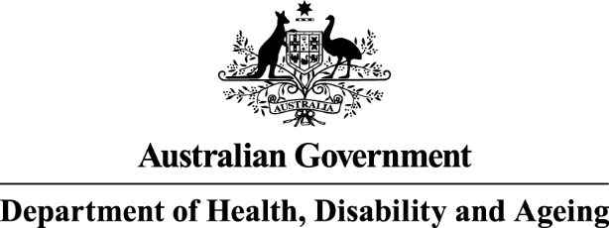

National Antimicrobial Prescribing Survey




Technical supplement 2023

Published by the Australian Government Department of Health, Disability and Ageing For issues regarding the content of the report:
Email: support@naps.org.au
Website: https://www.naps.org.au ISBN: 978-1-74186-106-8
© Australian Government Department of Health, Disability and Ageing
All material and work produced by the Department of Health, Disability and Ageing is protected by copyright.
The Department reserves the right to set out the terms and conditions for the use of such material.
Enquiries about the licence and any use of this publication are welcome and can be sent to AMR@health.gov.au
Preferred citation
Royal Melbourne Hospital and the National Centre for Antimicrobial Stewardship. National Antimicrobial Prescribing Survey: Technical Supplement 2023. Canberra: Department of Health, Disability and Ageing; 2025.
Disclaimer
This document is not intended to provide guidance on particular healthcare choices. You should contact
your healthcare provider for advice on particular healthcare choices.
This document includes the views or recommendations of its authors and third parties. Royal Melbourne Hospital, the National Centre for Antimicrobial Stewardship and the Australian Government Department
of Health, Disability and Ageing do not accept any legal liability for any injury, loss or damage incurred by the use of, or reliance on, this document.

Table of Contents
Acknowledgements 4
Abbreviations 5
Glossary 5
1. Introduction 8
2. Hospital NAPS 9
2.1 Methodology 9
2.2 Auditor education and support 11
2.3 Data analysis 12
2.4 Considerations for interpretation of results 12
2.5 Hospital NAPS data collection form 2023 14
2.6 Hospital NAPS compliance with guidelines assessment criteria 15
2.7 Hospital NAPS appropriateness definitions 16
3. Surgical NAPS 17
3.1 Methodology 17
3.2 Auditor education and support 18
3.3 Data analysis 19
3.4 Considerations for interpretation of results 24
3.5 Surgical NAPS data collection form 2023 25
3.6 Surgical NAPS appropriateness definitions 27
4. Aged Care NAPS 28
4.1 Methodology 28
4.2 Auditor education and support 30
4.3 Data analysis 31
4.4 Considerations for interpretation of results 31
4.5 Aged Care NAPS facility data collection form 2023 33
4.6 Aged Care NAPS antimicrobial and infection data collection form 2023 34
5. Ethical considerations 36
References 37

Acknowledgements

Contributing facilities
On behalf of the National Centre for Antimicrobial Stewardship and the Royal Melbourne Hospital Guidance Group, we would like to thank all contributing facilities and auditors for their time and effort in collecting and entering the data, in contributing data to all NAPS reports, to the Antimicrobial Use and Resistance in Australia (AURA) surveillance program and for their continued commitment to improving safety and quality across the Australian healthcare system.

Program contributors
Professor Karin Thursky
Dr Rodney James
Dr Courtney Ierano
Ms Caroline Chen
Ms Josephine Wen
Associate Professor Noleen Bennett
Mr Ron Cheah
Mr Pramode Varghese
Mr Logesh Palani
Mr Abukari Yakubu
Mr Freddy Lopez
Professor Lisa Hall
Mr Simon Burrell
Associate Professor Leon Worth
Dr Ann Bull
Dr Michael Malloy
The Australian Government Department of Health, Disability and Ageing provides funding for the Royal Melbourne Hospital Guidance Group and the National Centre for Antimicrobial Stewardship to conduct the NAPS and contribute data to the Antimicrobial Use and Resistance in Australia (AURA) surveillance program.1

Support at NAPS
NAPS end users requiring support are able to contact the NAPS Support Team via email and phone during office hours. The team is also available to provide additional clinical advice and online training
for facilities without infectious diseases expertise.
For more information and support regarding the NAPS, contact the Support Team via support@naps.org.au

Abbreviations
Abbreviation | Term
Aged Care NAPS | Aged Care National Antimicrobial Prescribing Survey
AMS | Antimicrobial stewardship
AURA | Antimicrobial Use and Resistance in Australia
Hospital NAPS | Hospital National Antimicrobial Prescribing Survey
IPC | Infection prevention and control
NAPS | National Antimicrobial Prescribing Survey
RACH | Residential aged care home
Surgical NAPS | Surgical National Antimicrobial Prescribing Survey
VICNISS | Victorian Healthcare Associated Infection Surveillance System

Glossary
Term |  | Definition
Antimicrobial use prevalence |  | The proportion of residents/patients present on the survey day who were prescribed at least one antimicrobial (current/active order on the survey day).
Appropriate prescribing |  | A prescription that is deemed appropriate (either ‘optimal’ or ‘adequate’) by the respective NAPS appropriateness definitions: see 2.7 Hospital NAPS appropriateness definitions and 3.6 Surgical NAPS appropriateness definitions.
Directed therapy |  | Treatment or prophylaxis guided by microbiology culture and susceptibility results.
Empirical therapy |  | Empirical use of antimicrobials to treat a suspected infection when the causative organism has not been identified. It is guided by the clinical presentation.
Existing antimicrobial therapy |  | Any antimicrobial prescribed for treatment or prophylaxis in the 24 hours prior  (72 hours if on dialysis) to the procedure; these are not analysed individually  but can be considered when assessing whether procedural antimicrobials were appropriately given or not given.
Inappropriate prescribing |  | A prescription that is deemed inappropriate (either ‘suboptimal’ or ‘inadequate’) by the respective NAPS appropriateness definitions:  see 2.7 Hospital NAPS appropriateness definitions and 3.6 Surgical NAPS  appropriateness definitions.
Initial dose |  | The first dose of an antimicrobial administered either immediately prior to or during the surgical procedure for the purpose of prophylaxis.
Local guidelines |  | Locally endorsed guidelines developed to provide guidance on antimicrobial prescribing. These guidelines must be readily available on wards or on the hospital intranet; exceptions include paediatric and neonatal guidelines from an Australian children’s hospital.
McGeer Criteria2 |  | Internationally recognised infection surveillance definitions for long-term care facilities. The definitions are largely based on signs and symptoms localising to a specific body system (gastrointestinal tract, respiratory tract, skin/soft tissue/mucosal, systemic, and urinary tract). For some definitions, additional microbiological or radiological evidence and use of devices  (e.g. urinary catheters) were also assessed.
Multi-Purpose Services |  | The Multi-Purpose Services Program provides integrated health and aged care services to rural and remote communities in areas that cannot support standalone aged care and hospitals.
Overall appropriateness | The overall appropriateness of prescribing for a surgical episode was determined by taking the lowest ranked assessment of the individual doses/prescription, including all episodes where antimicrobials were prescribed as well as those where none were prescribed - for example, procedural assessment was deemed appropriate and post-procedural was deemed inappropriate; the overall appropriateness is then inappropriate.
Peer group | Facilities of a similar type and complexity, as defined by the Australian Institute of Health and Welfare (AIHW). See the AIHW website for more information on each of the peer groups.3, 10  A peer group supports comparisons that reflect the purpose, resources and role  of each hospital and is defined by the type and nature of the services provided.
Post-procedural prescription | An antimicrobial prescribed following, but directly relating to, the procedure; each prescription of the antimicrobial is recorded, including any inpatient  or discharge scripts.
Procedural antimicrobial | An antimicrobial administered either immediately prior to or during the surgical procedure for the purpose of prophylaxis; each initial and repeat dose of the antimicrobial administered is recorded individually.
Procedure | The procedure(s) performed during the surgical episode, as documented on the procedure form or in the medical record; any procedure can be included - for example, colonoscopies, radiological procedures.
Procedure group | The specialty group under which each procedure is classed for reporting: see 3.3 Data analysis - Surgical procedure groups
Residential Aged Care Homes | For the purpose of NAPS, Residential Aged Care Homes (RACH) encompasses all mainstream aged care homes and Multi-Purpose Services.
Residential aged- care associated suspected infection | An infection that developed in an aged care resident at least 48 hours post (re-) admission.
Remoteness classification4 | The Australian Standard Geographical Classification – Remoteness Area assigns a remoteness classification to a location based on its physical road distance to the nearest urban centre.
Repeat dose | Any subsequent dose of an antimicrobial administered during the surgical procedure for the purpose of prophylaxis.
Surgical episode | Any individual procedure or set of procedures performed together during one session and the subsequent post-procedural care associated with  the procedure(s).
Suspected infection | At least one sign or symptom of a potential infection on the Aged Care NAPS survey day and, if present, other signs and/or symptoms in the 2 days prior to the survey day.

Introduction
The National Antimicrobial Prescribing Survey (NAPS) reports analyse antimicrobial prescribing practices across Australian hospitals and aged care facilities. There are 3 annual reports that detail the results from the Hospital NAPS,5 Surgical NAPS6 and Aged Care NAPS7 respectively.
This technical supplement is designed to be read alongside the NAPS reports to support readers’ understanding of the program and the methodological considerations when interpreting each report.
This technical supplement will provide information on the following:
- Methodology, including the participant recruitment, and data collection process
- Auditor education and support
- Data analyses
- Ethical considerations related to participant privacy, informed consent, and data security.
This technical supplement is designed to be read alongside the NAPS
reports to support readers’ understanding of the program and the methodological considerations when interpreting each module’s results.

Hospital NAPS

Methodology
The Hospital NAPS is a standardised web-based auditing tool available to all Australian hospitals to assess the quality of their antimicrobial prescribing, including an assessment of the appropriateness
of the prescription. Although voluntary, performing the Hospital NAPS will help to meet the requirements
for hospital accreditation - Actions 3.18 and 3.19 of the National Safety and Quality Health Service Standards.8 Data can be entered directly into the NAPS online platform or initially entered on a data collection form (2.5 Hospital NAPS data collection form).

Timeframe
Data entry and reporting is available throughout the year, allowing hospitals to complete the audit
whenever time and staffing resources permit. All finalised patient data that were audited from 1 January
to 31 December 2023 have been included for analysis in the 2023 Hospital NAPS report.

Recruitment
Using the existing registry of NAPS participants, auditors from more than 900 hospitals were invited
via email to participate in the 2023 survey. Further promotion by the National Centre for Antimicrobial Stewardship and the Royal Melbourne Hospital Guidance Group occurred throughout the year via their websites, X (formerly Twitter) accounts and newsletters.

Inclusion and exclusion criteria
All hospitals offering overnight stays can participate. Facilities such as same day services, sleep clinics
and other private specialty clinics without overnight stay are ineligible.

Included patients to be audited
Data should be collected for any admitted inpatient who:
- has an active antimicrobial order at 8:00 a.m. on the survey day, and/or
- was prescribed a stat dose (i.e. a single dose order) of an antimicrobial since 8.00 a.m. the previous day, and/or
- has had a surgical procedure performed and has been prescribed an antimicrobial for prophylaxis since 8.00 a.m. the previous day.

Antimicrobials to be audited
All antimicrobials, including antibiotics, antivirals, antifungals and antiparasitics, are to be included.
All formulations, including oral, intravenous, topical, et cetera, are to be included.

Excluded patients
Day stay, outpatient, Hospital in the Home and residential aged care patients are excluded. Patients present in the emergency department who have not yet been officially admitted are also excluded.

Audit methodology
Depending on the hospital size and the staffing resources available, participants can choose to conduct their audit using one of the following methodologies.
Method 1: Hospital-wide point prevalence audit
- This methodology requires all inpatients to be assessed so that prevalence of antimicrobial use can be calculated.
- Data are collected on both the number of inpatients prescribed antimicrobials (numerator) and the total number of inpatients (denominator).
- It is recommended that the data collection be completed on a single calendar day. However, if this was not possible, wards can be audited on separate days provided that all patients were audited once only.
Method 2: Repeat point prevalence audits
- For small hospitals (those with fewer than 100 acute beds), Method 1 may not allow enough data to be collected to meaningfully reflect prescribing practices.
- Therefore, small hospitals can conduct repeat point prevalence audits whereby a whole hospital audit is conducted multiple times, with audits at least one week apart, until at least 30 antimicrobial prescriptions have been collected.
- All inpatients should be included in the repeat audits, including those who have been audited previously, as the appropriateness of their respective antimicrobial prescriptions may change over time.
Method 3: Random sampling point prevalence audit
- For large hospitals where a whole-hospital point prevalence audit cannot be undertaken due to resource limitations, data can be collected from a random sample of inpatients provided the following guidelines are adhered to:
- A random sampling method should only be used in hospitals with ≥100 acute beds.
- The random sampling should include patients from all wards within the hospital.
- The proportion of patients sampled must be at least 50% of the inpatient population.
- The random sampling is based on inpatients, not antimicrobial prescriptions.

Assessment
Participants are advised that the assessments of guideline compliance and appropriateness should ideally be performed by multidisciplinary teams (2.6 Hospital NAPS compliance with guidelines assessment criteria and 2.7 Hospital NAPS appropriateness definitions). The membership of the auditing team is determined by each participating facility, depending on their staffing resources, and can consist of any combination of infectious diseases physicians, clinical microbiologists, other interested physicians, pharmacists, infection prevention and control practitioners or nurses. It is recommended that at least 2 members provide assessments whenever possible, as this facilitates discussion about more challenging assessments. Preferably, members providing assessment should have a sound clinical knowledge of antimicrobial prescribing and any local prescribing guidelines.
Guideline compliance is assessed according to the national guidelines (the Therapeutic guidelines: antibiotic9) or local guidelines where applicable. Appropriateness assessments are made in accordance with the Hospital NAPS definitions (2.7 Hospital NAPS appropriateness definitions). If adequate onsite clinical expertise is not available, participants are encouraged to seek support from other appropriately experienced clinicians available within their hospital network. The NAPS Support Team is also available to provide additional clinical advice for facilities without infectious diseases expertise.

Auditor education and support
Auditors are able to access the following essential online resources to promote accurate data collection and prescription assessment, as well as assist with the reporting and feedback process:
- user guides
- data collection form (2.5 Hospital NAPS data collection form)
- appropriateness definitions (2.7 Hospital NAPS appropriateness definitions)
- case examples
- Excel upload user guide
- Guide to the Clinical Care Standard indicators.
The NAPS Support Team also provides direct support throughout the data collection period in the form of:
- webinar training sessions
- helpdesk support via phone and email
- a remote expert assessment service
- assistance with the assessment of guideline compliance and prescription appropriateness for hospitals without access to infectious diseases or antimicrobial stewardship (AMS) specialists.

eLearning module
The Hospital NAPS eLearning module is available on the NAPS website and provides users with information regarding setting up the audit, data collection and assessments of compliance with guidelines and appropriateness.
Hospital NAPS participants must achieve a pass mark of 80% or more before they can finalise patient data and generate reports. The pass mark is kept high to promote consistency among auditors when performing their data collection and prescription assessments. Users who fail to pass the eLearning program within 3 attempts are encouraged to contact the NAPS support helpdesk to discuss any difficulties they may be experiencing.

Data analysis
Hospitals that conducted whole-hospital audits, including single point prevalence audits, repeat point prevalence audits and randomised sample audits, were included in the analyses. To avoid issues with systematic bias, all other audit methodologies, including directed audits of selected antimicrobials, indications, specialties or wards, were excluded.
De-identified hospital data are analysed by funding type (public or private), state or territory,vthe Australian Bureau of Statistics remoteness classifications and the Australian Institute of Health and Welfare peer group classifications.4, 10 Key performance indicators are analysed and reported for these categories.

Considerations for interpretation of results
Only patients who are prescribed antimicrobials are included in the audit. Patients who are not receiving any antimicrobials are excluded. Therefore, the audit does not describe the prescribing behaviour for
an indication in the context of a whole patient population, including, for example, patients who were appropriately not prescribed an antimicrobial. Therefore, for indications where the usual recommended therapy is for no antimicrobial treatment, only those patients receiving antimicrobials are included and hence the reported results may appear worse than they actually are for that indication.

Representativeness
Despite its voluntary nature, there is a high degree of representativeness5 across many hospital peer groups.10 Therefore, the results can be confidently presumed to be a true reflection of prescribing practices across most Australian hospitals.

Comparison with previous audits
The Hospital NAPS report includes reference data from 2015 onwards, although the ability to directly compare results from year to year is limited as a result of changes over time to the inclusion criteria, methodology and distribution of participating hospital types. The Hospital NAPS is a live database, and participating sites are able to edit or remove existing data. For the delivery of the annual national reports, the database is accessed and analysed each year; therefore, previous years’ data may have some small discrepancies in results compared with the previously published NAPS reports.5

Subjective nature of assessments
The Hospital NAPS has a mandatory eLearning module, detailed user guide, standardised appropriateness definitions and remote expert support to assist facilities to conduct their assessments. Nevertheless, individual auditors at each facility are ultimately responsible for assessing compliance with guidelines and antimicrobial prescribing appropriateness, and there is some degree of interpretation involved.

Hospital NAPS data collection form 2023
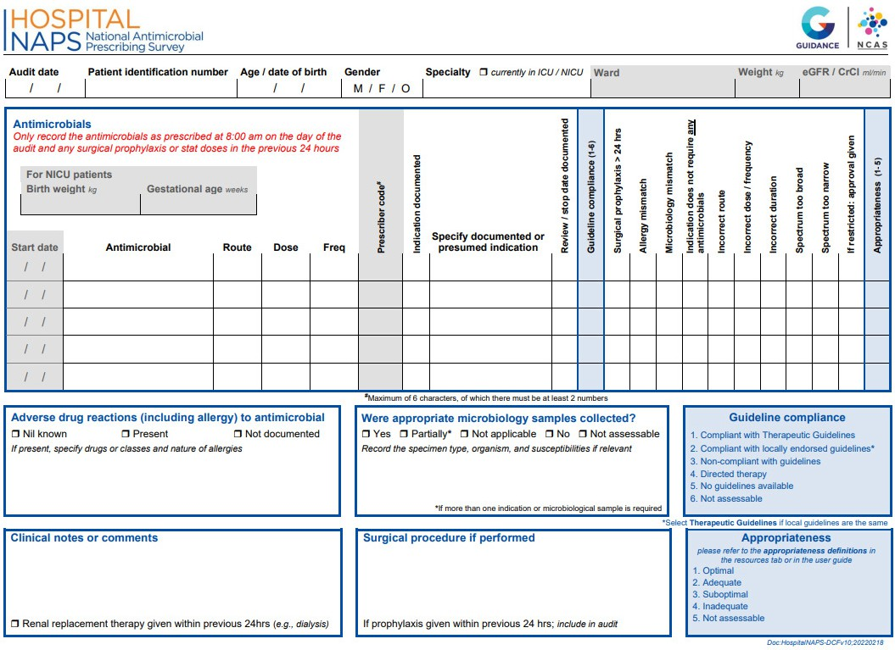
14 National Antimicrobial Prescribing Survey: Technical supplement 2023

Hospital NAPS compliance with guidelines assessment criteria
15 National Antimicrobial Prescribing Survey: Technical supplement 2023
Compliance with guidelines (only choose one of the following six criteria)
Compliant with Therapeutic Guidelinesa | The prescription complies with the current Therapeutic Guidelines, including:  - route, dose, frequency AND  - takes into account acceptable alterations due to age, weight, renal function,  allergies, other prescribed medications etc.
Compliant with locally endorsed guidelinesb | The prescription complies with an officially endorsed local guideline, including:  - route, dose, frequency AND  - takes into account acceptable alterations due to age, weight, renal function, allergies, other prescribed medications etc.  This does not include individual, departmental, or historical guidelines that do not have executive or drug and therapeutic committee approval  If the local guidelines are based exactly on the Therapeutic Guidelines, then choose the ‘Therapeutic Guidelines’ in preference to local guidelines
Non-compliant with guidelines | There is non-compliance with both Therapeutic Guidelines and local guidelines UNLESS  the prescription takes into account acceptable alterations due to age, weight,  renal function, allergies, other prescribed medications etc.
Directed therapy | The prescription has changed from empiric to directed therapy with microbiology culture or susceptibility results available
No guidelines available | There are no guidelines available for the documented or presumed indication
Not assessable | The medical records are not comprehensive enough to determine a documented or presumed indication  OR  It is difficult to assess if there is compliance
- Antibiotic Expert Group. Therapeutic Guidelines: Antibiotic. Version 16 (2019). Melbourne http://online.tg.org.au/ip/9
- Local guidelines must be authorised and readily available on wards or on the hospital intranet. They cannot be a web link to international guidelines or other non-approved sites. Exceptions include paediatric and neonatal guidelines from an Australian children’s hospital

Hospital NAPS appropriateness definitions
16 National Antimicrobial Prescribing Survey: Technical supplement 2023
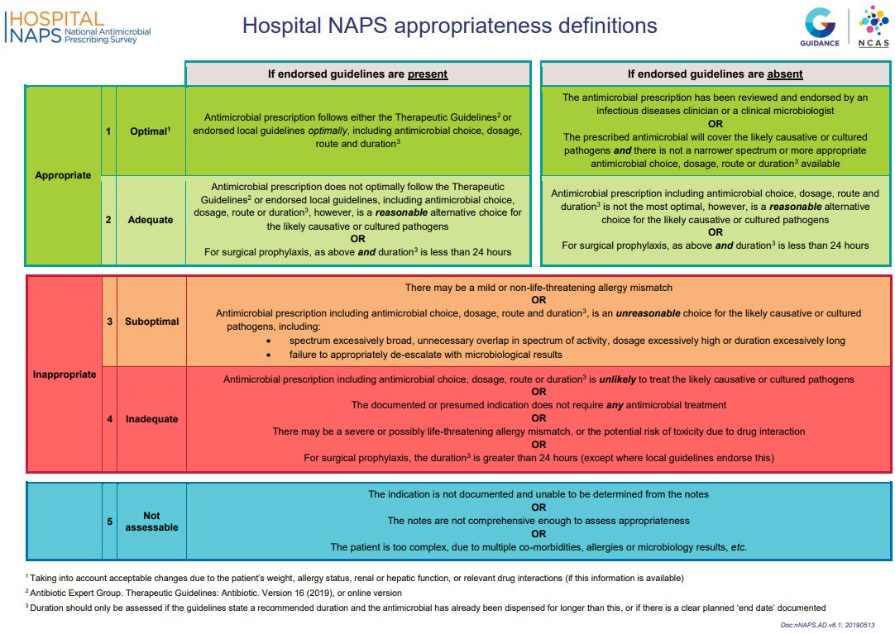

Surgical NAPS

Methodology
The Surgical NAPS is a standardised web-based auditing tool available to Australian health service organisations that perform incisional and non-incisional procedures to assess the quality of their surgical antimicrobial prophylaxis prescribing, including an assessment of the appropriateness of the prescription. Although voluntary, performing the Surgical NAPS will help to meet the requirements for hospital accreditation – Actions 3.18 and 3.19 of the National Safety and Quality Health Service Standards.8 Data can be entered directly into the NAPS online portal or initially entered on a data collection form (3.5 Surgical NAPS data collection form).

Timeframe
Data entry and reporting were available throughout the year (1 January to 31 December 2023), allowing hospitals to complete the audit whenever time and staffing resources permitted. Hospitals may retrospectively audit data from previous years or edit or remove existing data. Therefore, the total number of hospitals contributing annually differs slightly each year. Data from previous years that were retrospectively entered onto the data entry platform in 2023 were excluded.
All finalised patient data audited in 2023 have been included for analysis in the 2023 Surgical NAPS report.6

Recruitment
Using the existing registry of NAPS participants, auditors from more than 900 hospitals were invited via email to participate in the 2023 Surgical NAPS. Further promotion by the National Centre for Antimicrobial Stewardship and the Royal Melbourne Hospital Guidance Group occurred throughout the year via their websites, X (formerly Twitter) accounts and newsletters.

Inclusion criteria
Any procedure type can be audited, including incisional or non-incisional procedures.

Audit methodology
Auditors can choose a variety of methods to perform the audit, depending on the size of the facility and available resources. Data can be collected on paper data collection forms then entered into the NAPS
online portal (see 3.5 Surgical NAPS data collection form for data fields) or can be entered directly into
the online portal. The data collection form is standardised across both paper and online platforms.
Retrospective audits were the preferred methodology undertaken by auditors. Auditors were advised
to complete the audit over any chosen timeframe with a minimum of one week or 30 consecutive procedures or surgical episodes. Theatre lists were recommended to be obtained to capture all procedures during this timeframe.

Assessment
Participants are advised that the assessments of guideline compliance and appropriateness should
ideally be performed by multidisciplinary teams. The membership of the auditing team is determined by each participating facility, depending on their staffing resources, and can consist of any combination of infectious diseases physicians, clinical microbiologists, other interested physicians, pharmacists, infection prevention and control practitioners and nurses. It is recommended that at least 2 members provide assessments whenever possible, as this facilitates discussion about more challenging assessments. Preferably, members providing assessment should have a sound clinical knowledge of antimicrobial prescribing and any local prescribing guidelines.
Guideline compliance is assessed according to the national guidelines (the Therapeutic guidelines: antibiotic9) or local guidelines where applicable. Appropriateness assessments are made in accordance with the Surgical NAPS definitions (3.6 Surgical NAPS appropriateness definitions).
If an onsite assessment team is not available, participants are encouraged to seek support from other appropriately experienced clinicians available within their hospital network. The NAPS Support Team is also available to provide additional clinical advice for facilities without infectious diseases expertise.

Auditor education and support
Auditors are able to access the following essential online resources to promote accurate data collection and prescription assessment, as well as assist with the reporting and feedback process:
- user guide
- data collection form (3.5 Surgical NAPS data collection form)
- appropriateness definitions (3.6 Surgical NAPS appropriateness definitions).
A guide to the timing and duration of surgical prophylaxis was created to help with the assessment of appropriateness regarding these issues.11 With the release of the newly designed Surgical NAPS reports in 2021 and based on early feedback regarding the complex nature of the reports, a written guide to interpreting these reports was also developed to assist users to understand their results.14
The NAPS Support Team also provide direct support throughout the data collection period in the form of:
- webinar training sessions
- helpdesk support via phone and email
- a remote expert assessment service
- assistance with the assessment of guideline compliance and prescription appropriateness for hospitals without access to infectious diseases or AMS specialists.

eLearning module
The Surgical NAPS online eLearning module is available on the NAPS website at any time. The package provides users with information regarding setting up the audit, data collection and assessments of compliance with guidelines and appropriateness.
Surgical NAPS participants must achieve a pass mark of 80% or more before they can finalise patient data and generate reports. The pass mark is kept high to promote consistency among auditors when performing their data collection and prescription assessments. Users who fail to pass the eLearning program within 3 attempts are encouraged to contact the NAPS support helpdesk to discuss any difficulties they may be experiencing.

Data analysis
The Surgical NAPS database is live and participating hospitals are free to amend, add or remove their data at any time. For the delivery of the annual national reports, the database is accessed and analysed each year; therefore, previous years’ data may have some small discrepancies in results compared with the previously published NAPS reports.

Surgical procedure groups
The procedures listed in the Surgical NAPS database have been adopted from The Royal Australasian College of Surgeons Morbidity Audit and Logbook tools.12

The surgical procedure groups listed are:

    - Abdominal surgery
- anorectal
- bariatric and other
- biliary
- colorectal
- gastro–oesophageal
- hepatic
- pancreas and duodenum
    - Breast surgery
    - Cardiac surgery
    - Dentoalveolar surgery
    - Gastrointestinal endoscopic procedures
    - Gynaecological surgery
    - Head and neck surgery
      - laryngology
      - Ontology
      - rhinology
    - Neurosurgery
- Cerebrovascula
- Peripheral nerve
- Spinal
- other
    - Obstetrics
    - Ophthalmology
    - Orthopaedic surgery
    - Plastic and reconstructive surgery
    - Thoracic surgery
    - Urological surgery
      - endoscopic procedures
      - laparoscopic procedures
      - open procedures
      - other
    - Vascular surgery
      - dialysis access

Appropriateness assessments
For reporting purposes, ‘optimal’ and ‘adequate’ are deemed to be appropriate, while ‘suboptimal’ and ‘inadequate’ are deemed to be inappropriate (see 3.6 Surgical NAPS appropriateness definitions for more information on definitions of appropriateness). Each surgical episode was given an overall assessment of inappropriate if any single aspect of the procedural or post-procedural prescribing was deemed inappropriate by the auditor. This included allergy or microbiology mismatch; incorrect antimicrobial timing, dose, route, frequency or duration; if the antimicrobial spectrum was too broad or too narrow; or if the procedure did not require any antimicrobials (see 3.6 Surgical NAPS appropriateness definitions for detailed definitions).

Calculation of duration of surgical prophylaxis
Duration of surgical prophylaxis was calculated from the surgical incision date and time, if recorded; otherwise, the surgery start date and time were used. These dates and times were used as a surrogate measure to the more acute measure of administration date and time of the first procedural antimicrobial prescribed, which was not able to be determined for 941 (10.1%) of the prescribed initial procedural doses (n=9,276) in 2023. The end date and time for the last prophylactic antimicrobial prescribed was then used to determine the end date and time of surgical prophylaxis.
For calculation of duration of surgical prophylaxis greater than 24 and 48 hours, the required dates and times were consistently completed by auditors, and these were able to be calculated accurately. For days of therapy calculations, any incomplete administration time for the last dose of therapy did not affect these overall calculations.

Calculation of participation rates
In order to define the denominator for participation rates by different reporting groups (states and territories), the Australian Institute of Health and Welfare peer group classification system10 and the Australian Bureau of Statistics remoteness categories4 were used. Hospital peer groups that would not be expected to perform surgical procedures were excluded from the denominator calculation.
The peer groups included for determination of denominator numbers for rates of participation are shown in Table 1.

Table 1. Australian Institute of Health and Welfare peer groups included for calculation of participation rates
Public facilities | Private facilities
Children’s hospitals  Combined women’s and children’s hospitals  Mixed day procedure hospitals Other day procedure hospitals  Principal referral hospitals  Public Acute Group A hospitals Public Acute Group B hospitals Public Acute Group C hospitals Public Acute Group D hospitals Women’s hospitals | Combined women’s and children’s hospitals Endoscopy centres  Eye surgery centres Gynaecology day hospitals Mixed day procedure hospitals  Oral and maxillofacial surgery centres Other acute specialised hospitals Other specialist day hospitals  Plastic and reconstructive surgery centres Private Acute Group A hospitals  Private Acute Group B hospitals Private Acute Group C hospitals Private Acute Group D hospitals  Women’s hospitals
The peer groups excluded for determination of denominator numbers for rates of participation are shown in Table 2.

Table 2. Australian Institute of Health and Welfare peer groups excluded for calculation of participation rates
Public facilities | Private facilities
Drug and alcohol hospitals Early parenting centres  Mixed subacute and non-acute hospitals  Other acute specialised hospitals  Other public acute specialised hospitals Outpatient hospitals  Public acute psychiatric hospitals  Public child, adolescent and young adult psychiatric hospitals  Public forensic psychiatric hospitals Public rehabilitation hospitals  Public subacute and non-acute psychiatric hospitals  Unpeered hospitals  Very small hospitals | Cardiovascular health centres Dialysis clinics  Drug and alcohol hospitals Fertility clinics  Haematology and oncology clinics Hyperbaric health centres  Mixed subacute and non-acute hospitals Private acute psychiatric hospitals Private rehabilitation hospitals Reproductive health centres  Same day hospitals Sleep centres Unpeered hospitals Very small hospitals

Considerations for interpretation of results
The results presented in the 2023 Surgical NAPS report6 should be interpreted in the context of the following limitations and considerations.

Sampling and selection bias
The facilities that participated were not a randomised sample because participation was voluntary. Therefore, the results might not be representative of all Australian facilities where surgery is performed. Each hospital could choose how to perform the Surgical NAPS audit. Audits may have been conducted
as prevalence audits (consecutive or random patients), directed audits (particular surgical specialties or procedures) or other types of audits; therefore, it is not possible to determine the exact prevalence of the surgical procedures or antimicrobials prescribed.

Audit methodology was not defined
For the Surgical NAPS, each hospital could decide how they performed the audit and which patients, or surgical specialties, were audited. If directed audits were performed, patient sampling may not have been random, and auditors may have targeted problem or higher volume surgical units.

Subjective nature of assessments
Individual auditors at each contributing facility were responsible for assessing the compliance with guidelines and appropriateness of antimicrobial prescribing. These assessments are not completely objective, as they involve some degree of interpretation, although the Surgical NAPS appropriateness definitions (3.6 Surgical NAPS appropriateness definitions) improve this objectivity. This is further supplemented by the NAPS Support Team and online training resources. Remote expert assessments were also able to be conducted by the NAPS support team on request.

Comparison of data over time
Care is required in relation to comparisons of Surgical NAPS data from one year to another, as the cohort of contributors varies from year to year, along with the proportions of surgical procedure groups represented.

Surgical NAPS data collection form 2023
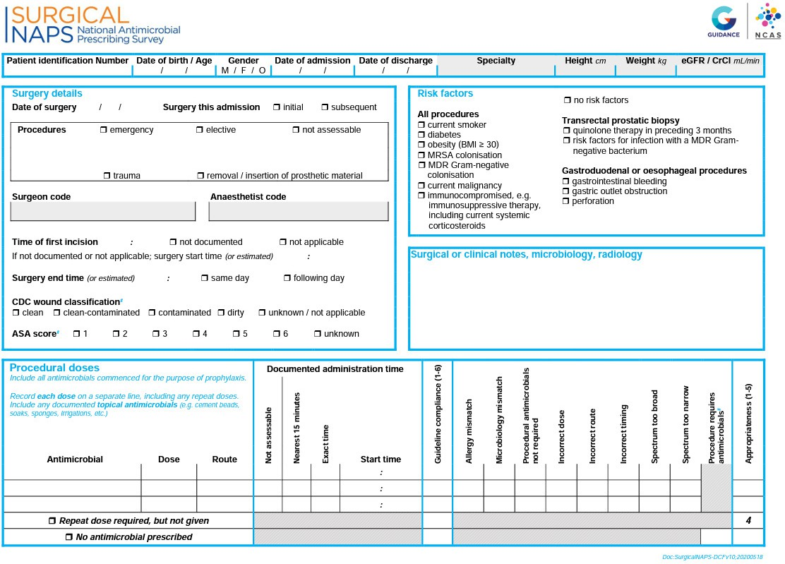

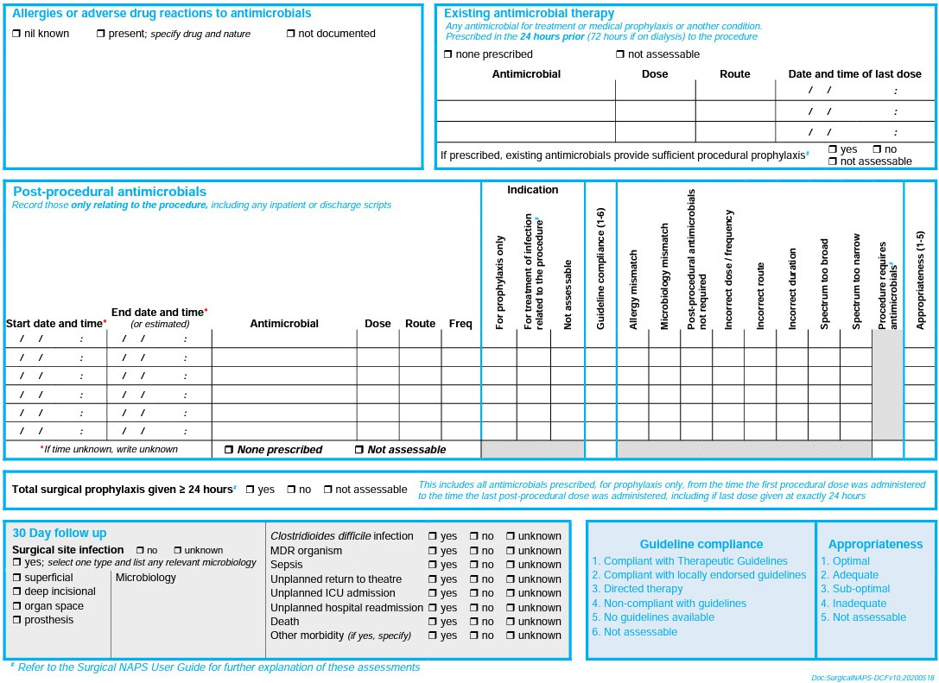

Surgical NAPS appropriateness definitions
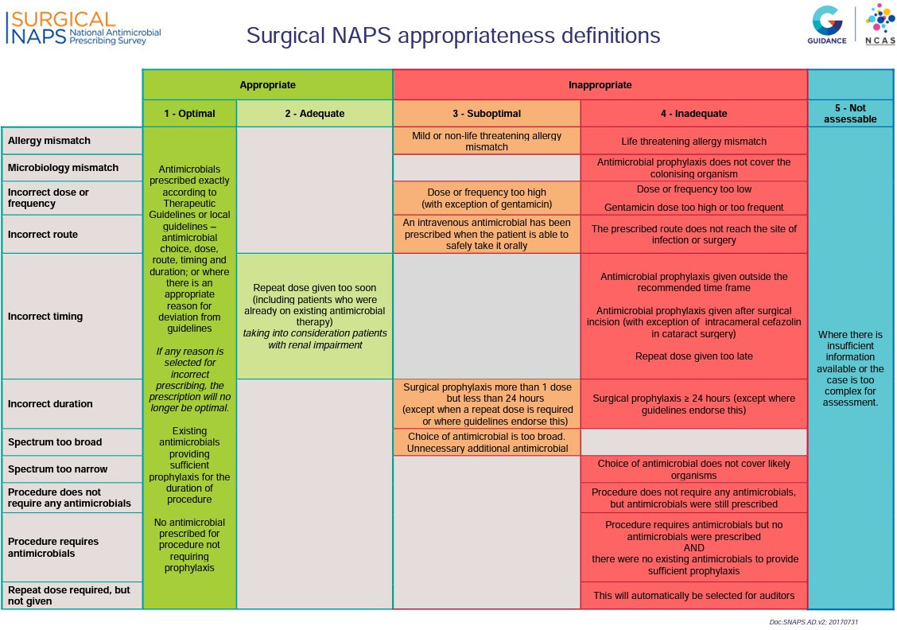

Aged Care NAPS

Methodology
The Aged Care NAPS is a standardised surveillance tool that residential aged care homes (RACHs)
can use to monitor the prevalence of infections and antimicrobial use, provide feedback to key clinicians and administrators, and measure the effectiveness of infection prevention and control (IPC) and AMS programs.
Performing the Aged Care NAPS will help IPC and AMS services in RACHs meet the requirements of
the Aged Care Quality Standards.13 Standard 3 (3.g) specifically aims to minimise infection-related risks
by implementing standard and transmission-based precautions and practices to promote appropriate antimicrobial use. Standard 8 (3.e) notes that where clinical care is provided a clinical governance framework must include AMS.
Participants who register are granted access to the NAPS online portal where they can submit their data. Data are able to be entered directly into the online portal or collected on a paper-based data collection form first (see 4.5 Aged Care NAPS facility data collection form and 4.6 Aged Care NAPS antimicrobial and infection data collection form).
The Aged Care NAPS is commonly completed by senior nurses, IPC practitioners and/or pharmacists. Ideally, auditors have had at least 2 years of clinical experience.

Timeframe
The Aged Care NAPS module is open for data entry and reporting all year round.
The official data collection and submission period for the 2023 Aged Care NAPS was 1 June to 31 December 2023. All finalised data that were audited during this timeframe have been included for analysis in this report.

Recruitment
All Australian RACHs were eligible to participate in the 2023 Aged Care NAPS. Since 2017, participation by Victorian Government RACHs has been mandatory, as part of the Victorian Healthcare Associated Infection Surveillance System (VICNISS) Infection Control Indicator Program. The remainder of participants contribute on a voluntary basis.
Using the existing registry of NAPS participants, individuals from more than 900 RACHs were invited via email to participate in the 2023 Aged Care NAPS. Further promotion by National Centre for Antimicrobial Stewardship, VICNISS and the Royal Melbourne Hospital Guidance Group occurred throughout the year via their websites, X (formerly Twitter) accounts and newsletters.

Inclusion criteria
All residents living in the participating RACH and present on the survey day are eligible to be included.
This includes permanent, respite or transient residents, as well as those being managed by Hospital in the Home or In-Reach service.

Audit methodology
On any day during the 2023 timeframe, participating RACHs chose 1 of 2 audit methods to collect data
(see box below).
Method 2 was recommended for smaller RACHs that wished to expand their sample size to better assess
their performance.

RACHs could participate more than once.
Method 1: A single-day point prevalence audit
On the survey day, all residents are screened to determine if they:
- have an antimicrobial prescription noted on their medication chart, and/or
- have signs and symptoms of a suspected infection.
Method 2: A single-day point prevalence audit plus an additional one-month retrospective audit
On the survey day, all residents are screened to determine if they:
- have an antimicrobial prescription noted on their medication chart, and/or
- have signs and symptoms of a suspected infection.
In addition, all residents present on the survey day are screened to determine if they had an antimicrobial prescription noted on their medication chart on any day during the previous month that was ceased prior to the survey day.

Data collection forms

Facility data collection form
Each participating RACH completed the facility form (4.5 Aged Care NAPS facility data collection form). Resident-level data fields included listing the number of residents present on the survey day. All residents who were present on the survey day were eligible for inclusion.

Antimicrobial and infection data collection form
The antimicrobial and infection form (4.6 Aged Care NAPS antimicrobial and infection data collection form) was completed for residents who:
- were prescribed an antimicrobial on the survey day (Methods 1 and 2), and within the previous month (Method 2 only), and/or
- had at least one sign and/or symptom of a suspected infection present on the survey day (Methods 1 and 2).

Auditor education and support
Auditors are able to access the following essential online resources to promote accurate data collection and prescription assessment, as well as assist with the reporting and feedback process:
- user guide
- facility form
- antimicrobial and infection form
- list of commonly prescribed antimicrobials
- indications list
- McGeer et al. infection definitions.2
The NAPS Support Team also provides direct support throughout the data collection period in the form of:
- webinar training sessions
- helpdesk support via phone and email
- a remote expert assessment service
- assistance with auditing and clinical queries for RACHs without access to infectious diseases or AMS specialists.

eLearning module
The Aged Care NAPS online eLearning module is available on the NAPS website at any time. The package provides users with information regarding setting up the audit, how to prepare for the audit, the methodology and how to complete the data collection form.
Currently, it is not mandatory for Aged Care NAPS participants to complete the eLearning module, although it is highly recommended and a valued resource amongst participants.

Data analysis
Data quality processes for the Aged Care NAPS dataset included identification and, if necessary and possible, ‘follow-up consultation’ with the auditors to correct missing, miscoded and out-of-range errors. Duplicate and non-finalised resident records were excluded; audits that included only non-finalised resident records were omitted. For those RACHs that participated more than once each year, only their last audit was included in the analyses for this report. Changes to the dataset and decisions about how to assess certain data fields were documented.
An electronic decision algorithm was applied to each suspected infection to determine whether or not the McGeer et al. infection surveillance definitions2 were met. These widely referenced definitions, which were specifically developed for use in long-term care facilities, were last revised in 2012 to take into account the most recent evidence and the availability of improved diagnostics for surveillance. The criteria that define the infections were selected to increase the likelihood that ‘true infections’2 were captured.
To analyse antimicrobial use, Method 1 and Method 2 antimicrobial data were usually combined. Antimicrobials prescribed on a known start date within 6 months and still prescribed on the survey day only were included in exact duration and date of administration estimates. This is because both the start and audit date were required for these analyses.

Considerations for interpretation of results

Aged Care NAPS data
The 2016–2022 data included in the analyses for the 2023 report differ from previous reports: some data were retrospectively entered, and an extensive data cleaning process was undertaken before commencing the 2023 analysis.

Sampling
For some state and territory remoteness and provider type categories, there was a relatively small number of participating RACHs.
Over time, different cohorts of RACHs have participated in the annual Aged Care NAPS. Each year, the number of participating RACHs has mostly increased, ‘new’ RACHs have participated and some RACHs which had previously participated have chosen not to participate.

Signs and symptoms
In many cases, prescriptions audited were prescribed more than 3 days prior to the survey day. Signs
and symptoms of infection are likely to be most significant in the period just prior to considering, or on commencement of, antimicrobial prescriptions. Therefore, the number of audited suspected infections may under-represent the true number of antimicrobial prescriptions where signs and symptoms of infection
were present prior to the prescription.

Infection surveillance definitions
Signs and symptoms of infection in older residents may be atypical, so failure to meet the revised McGeer et al. definitions2 may not fully exclude the presence of a true infection.
In addition, the McGeer et al. definitions2 require microbiological confirmation for some infections (e.g. urinary tract infections). This means that these infections will not be confirmed unless microbiological specimens are collected. Specimens for microbiological testing are less likely to be collected in RACHs than in acute care services.
The McGeer et al. definitions are generally useful to compare the proportion of defined infections between facilities over time as opposed to being used to rule in or rule out the clinical need for a prescription.2

Variation
The audit was conducted on a single day. The results may have been different on another day dependent
on the season. Certain respiratory infections, for example, are usually more frequent in winter.

Validation
The analysis relied on the validity of local assessments. There was no additional external validation undertaken.

Aged Care NAPS facility data collection form 2023
For this form, the term ‘facility’ is interchangeable with RACHs.
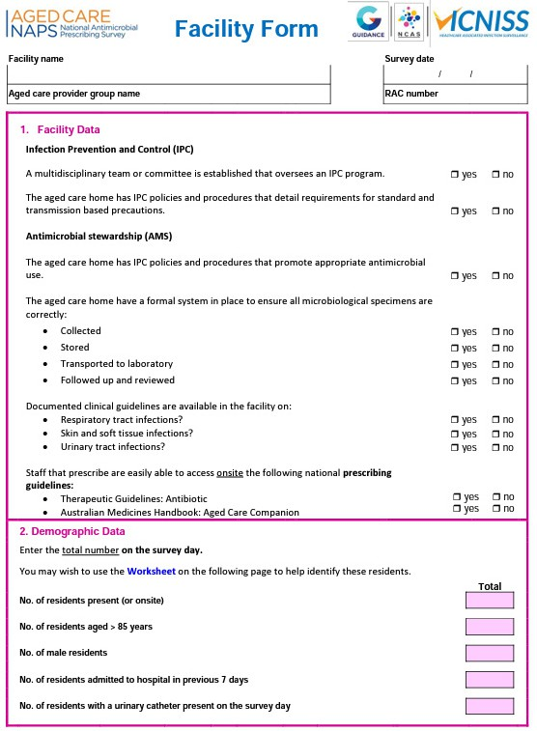

Aged Care NAPS antimicrobial and infection data collection form 2023
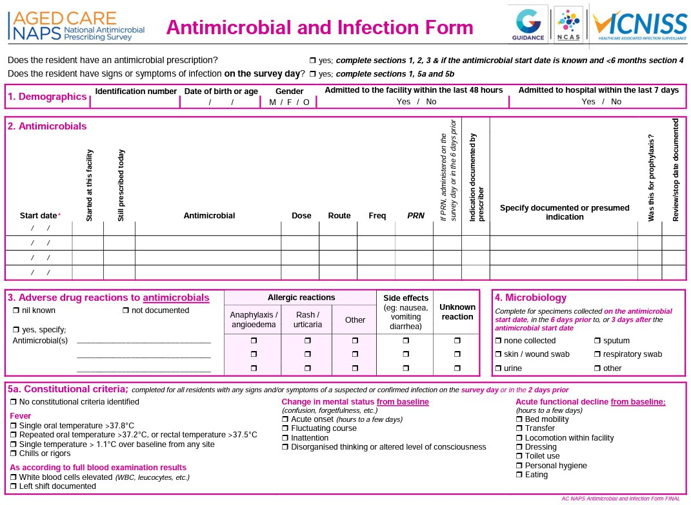

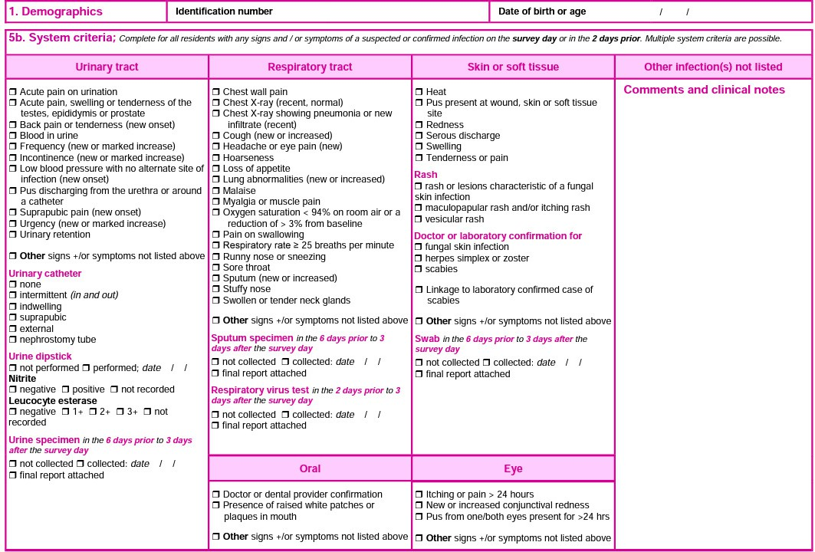

Ethical considerations
The NAPS program has been granted a Low-Risk Human Research Ethics Approval by the Melbourne Health Human Research Ethics Committee (project number HREC/74195/MH-2022).
The NAPS datasets utilised for annual reporting purposes contain data that are both patient and hospital de-identifiable. Additionally, there is no direct patient involvement in the data collection process or subsequent research. In accordance with the current ethics approval, individual patient consent is not required.
Each NAPS Auditor provides consent to the NAPS by agreeing to the Terms and Conditions, which are available on the NAPS website.
The NAPS™ database and program are managed by the RMH Guidance Group and hosted within the web applications servers accessible from the internet and database servers behind internal security firewalls at Melbourne Health. Access is only granted to NAPS staff employed by Melbourne Health and to authenticated users.

References
- Australian Government Department of Health and Aged Care, Australian Government Department
of Agriculture, Fisheries and Forestry. Surveillance of antimicrobial use and resistance in human health. [Internet] Canberra: Australian Government; 2023 [cited May 2024]. Available from:
- https: /www.amr.gov.au/australias-response/objective-5-integrated-surveillance-and-response- resistance-and-usage/surveillance-antimicrobial-use-and-resistance-human-health.
- Stone ND, Ashraf MS, Calder J, Crnich CJ, Crossley K, Drinka PJ, et al. Surveillance definitions
of infections in long-term care facilities: revisiting the McGeer criteria. Infection Control & Hospital Epidemiology. 2012; 33(10):965-77.
- Australian Institute of Health and Welfare. Hospital resources 2020-21: Australian hospital statistics. [Internet] Canberra: AIHW; 2021 [cited May 2024]. Available from: https: /www.aihw.gov. au/getmedia/e0e946d9-3d84-48b3-954a-e97f96814c0a/Hospital-resources-tables-2020-21.xls. aspx.
- Australian Bureau of Statistics. 1270.0.55.005 - Australian Statistical Geography Standard. In: Australian Bureau of Statistics, editor. Canberra. 2016.
- Royal Melbourne Hospital and the National Centre for Antimicrobial Stewardship. Antimicrobial prescribing practice in Australian hospitals. Results of the 2023 Hospital National Antimicrobial Prescribing Survey. Canberra: Department of Health, Disability and Ageing; 2025.
- Royal Melbourne Hospital and the National Centre for Antimicrobial Stewardship. Surgical prophylaxis prescribing in Australian hospitals. Results of the 2023 Surgical National Antimicrobial Prescribing Survey. Canberra: Department of Health, Disability and Ageing; 2025.
- Royal Melbourne Hospital and the National Centre for Antimicrobial Stewardship. Infections and antimicrobial prescribing in Australian residential aged care homes. Results of the 2023 Aged Care National Antimicrobial Prescribing Survey. Canberra: Department of Health, Disability and Ageing; 2025.
- Australian Commission on Safety and Quality in Health Care. National safety and quality health service standards. 2nd ed. - version 2. Sydney (Australia): ACSQHC; 2021.
- Antibiotic Expert Group. Therapeutic guidelines: antibiotic. 16th ed. Melbourne: Therapeutic Guidelines Limited; 2019.
- Australian Institute of Health and Welfare. Australian hospital peer groups. Health services series
- no. 66. Cat. no. HSE 170. Canberra: AIHW; 2015.
- Royal Melbourne Hospital and the National Centre for Antimicrobial Stewardship. Surgical NAPS: timing and duration of surgical prophylaxis, Recommendations 2020. Melbourne: Group RG; 2020.
- Royal Australasian College of Surgeons. Morbidity audit and logbook tool - Procedure list for SET and IMG general surgery. Royal Australasian College of Surgeons, editor. East Melbourne (Australia): Royal Australasian College of Surgeons; 2015.
- Aged Care Quality and Safety Commission. Aged Care Quality Standards. Canberra: ACQSC; 2021.
- Royal Melbourne Hospital and the National Centre for Antimicrobial Stewardship. Surgical NAPS: interpreting reports user guide 2021. Melbourne: Group RG; 2021.

All information in this publication is correct as at January 2025.
amr.gov.au

