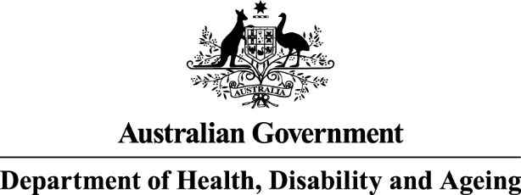

Infections and antimicrobial prescribing in Australian residential aged care homes

Results of the 2023 Aged Care




National Antimicrobial Prescribing Survey

Published by the Australian Government Department of Health, Disability and Ageing
For issues regarding the content of the report:
Email: support@naps.org.au
Website: https://www.naps.org.au ISBN: 978-1-74186-103-7
© Australian Government Department of Health, Disability and Ageing
All material and work produced by the Department of Health, Disability and Ageing is protected by copyright.
The Department reserves the right to set out the terms and conditions for the use of such material.
Enquiries about the licence and any use of this publication are welcome and can be sent to AMR@health.gov.au
Preferred citation
Royal Melbourne Hospital and the National Centre for Antimicrobial Stewardship. Infections and antimicrobial prescribing in Australian residential aged care homes. Results of the 2023 Aged Care National Antimicrobial Prescribing Survey. Canberra: Department of Health, Disability and Ageing; 2025.
Disclaimer
This document is not intended to provide guidance on particular healthcare choices. You should contact your healthcare provider for advice on particular healthcare choices.
This document includes the views or recommendations of its authors and third parties. Royal Melbourne Hospital, the National Centre for Antimicrobial Stewardship and the Australian Government Department of Health, Disability and Ageing do not accept any legal liability for any injury, loss or damage incurred by the use of, or reliance on, this document.

Table of Contents
Acknowledgements 4
Contributing facilities 4
Abbreviations 5
Summary 6
Key results 6
Recommendations 6
1. Introduction 7
2. Results 8
2.1 Participation 8
2.2 Prevalence of infections and antimicrobial use 11
2.3 Suspected infections on the survey day 12
2.4 Most commonly prescribed antimicrobials 13
2.5 Common indications for prescribing antimicrobials 14
2.6 Most commonly prescribed antimicrobials for common indications 15
2.7 Quality indicators 16
2.8 Duration 17
2.9 Microbiology 17
3. Conclusion 18
Appendix 19
References 30

Preface
This report is best interpreted when read in conjunction with the National Antimicrobial Prescribing Survey: technical supplement 2023.⁵

Acknowledgements

Contributing facilities
On behalf of the National Centre for Antimicrobial Stewardship, Royal Melbourne Hospital Guidance Group
and Victorian Healthcare Associated Infection Surveillance System (VICNISS) Co-ordinating Centre, we would like to thank all contributing residential aged care homes and auditors for collecting and entering the data for this and the Antimicrobial Use and Resistance in Australia (AURA) surveillance program reports, thereby committing to improving safety and quality across the Australian aged care system.
National Centre for Antimicrobial Stewardship and Royal Melbourne Hospital Guidance Group
Professor Karin Thursky
Dr Rodney James
Associate Professor Noleen Bennett
Dr Courtney Ierano
Associate Professor Lisa Hall
Ms Caroline Chen
Ms Josephine Wen
Mr Simon Burrell
Mr Pramode Varghese
Mr Logesh Palani
Mr Abukari Yakubu
VICNISS Co-ordinating Centre
Associate Professor Leon Worth
Dr Ann Bull
Associate Professor Noleen Bennett
Dr Michael Malloy

Abbreviations
Abbreviation | Term
Aged Care NAPS | Aged Care National Antimicrobial Prescribing Survey
AMS | Antimicrobial stewardship
AURA | Antimicrobial Use and Resistance in Australia
HALT | Healthcare-Associated Infection in Long Term Care Facilities
IPC | Infection prevention and control
NAPS | National Antimicrobial Prescribing Survey
PRN | Pro re nata
RACH | Residential aged care home. For the purposes of NAPS, RACH encompasses  all mainstream residential aged care homes as well as Multi-Purpose Services.
VICNISS | Victorian Healthcare Associated Infection Surveillance System

Summary
The Aged Care National Antimicrobial Prescribing Survey (Aged Care NAPS) continues to play a pivotal role in Australian residential aged care homes (RACHs) as part of their infection prevention and control (IPC) and antimicrobial stewardship (AMS) programs. Aged Care NAPS is a standardised tool that can be used to monitor the prevalence of infections and antimicrobial use, provide feedback to key clinicians and administrators and measure the effectiveness of IPC and AMS initiatives.
A total of 852 RACHs participated in 2023 – an increased number from 2022 (n=744). The ongoing large number of Aged Care NAPS contributors indicates that Australian RACHs value the opportunity to participate in this point prevalence survey. All provider states and territories (except Northern Territory), Remoteness Areas and provider groups (government, not for profit and private) were represented.

Key results
- On the survey day, the prevalence of residents who had signs and/or symptoms of at least one suspected infection was 3.6%; the prevalence of residents prescribed at least one antimicrobial (active medication order) was 11.9%.
- On the survey day, suspected skin or soft tissue (47.6%), urinary tract (19.0%) and respiratory tract (17.1%) infections continued to be most commonly reported; only 36.1% met surveillance definitions
for confirmed infections.
- Clotrimazole (21.6%) and cefalexin (21.1%) continue to be the most commonly prescribed antimicrobials.
- Documentation of indication for an antimicrobial prescription increased slightly compared with 2022 (83.0% vs 80.3%).
- The most common indication (therapeutic or prophylactic) for prescribing antimicrobials was ‘Other - Skin, soft tissue or mucosal’ infection (17.8%); that is, all skin, soft tissue or mucosal conditions or infections not available as an option in the NAPS indication list for selection.
- Documentation of review or stop date for an antimicrobial prescription was similar to 2022 (56.6% compared with 56.8%) but still remains well below the expected best-practice target of 95%.
- For those antimicrobials still prescribed on the survey day, over one-third (34.7%) were commenced more than 6 months prior.
- A microbiology specimen was collected for less than one-quarter (20.1%) of antimicrobial prescriptions where the start date was known and less than 6 months prior to the survey date.

Recommendations
The Aged Care NAPS key results again demonstrate that there are significant opportunities for improvement. Recommendations for those working at a local or national level include:
- participation in the Aged Care NAPS
- continuing training and providing support to participating RACH staff, especially to prevent and control common infections and improve antimicrobial use
- sharing Aged Care NAPS results with administrators and clinicians to develop targeted IPC and AMS improvement strategies
- tailoring RACH AMS programs to improve antimicrobial prescribing. This could include, for example, ensuring the documentation of key prescribing elements.

Introduction
This report presents analyses of data collected for the 2023 Aged Care National Antimicrobial Prescribing Survey (Aged Care NAPS) and includes comparisons with previous annual (2016 to 2022)1 Aged Care NAPS data. It supersedes all previous Aged Care NAPS reports.
Monitoring of infections and antimicrobial use in residential aged care homes (RACHs) is an important safety and quality activity, as there is longstanding evidence of residents being colonised or infected by multidrug-resistant organisms; and inappropriate antimicrobial use.
Aged Care NAPS, first piloted in 2015, was modelled on the European Centre for Disease Prevention and Control Healthcare-Associated Infection in Long Term Care Homes (HALT) study. Aged Care NAPS has subsequently been conducted annually. Coordination of the Aged Care NAPS is overseen by the National Centre for Antimicrobial Stewardship, Royal Melbourne Hospital Guidance Group and Victorian Healthcare Associated Infection Surveillance System (VICNISS) Co-ordinating Centre. In 2023, funding was provided by the then Australian Government Department of Health and Aged Care. Aged Care NAPS data are included in Antimicrobial Use and Resistance in Australia (AURA) surveillance program reports; AURA is a comprehensive and coordinated national surveillance system of antimicrobial use and antimicrobial resistance in human health.³
Aged Care NAPS is a standardised surveillance tool that all Australian mainstream RACHs and Multi- Purpose Services can use to monitor the prevalence of infections and antimicrobial use, provide feedback to key clinicians and administrators, and measure the effectiveness of infection prevention and control (IPC) and antimicrobial stewardships (AMS) programs.^{2, 3} It is recommended RACHs participate at least once during the official timeframe. Each year since 2020, the official timeframe has been from June to December. Participation assists RACHs to demonstrate that they meet the action requirements of Aged Care Quality Standards. Standard 3 (3)(g) specifically aims to minimise infection-related risks by implementing standard and transmission-based precautions and practices to promote appropriate antimicrobial use. Standard 8 (3)(e) notes that, where clinical care is provided, a clinical governance framework must include AMS.²
For details on the Aged Care NAPS methodology (Methods 1 and 2), 2 data collection forms (facility data collection form and antimicrobial and infection data collection form), analyses and considerations for data interpretation, please refer to the National Antimicrobial Prescribing Survey 2023: technical supplement.⁴

Results

Participation
In 2022, 744 RACHs collected and submitted Aged Care NAPS data at least once during the official timeframe. In 2023, an increased number of RACHs (852 RACHs consisting of 782 mainstream RACHs and 70 Multi-Purpose Services) similarly collected and submitted Aged Care NAPS data. Thirty-one homes participated more than once. Since 2021, 424 RACHs have participated at least once each year during the official data collection period.
Most participating RACHs were located in Victoria (38.7%) or New South Wales (19.5%) and over half (55.9%) were located in major cities. Approximately 2 in every 5 RACHs (42.0%) were not for profit (Table 1).
Participation of eligible RACHs within different states/territories, Remoteness Areas and provider groups varied; from 0% in the Northern Territory (there are only 11 eligible RACHs in the Northern Territory) to 48.3% in Western Australia; from 18.4% in ‘Very Remote’ to 35.9% in ‘Outer Regional’ areas; and from 23.8% not for profit to 64.5% government RACHs (Table 1).
See Figure 1 and Appendix Table A1 for annual participation data from 2016 to 2022.
Table 1. Residential aged care homes by state, Remoteness Area classification and provider type, Aged Care National Antimicrobial Prescribing Survey contributors, 2023
Category |  | Residents audited | Participating RACHs |  | RACHs in reporting group^ | Participating RACHs in the reporting group^
 |  | n | n | % | n | %
State and territory | ACT | 1,147 | 11 | 1.3 | 27 | 40.7
State and territory | NSW | 11,816 | 166 | 19.5 | 897 | 18.5
State and territory | NT | 0 | 0 | 0.0 | 11 | 0.0
State and territory | Qld | 8,518 | 107 | 12.6 | 500 | 21.4
State and territory | SA | 5,275 | 91 | 10.7 | 254 | 35.8
State and territory | Tas | 513 | 9 | 1.1 | 70 | 12.9
State and territory | Vic | 17,834 | 330 | 38.7 | 757 | 43.6
State and territory | WA | 8,740 | 138 | 16.2 | 286 | 48.3
Remoteness Area* | Major Cities | 38,547 | 476 | 55.9 | 1,650 | 28.8
Remoteness Area* | Inner Regional | 10,640 | 217 | 25.5 | 668 | 32.5
Remoteness Area* | Outer Regional | 4,277 | 136 | 16.0 | 379 | 35.9
Remoteness Area* | Remote | 249 | 16 | 1.9 | 67 | 23.9
Remoteness Area* | Very Remote | 130 | 7 | 0.8 | 38 | 18.4
Provider type | Government | 6,559 | 254 | 29.8 | 394 | 64.5
Provider type | Not-for-profit | 26,601 | 358 | 42.0 | 1,505 | 23.8
Provider type | Private | 20,683 | 240 | 28.2 | 903 | 26.6
Total |  | 53,843 | 852 | 100 | 2,802 | 30.4
* See the Australian Bureau of Statistics Australian Statistical Geography Standard.⁵
^ ‘Reporting group’ comprises the actual number of RACHs in each category. Notes:
Sources - Facility data collection form and Aged Care service list: 30 June 2023; AIHW GEN Aged Care.⁶ See Figure 1 for graphical presentation.
Transition Care, Innovative Pool, National Aboriginal and Torres Strait Island and Short-term restorative care services are excluded.
ACT = Australian Capital Territory; NSW = New South Wales; NT = Northern Territory; Qld = Queensland; RACHs = residential aged care homes; SA = South Australia; Tas = Tasmania; Vic = Victoria; WA = Western Australia
Figure 1. Percentage of participating residential aged care homes within different provider types, Aged Care National Antimicrobial Prescribing Survey contributors, 2016-2023
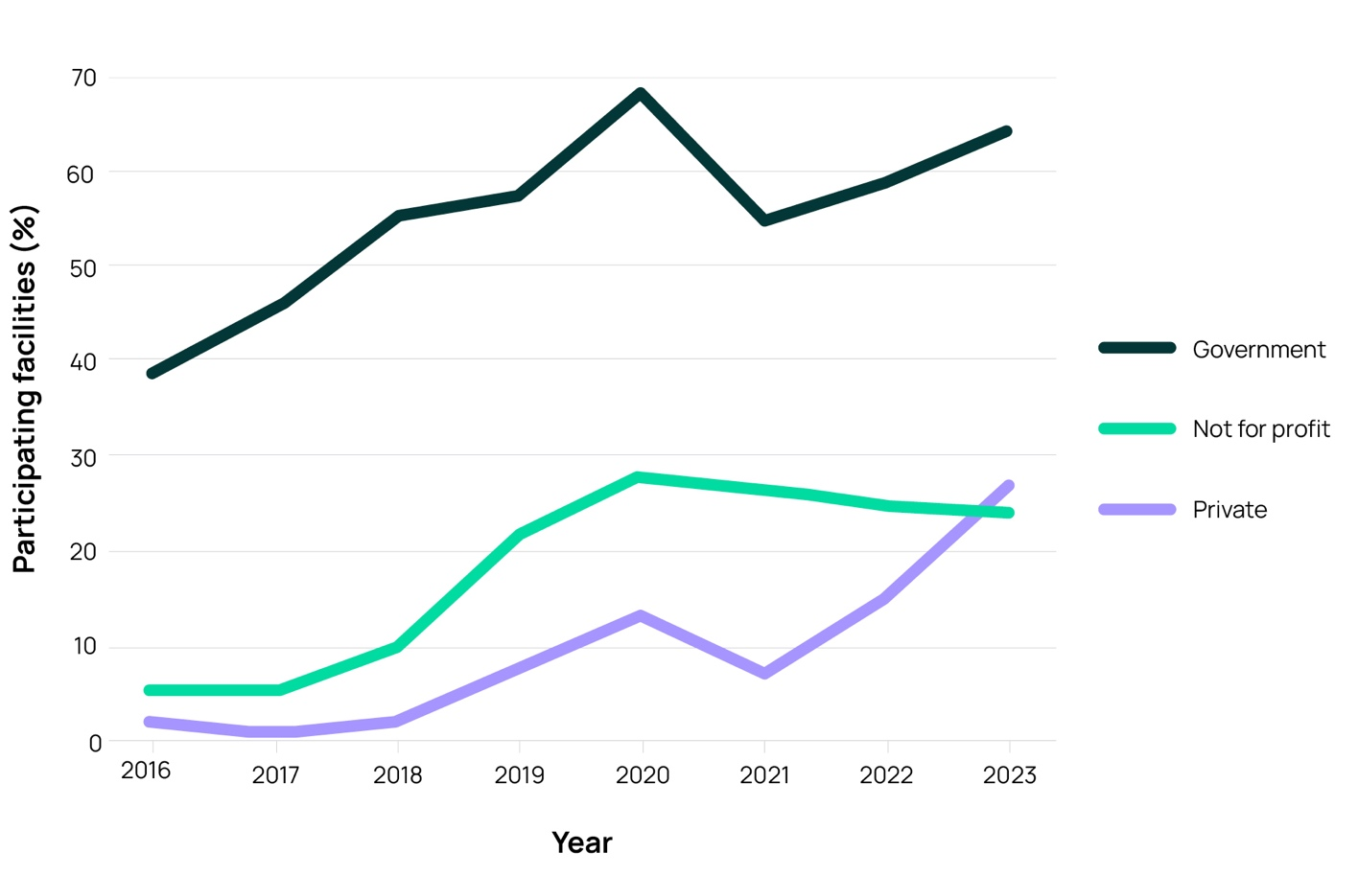
Note: Sources – Facility data collection form and Aged Care service list: 30 June 2016 to 2023; AIHW GEN Aged Care Data.⁶
In 2023, on the survey day over half (58.3%) of the residents were aged >85 years and about one-third (33.9%) were male (Table 2).
Table 2. Number and characteristics of all residents on the survey day, Aged Care National Antimicrobial Prescribing Survey contributors, 2023
Measurement |  | 2023
Measurement | n | %
Present on survey day | 53,843 | -
Aged >85 years | 31,410 | 58.3
Male | 18,272 | 33.9
Admitted to hospital in previous 7 days | 1,062 | 2.0
Indwelling urinary catheter present | 2,015 | 3.7

Prevalence of infections and antimicrobial use
On the survey day in 2023, the prevalence of residents who had signs and/or symptoms of at least one suspected infection was 3.6% (n=1,941). The prevalence of residents prescribed at least one antimicrobial (active medication order) was 11.9% (n=6,429). If all topical antimicrobial orders were excluded, the prevalence of residents prescribed at least one antimicrobial on the survey day was 7.0%. If all pro re nata (PRN) orders not administered in the previous 7 days were excluded, the prevalence of residents prescribed at least one antimicrobial on the survey day was 9.6% (Appendix Table A2).
The same prevalence measurements for those RACHs that have participated each year since 2021 are presented in Figure 2 and Appendix Table A3.
Figure 2. Prevalence of suspected infections and antimicrobial use on the survey day, Aged Care National Antimicrobial Prescribing Survey contributors that have participated each year from 2021 to 2023 (n=424)
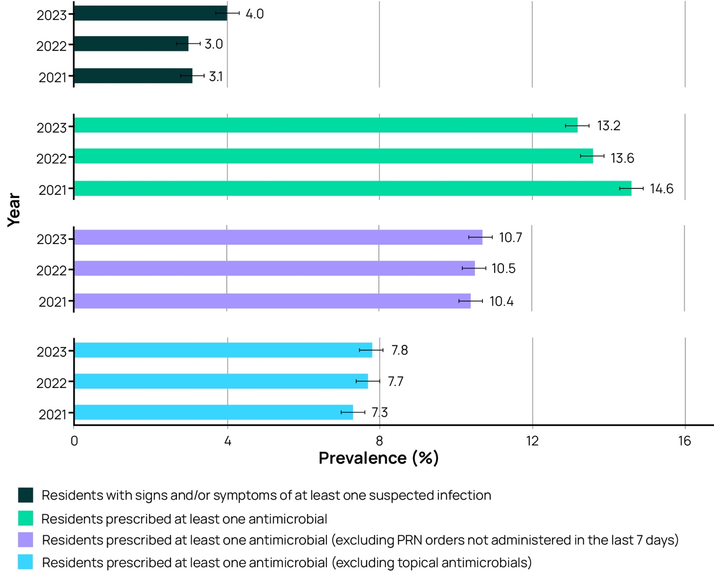
Notes:
Sources - Facility data collection form and Antimicrobial and infection data collection form. Refer to Appendix Table A3 for confidence intervals.
PRN = pro re nata.

Suspected infections on the survey day
Older persons are especially vulnerable to infections and may not have typical signs and symptoms of infection. In 2023, a total of 1,941 residents were reported to have a total of 2,037 suspected infections on the survey day. Suspected skin or soft tissue (47.6%), urinary tract (19.0%) and respiratory tract (17.1%) infections were most commonly reported (Table 3). Only 36.1% met the McGeer et al. infection surveillance definitions7 specifically for use in RACHs; these definitions have been designed to increase the likelihood that events captured are confirmed infections.
Table 3. Number and percentage of suspected infections by body system, Aged Care National Antimicrobial Prescribing Survey contributors, 2023
Body system | Suspected infections |  | RACH associated suspected infections*
Body system | n | % | n | %
Skin or soft tissue | 970 | 47.6 | 934 | 47.4
Respiratory tract | 348 | 17.1 | 339 | 17.2
Urinary tract | 387 | 19.0 | 373 | 18.9
Eye | 114 | 5.6 | 111 | 5.6
Oral | 63 | 3.1 | 62 | 3.1
Other systems | 155 | 7.6 | 151 | 7.7
Total | 2,037 | 100 | 1,970 | 100
* ‘RACH-associated suspected infection’ is an infection that developed in the resident 48 hours post (re-) admission.
Note: Source – Antimicrobial and infection data collection form, Section 5, Method 1 data.
RACH = residential aged care home.

Most commonly prescribed antimicrobials
Most antimicrobials were prescribed for oral (58.5%) or topical (40.6%) administration. Just over one- fifth (22.7%) of prescriptions were for prophylactic use. Similar to previous surveys, clotrimazole (21.6%) and cefalexin (21.1%) were the most frequently prescribed antimicrobials (Figure 3, Appendix Table A4).
Figure 3. Most commonly prescribed antimicrobials, Aged Care National Antimicrobial Prescribing Survey contributors, 2021–2023
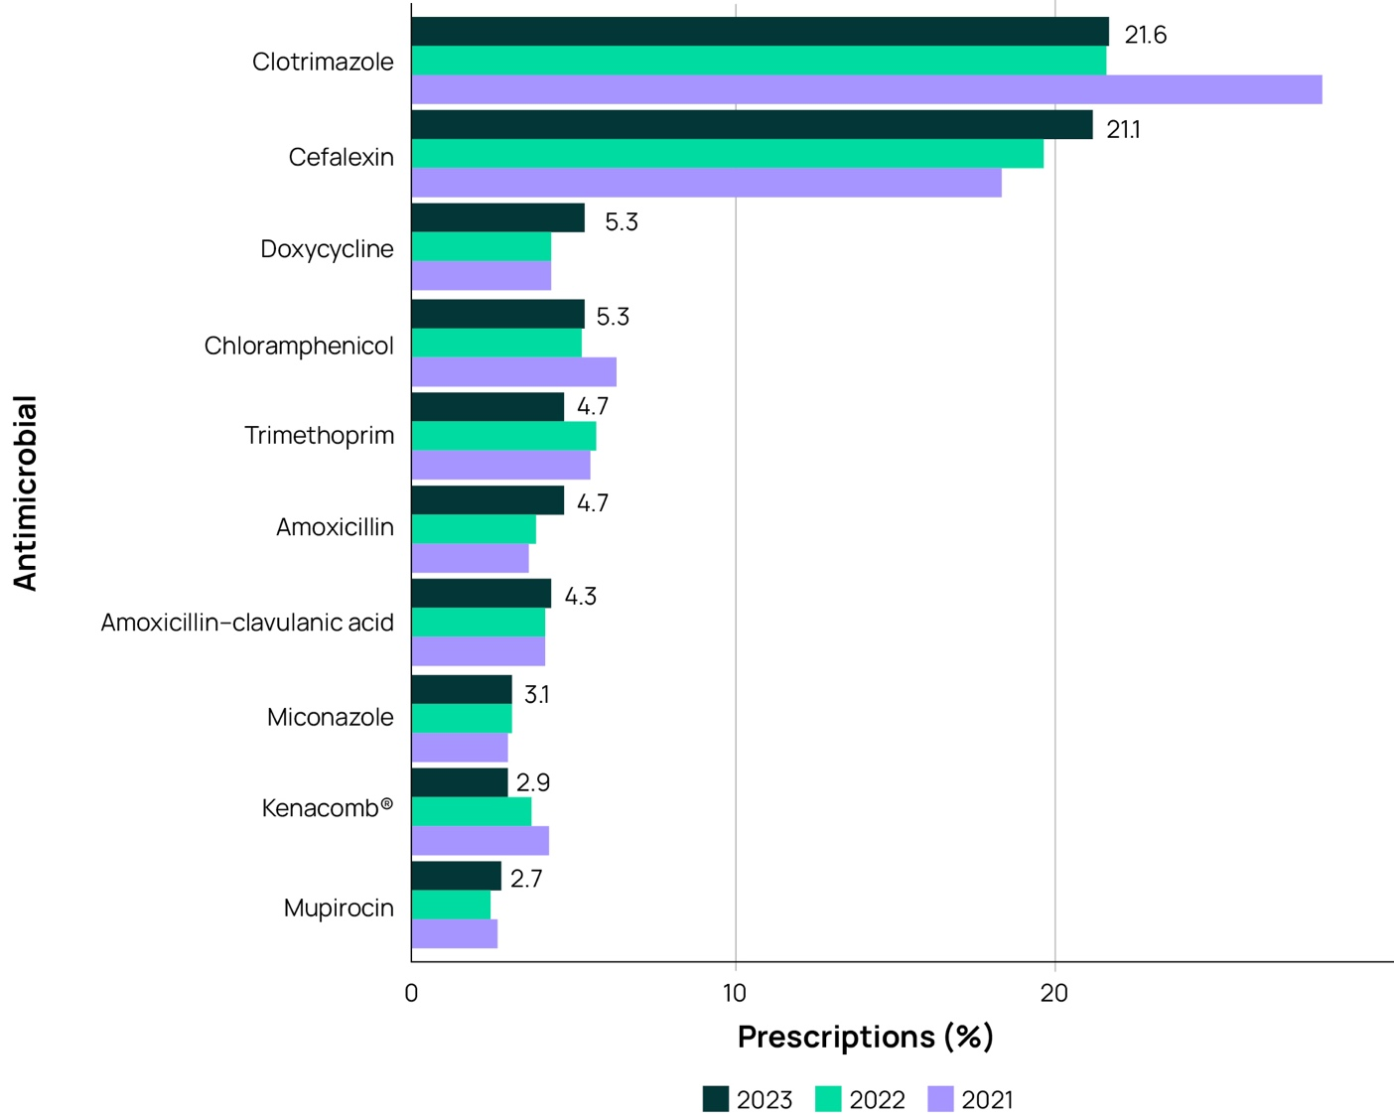
*Kenacomb® contains triamcinolone, neomycin, nystatin and gramicidin. Notes:
Source – Antimicrobial and infection data collection form, Section 2, Methods 1 and 2 data.
Only the top 10 antimicrobials prescribed are listed (methenamine hippurate, an antibacterial, is excluded).
Clotrimazole (93.0%) and cefalexin (58.7%) were mostly prescribed for therapeutic indications (Table 4).
Table 4. Clotrimazole and cefalexin prescriptions, therapeutic and prophylactic use, Aged Care National Antimicrobial Prescribing Survey contributors, 2023
Antimicrobial | Category | n | % | % of total prescriptions (n=8,999)
Clotrimazole (n=1,944) | Therapeutic | 1,808 | 93.0 | 20.1
Clotrimazole (n=1,944) | Prophylactic | 136 | 7.0 | 1.5
Cefalexin (n=1,898) | Therapeutic | 1,115 | 58.7 | 12.4
Cefalexin (n=1,898) | Prophylactic | 783 | 41.3 | 8.7
Note: Source – Antimicrobial and infection data collection form, Methods 1 and 2 data.

Common indications for prescribing antimicrobials
The most commonly reported indication for antimicrobial prescriptions (therapeutic and prophylactic) was ‘Other – Skin, soft tissue or mucosal’ (17.8%) (Figure 4, Appendix Table A5). Refer to Appendix Table A6 for comparison of therapeutic and prophylactic antimicrobial prescriptions. The most commonly reported indication for prophylactic antimicrobial prescriptions was ‘cystitis’ (25.0%) (Figure 5, Appendix Table A7).
Figure 4. Most common indications for all antimicrobial prescriptions, Aged Care National Antimicrobial Prescribing Survey contributors, 2021–2023
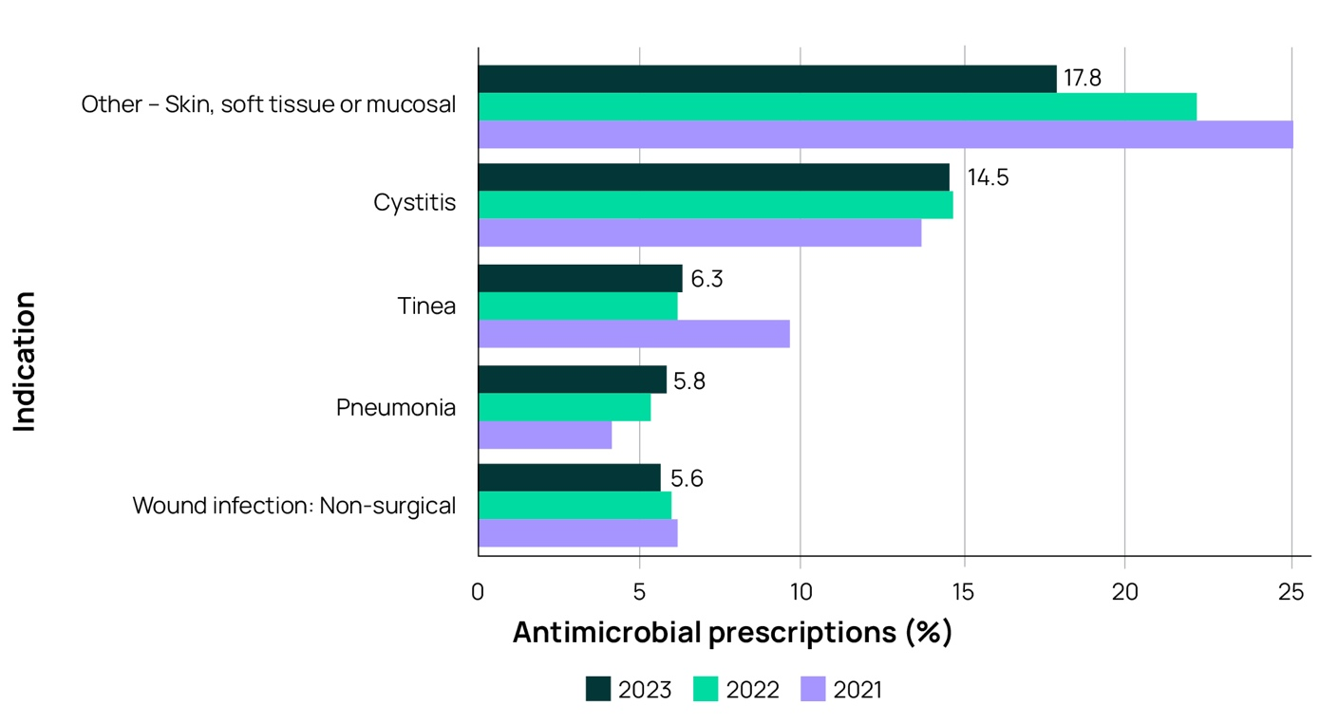
Notes:
Source - Antimicrobial and infection data collection form, Section 2, Methods 1 and 2 data. See Appendix Table A5 for tabular presentation of data.
Only the top 5 indications for antimicrobial prescriptions are listed.
Figure 5. Most common indications for prophylactic antimicrobial prescriptions, Aged Care National Antimicrobial Prescribing Survey contributors, 2021–2023
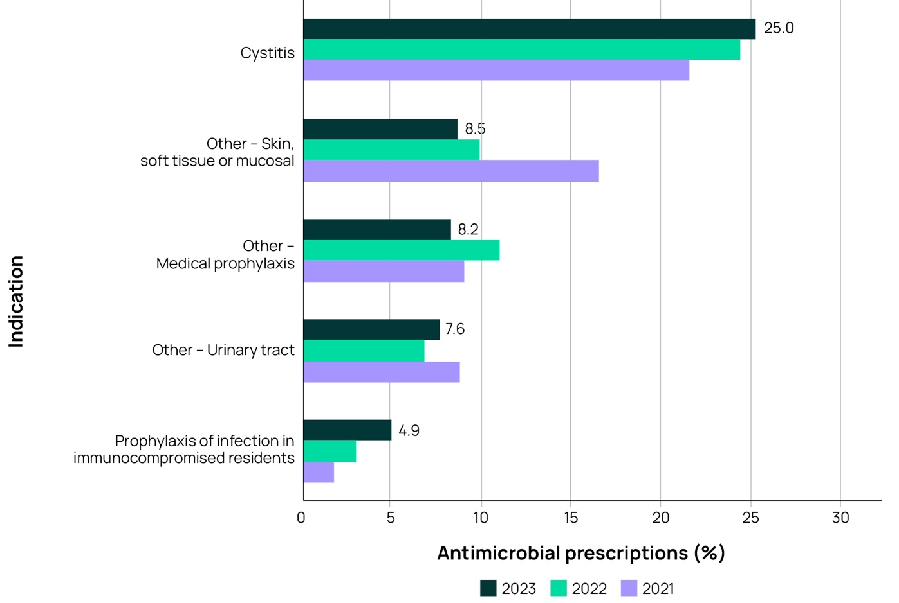
Notes:
Source - Antimicrobial and infection data collection form, Section 2, Methods 1 and 2 data.
See Appendix Table A7 for tabular presentation of data.
Only the top 5 indications for prophylactic antimicrobial prescriptions are listed.

Most commonly prescribed antimicrobials for common indications
The most commonly prescribed antimicrobials for cystitis, tinea and pneumonia (the top 3 specific indications) were cefalexin (54.0%), clotrimazole (71.4%) and amoxicillin (25.5%) respectively (Table 5).
Table 5. Commonly prescribed antimicrobials for cystitis, tinea and pneumonia, Aged Care National Antimicrobial Prescribing Survey contributors, 2023
Cystitis (n=1,301) |  |  | Tinea (n=567) |  |  | Pneumonia (n=526)
Antimicrobial | n | % | Antimicrobial | n | % | Antimicrobial | n | %
Cefalexin | 703 | 54.0 | Clotrimazole | 405 | 71.4 | Amoxicillin | 134 | 25.5
Trimethoprim | 297 | 22.8 | Miconazole | 74 | 13.1 | Amoxicillin– clavulanic acid | 123 | 23.4
Nitrofurantoin | 124 | 9.5 | Terbinafine | 34 | 6.0 | Doxycycline | 114 | 21.7
Amoxicillin– clavulanic acid | 47 | 3.6 | Kenacomb®* | 20 | 3.5 | Cefalexin | 58 | 11.0
Amoxicillin | 34 | 2.6 | Ketoconazole | 12 | 2.1 | Roxithromycin | 23 | 4.4
*Kenacomb® contains triamcinolone, neomycin, nystatin and gramicidin.
Note: Source – Antimicrobial and infection data collection form, Section 2, Methods 1 and 2 data.

Quality indicators
Complete and accurate documentation ensures that all those involved in resident care have access to consistent and current information. For example, when a resident is prescribed an antimicrobial, the indication, active ingredient, dose, frequency and route of administration, and the intended duration or review plan should be documented in their healthcare record.8 Where electronic healthcare records are being used, flags and reminders in the record management system can be incorporated to support documentation in all relevant fields.
For RACHs that have participated every year since 2021, there was an increase in the percentage of antimicrobial prescriptions that had a documented indication for prescribing an antimicrobial (82.0%) and documented review or stop date (59.9%) in 2023 (Figure 6, Appendix tables A8 and A9).
Figure 6. Key quality indicators, Aged Care National Antimicrobial Prescribing Survey contributors that have participated each year from 2021 to 2023 (n=424)
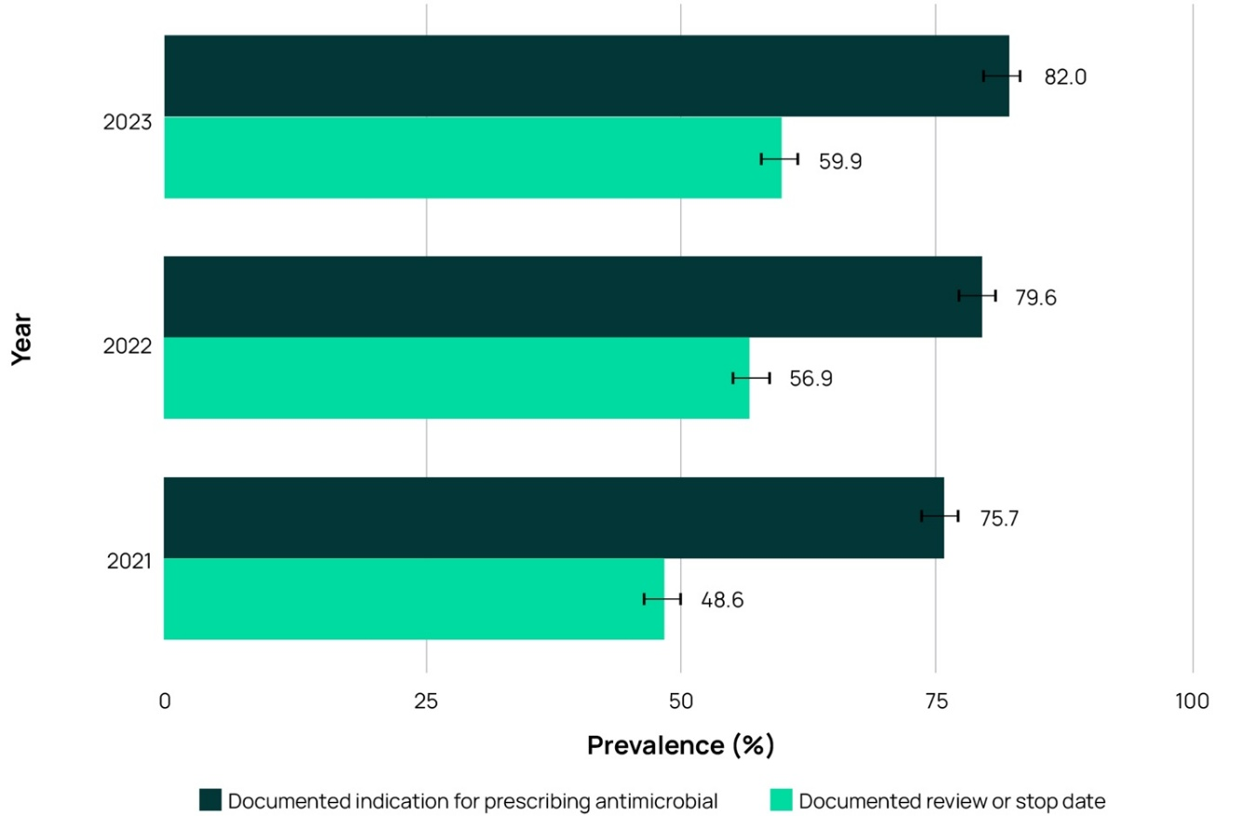
Notes:
Source – Antimicrobial and infection data collection form, Section 2, Methods 1 and 2 data. Refer to Appendix Table A9 for confidence intervals.

Duration
In general, the shortest possible duration of therapy, consistent with the condition being treated and the resident’s clinical response, should be used. Prolonged duration of antimicrobial therapy is associated with an increased risk of adverse outcomes, including antimicrobial resistance.⁹
In 2023, for antimicrobials still prescribed on the survey day, the start date was unknown for 2.4% of prescriptions and 34.7% were commenced greater than 6 months prior. For antimicrobials still prescribed on the survey day, with a known start date and prescribed less than 6 months prior to the survey day, 31.7% had been commenced greater than 7 days prior to the survey day.

Microbiology
For antimicrobials still prescribed on the survey day, with a known start date and prescribed less than 6 months prior to the survey day, a microbiology specimen was collected for less than one-quarter (20.1%) of prescriptions (n=1,807 prescriptions). For one prescription, more than one specimen type could be taken. The types of specimens collected are presented in Table 6.
Table 6. Microbiology specimen collection, Aged Care National Antimicrobial Prescribing Survey contributors, 2023
Specimen type | n | %
Urine | 938 | 51.9
Skin/wound swab | 366 | 20.3
Respiratory swab | 334 | 18.5
Sputum | 45 | 2.5
Other | 124 | 6.9
Total | 1,807 | 100
Note: Source - Antimicrobial and infection data collection form, Section 2, Methods 1 and 2 data.

Conclusion
Now in its eighth year, the Aged Care NAPS continues to play a pivotal role in Australian RACHs as part of their IPC and AMS programs. This year’s key results again demonstrate that there are significant opportunities for improvement. Updated priorities for those working at a local or national level at least include:
- advocating that all Australian RACHs participate in Aged Care NAPS
- continuing training and helpdesk support to participating RACH staff to ensure accurate Aged Care NAPS data collection and submission
- sharing Aged Care NAPS results with administrators and clinicians such as general practitioners, pharmacists, nurses and aged care IPC leads and using these results to develop targeted IPC and AMS improvement strategies
- enhancing the level of IPC training among RACH staff, focusing on evidence-based strategies that prevent and control common infections such as skin or soft tissue, urinary tract and respiratory tract infections
- tailoring RACH AMS programs to improve antimicrobial use. This could include, for example, ensuring the documentation of key prescribing elements (indication and review or stop included), rationalising antimicrobial prescriptions for prophylactic use and promoting appropriate microbiological sampling.

Appendix
Table A1. Participation of eligible residential aged care homes within state and territory and provider groups, Aged Care National Antimicrobial Prescribing Survey contributors, 2016-2022
Category |  | 2016 |  |  | 2017 |  |  | 2018
 |  | No of PF | No of facilities in RG | % of PF  in the RG | No of PF | No of facilities in RG | % of PF in the RG | No of PF | No of facilities in RG | % of PF in the RG
State and territory | ACT | 0 | 26 | 0.0 | 0 | 26 | 0.0 | 4 | 26 | 15.4
State and territory | NSW | 31 | 928 | 3.3 | 37 | 937 | 3.9 | 63 | 940 | 6.7
State and territory | NT | 0 | 11 | 0.0 | 0 | 11 | 0.0 | 2 | 11 | 18.2
State and territory | Qld | 26 | 469 | 5.5 | 19 | 473 | 4.0 | 49 | 478 | 10.3
State and territory | SA | 7 | 275 | 2.5 | 8 | 268 | 3.0 | 36 | 268 | 13.4
State and territory | Tas | 10 | 73 | 13.7 | 5 | 73 | 6.8 | 6 | 72 | 8.3
State and territory | Vic | 168 | 761 | 22.1 | 185 | 766 | 24.2 | 200 | 770 | 26.0
State and territory | WA | 14 | 276 | 5.1 | 22 | 271 | 8.1 | 36 | 278 | 12.9
Provider type | Government | 163 | 422 | 38.6 | 192 | 418 | 45.9 | 229 | 415 | 55.2
Provider type | Not for profit | 78 | 1,535 | 5.1 | 75 | 1,529 | 4.9 | 148 | 1,524 | 9.7
Provider type | Private | 15 | 862 | 1.7 | 9 | 878 | 1.0 | 19 | 904 | 2.1
Total |  | 256 | 2,819 | 9.1 | 276 | 2,825 | 9.8 | 396 | 2,843 | 13.9

Category |  | 2019 |  |  | 2020 |  |  | 2021 |  |  | 2022
 |  | No of PF | No of facilities in RG | % of PF in the RG | No of PF | No of facilities in RG | % of PF in the RG | No of PF | No of facilities in RG | % of PF in the RG | No of PF | No of facilities in RG | % of PF in the RG
State and territory | ACT | 6 | 25 | 24.0 | 6 | 25 | 24.0 | 8 | 26 | 30.8 | 9 | 27 | 33.3
State and territory | NSW | 136 | 937 | 14.5 | 171 | 940 | 18.2 | 136 | 928 | 14.7 | 157 | 912 | 17.2
State and territory | NT | 1 | 11 | 9.1 | 1 | 11 | 9.1 | 0 | 11 | 0.0 | 0 | 11 | 0.0
State and territory | Qld | 82 | 492 | 16.7 | 97 | 499 | 19.4 | 96 | 504 | 19.0 | 94 | 498 | 18.9
State and territory | SA | 66 | 271 | 24.4 | 89 | 267 | 33.3 | 88 | 263 | 33.5 | 64 | 259 | 24.7
State and territory | Tas | 28 | 71 | 39.4 | 31 | 71 | 43.7 | 25 | 69 | 36.2 | 14 | 69 | 20.3
State and territory | Vic | 227 | 778 | 29.2 | 295 | 776 | 38.0 | 239 | 767 | 31.2 | 271 | 764 | 35.5
State and territory | WA | 90 | 283 | 31.8 | 134 | 284 | 47.2 | 95 | 287 | 33.1 | 135 | 283 | 47.7
Provider type | Government | 238 | 413 | 57.6 | 279 | 410 | 68.0 | 224 | 408 | 54.9 | 236 | 401 | 58.9
Provider type | Not for profit | 330 | 1,535 | 21.5 | 422 | 1,530 | 27.6 | 400 | 1,516 | 26.4 | 366 | 1,493 | 24.5
Provider type | Private | 68 | 920 | 7.4 | 123 | 933 | 13.2 | 63 | 931 | 6.8 | 142 | 929 | 15.3
Total |  | 636 | 2,868 | 22.2 | 824 | 2,873 | 28.7 | 687 | 2,855 | 24.1 | 744 | 2,823 | 26.4
Notes:
Sources - Facility data collection form and Aged Care service list: 30 June 2016 to 2023; AIHW GEN Aged Care Data.6 See Table 1 for 2023 data.
ACT = Australian Capital Territory; NSW = New South Wales; NT = Northern Territory; PF = participating facilities; Qld = Queensland; RG = reporting group; SA = South Australia; Tas = Tasmania; Vic = Victoria; WA = Western Australia.

Table A2. Prevalence of suspected infections and antimicrobial use on the survey day, Aged Care National Antimicrobial Prescribing Survey contributors, 2016-2023
On survey day | 2016 |  | 2017 |  | 2018 |  | 2019 |  | 2020 |  | 2021 |  | 2022 |  | 2023
On survey day | n | % | n | % | n | % | n | % | n | % | n | % | n | % | n | %
Residents with signs and/or symptoms of at least one suspected infection | 384 | 3.2 | 343 | 2.9 | 561 | 2.9 | 983 | 2.8 | 1,377 | 2.9 | 1,241 | 3.1 | 1,311 | 3.0 | 1,941 | 3.6
Residents with signs and/or symptoms of at least one RACH-associated suspected infection | n/a | - | n/a | - | n/a | - | n/a | - | n/a | - | 1,215 | 3.0 | 1,294 | 3.0 | 1,879 | 3.5
Residents prescribed at least one antimicrobial | 1,211 | 10.0 | 1,060 | 9.1 | 1,909 | 9.9 | 3,491 | 9.9 | 5,610 | 11.9 | 5,543 | 13.8 | 5,456 | 12.5 | 6,429 | 11.9
Residents prescribed at least one antimicrobial (excluding PRN orders not administered in the last 7 days) | 1,211 | 10.0 | 1,058 | 9.0 | 1,621 | 8.4 | 2,920 | 8.3 | 4,133 | 8.8 | 3,911 | 9.8 | 4,227 | 9.7 | 5,173 | 9.6
Residents prescribed at least one antimicrobial (excluding topical antimicrobials) | 867 | 7.2 | 730 | 6.2 | 1,261 | 6.5 | 2,197 | 6.2 | 3,052 | 6.5 | 2,724 | 6.8 | 3,025 | 6.9 | 3,744 | 7.0
Number of residents present | 12,055 | - | 11,696 | - | 19,312 | - | 35,190 | - | 46,995 | - | 40,075 | - | 43,655 | - | 53,843 | -
Note: Sources – Facility data collection form and Antimicrobial and infection data collection form. See National Antimicrobial Prescribing Survey 2023: technical supplement for definition of ‘RACH-associated suspected infection’. n/a = not available – new data field introduced in 2021; PRN = pro re nata; RACH = residential aged care home.

Table A3. Prevalence of suspected infections and antimicrobial use, Aged Care National Antimicrobial Prescribing Survey contributors that have participated each year from 2021 to 2023 (n=424)
On survey day | 2021 |  |  | 2022 |  |  | 2023
On survey day | n | % | 95% CI | n | % | 95% CI | n | % | 95% CI
Residents with signs and/or symptoms  of at least one suspected infection | 734 | 3.1 | 2.9 – 3.3 | 714 | 3.0 | 2.8-3.2 | 952 | 4.0 | 3.7-4.2
Residents prescribed at least one antimicrobial | 3,468 | 14.6 | 14.1-15.0 | 3,202 | 13.6 | 13.1-14.0 | 3,178 | 13.2 | 12.8-13.7
Residents prescribed at least one antimicrobial (excluding PRN orders not administered in the last 7 days) | 2,478 | 10.4 | 10.0-10.8 | 2,486 | 10.5 | 10.1-10.9 | 2,573 | 10.7 | 10.3-11.1
Residents prescribed at least one antimicrobial (excluding topical antimicrobials) | 1,726 | 7.3 | 6.9-7.6 | 1,819 | 7.7 | 7.4-8.0 | 1,867 | 7.8 | 7.4-8.1
Number of residents present | 23,797 | - | - | 23,627 | - | - | 24,022 | - | -
Notes:
Sources – Facility data collection form and Antimicrobial and infection data collection form.
See Figure 2 for graphical presentation.
CI = confidence interval; PRN = pro re nata.

Table A4. Most commonly prescribed antimicrobials, Aged Care National Antimicrobial Prescribing Survey contributors, 2021-2023
Antimicrobial | 2021 (n=7,622) |  | 2022 (n=8,401) |  | 2023 (n=8,999)
 | n | % | n | % | n | %
Clotrimazole | 2,159 | 28.3 | 1,818 | 21.6 | 1,944 | 21.6
Cefalexin | 1,396 | 18.3 | 1,650 | 19.6 | 1,898 | 21.1
Doxycycline | 329 | 4.3 | 364 | 4.3 | 479 | 5.3
Chloramphenicol | 478 | 6.3 | 437 | 5.2 | 476 | 5.3
Trimethoprim | 419 | 5.5 | 476 | 5.7 | 424 | 4.7
Amoxicillin | 278 | 3.6 | 319 | 3.8 | 423 | 4.7
Amoxicillin–clavulanic acid | 310 | 4.1 | 346 | 4.1 | 389 | 4.3
Miconazole | 220 | 2.9 | 257 | 3.1 | 276 | 3.1
*Kenacomb® | 321 | 4.2 | 312 | 3.7 | 265 | 2.9
Mupirocin | 200 | 2.6 | 204 | 2.4 | 244 | 2.7
*Kenacomb® contains triamcinolone, neomycin, nystatin and gramicidin. Notes:
Source – Antimicrobial and infection form, Methods 1 and 2 data. See Figure 3 for graphical presentation.
Only the top 10 antimicrobials prescribed are listed (methenamine ^{i}ppurate, an antibacterial, is excluded).

Table A5. Most common indications for all antimicrobial prescriptions (therapeutic and prophylactic), Aged Care National Antimicrobial Prescribing Survey contributors, 2021-2023
Indication | 2021 (n=7,622) |  | 2022 (n=8,401) |  | 2023 (n=8,999)
Indication | n | % | n | % | n | %
Other – Skin, soft tissue or mucosal | 1,914 | 25.1 | 1,853 | 22.1 | 1,605 | 17.8
Cystitis | 1,039 | 13.6 | 1,229 | 14.6 | 1,301 | 14.5
Tinea | 735 | 9.6 | 516 | 6.1 | 567 | 6.3
Pneumonia | 312 | 4.1 | 443 | 5.3 | 526 | 5.8
Wound infection: Non-surgical | 476 | 6.2 | 507 | 6.0 | 505 | 5.6
Notes:
Source – Antimicrobial and infection data collection form, Methods 1 and 2 data.
See Figure 4 for graphical presentation.
Only the top 5 indications for antimicrobial prescriptions are listed.

Table A6. Comparison of therapeutic and prophylactic antimicrobial prescriptions for common indications, Aged Care National Antimicrobial Prescribing Survey contributors, 2023
Indication | Therapeutic |  | Prophylactic |  | Total
Indication | n | % | n | %
Other – Skin, soft tissue or mucosal | 1,432 | 89.2 | 173 | 10.8 | 1,605
Cystitis | 791 | 60.8 | 510 | 39.2 | 1,301
Tinea | 539 | 95.1 | 28 | 4.9 | 567
Pneumonia | 485 | 92.2 | 41 | 7.8 | 526
Wound infection: Non-surgical | 464 | 91.9 | 41 | 8.1 | 505
Cellulitis | 340 | 95.5 | 16 | 4.5 | 356
Conjunctivitis | 298 | 93.1 | 22 | 6.9 | 320
Other – Respiratory tract | 292 | 91.2 | 28 | 8.8 | 320
Cutaneous candidiasis | 299 | 96.5 | 11 | 3.5 | 310
Other – Urinary tract | 84 | 35.1 | 155 | 64.9 | 239
Notes:
Source – Antimicrobial and Infection data collection form, Section 2, Methods 1 and 2 data. Only the top 10 indications for antimicrobial prescription are listed.
Unknown and medical prophylaxis indications for commencing an antimicrobial are excluded.

Table A7. Most common indications for prophylactic antimicrobial prescriptions, Aged Care National Antimicrobial Prescribing Survey contributors, 2021-2023
Indication | 2021 (n=1,699) |  | 2022 (n=1,585) |  | 2023 (n=2,039)
Indication | n | % | n | % | n | %
Cystitis | 364 | 21.4 | 383 | 24.2 | 510 | 25.0
Other – Skin, soft tissue or mucosal | 277 | 16.3 | 156 | 9.8 | 173 | 8.5
Other – Medical prophylaxis | 151 | 8.9 | 173 | 10.9 | 168 | 8.2
Other – Urinary tract | 148 | 8.7 | 106 | 6.7 | 155 | 7.6
Prophylaxis of infection in immunocompromised residents | 31 | 1.8 | 48 | 3.0 | 100 | 4.9
Notes:
Source – Antimicrobial and infection form, Section 2, Methods 1 and 2 data.
See Figure 5 for graphical presentation.
Only the top 5 indications for prophylactic antimicrobial prescriptions are listed.

Table A8. Key quality indicators, Aged Care National Antimicrobial Prescribing Survey contributors, 2016-2023
Indicator | 2016 |  | 2017 |  | 2018 |  | 2019
Indicator | n | % | n | % | n | % | n | %
Indication for prescribing an antimicrobial
Documented | 1,377 | 78.7 | 1,191 | 79.3 | 1,906 | 77.0 | 3,376 | 73.2
Not documented | 372 | 21.3 | 311 | 20.7 | 568 | 23.0 | 1,237 | 26.8
Review or stop date
Documented | 895 | 51.2 | 785 | 52.3 | 1,165 | 47.1 | 2,508 | 54.4
Not documented | 854 | 48.8 | 717 | 47.7 | 1,309 | 52.9 | 2,105 | 45.6
Total | 1,749 | - | 1,502 | - | 2,474 | - | 4,613 | -

Indicator | 2020 |  | 2021 |  | 2022 |  | 2023
Indicator | n | % | n | % | n | % | n | %
Indication for prescribing an antimicrobial
Documented | 5,799 | 76.5 | 5,610 | 73.6 | 6,747 | 80.3 | 7,472 | 83.0
Not documented | 1,784 | 23.5 | 2,012 | 26.4 | 1,654 | 19.7 | 1,527 | 17.0
Review or stop date
Documented | 3,468 | 45.7 | 3,407 | 44.7 | 4,769 | 56.8 | 5,097 | 56.6
Not documented | 4,115 | 54.3 | 4,215 | 55.3 | 3,632 | 43.2 | 3,902 | 43.4
Total | 7,583 | - | 7,622 | - | 8,401 | - | 8,999 | -
Note: Source – Antimicrobial and infection data collection form, Section 2, Methods 1 and 2 data.
Table A9. Key quality indicators, Aged Care National Antimicrobial Prescribing Survey contributors that have participated each year from 2021 to 2023 (n=424)
Indicator |  | 2021 |  |  | 2022 |  |  | 2023
Indicator | n | % | 95% CI | n | % | 95% CI | n | % | 95% CI
Indication for prescribing an antimicrobial
Documented | 3,767 | 75.7 | 74.5 - 76.9 | 3,749 | 79.6 | 78.4-80.7 | 4,004 | 82.0 | 80.9 - 83.1
Not documented | 1,210 | 24.3 | 23.1 - 25.5 | 961 | 20.4 | 19.3-21.6 | 879 | 18.0 | 16.9 - 19.1
Review or stop date
Documented | 2,419 | 48.6 | 47.2 - 50.0 | 2,680 | 56.9 | 55.5 - 58.3 | 2,925 | 59.9 | 58.5 - 61.3
Not documented | 2,558 | 51.4 | 50.0 - 52.8 | 2,030 | 43.1 | 41.7 - 44.5 | 1,958 | 40.1 | 38.7 - 41.5
Total | 4,977 | - | - | 4,710 | - | - | 4,883 | - | -
Notes:
Source – Antimicrobial and infection data collection form, Section 2, Methods 1 and 2 data. See Figure 6 for graphical presentation.
CI = confidence interval.

References
31 Results of the 2023 Aged Care National Antimicrobial Prescribing Survey
- Royal Melbourne Hospital and the National Centre for Antimicrobial Stewardship. NCAS publications. [Webpage] Available from: www.ncas-australia.org/ncas-publications.
- Aged Care Quality and Safety Commission. Guidance and resources for providers to support the Aged Care Quality Standards. Sydney: ACQSC; 2023.
- Australian Government Department of Health and Aged Care, Australian Government Department of Agriculture, Fisheries and Forestry. Surveillance of antimicrobial use and resistance in human health. Canberra: Australian Government; 2023. Available from: https: /www.amr.gov.au/australias- response/objective-5-integrated-surveillance-and-response-resistance-and-usage/surveillance- antimicrobial-use-and-resistance-human-health
- Royal Melbourne Hospital and the National Centre for Antimicrobial Stewardship. National Antimicrobial Prescribing Survey 2023: technical supplement. Canberra: Department of Health, Disability and Ageing; 2025.
- Australian Bureau of Statistics. 1270.0.55.005 - Australian Statistical Geography Standard. Canberra (Australia); 2016. Available from https: /www.abs.gov.au/AUSSTATS/abs@.nsf/ Lookup/1270.0.55.005Main+Features1July%202016?OpenDocument.
- Australian Institute of Health and Welfare. GEN Aged Care Data. Canberra: Australian Government; 2023. Available from https: /www.gen-agedcaredata.gov.au/Topics.
- Stone ND, Ashraf MS, Calder J, et al. Surveillance definitions of infections in long-term care facilities: revisiting the McGeer criteria. Infect Control Hosp Epidemiol 2012; 33(10):965-77. [In eng] DOI: 10.1086/667743.
- Australian Commission on Safety and Quality in Health Care. Antimicrobial Stewardship Clinical Care Standard. Sydney: ACSQHC; 2020.
- Antibiotic Expert Group. Therapeutic guidelines: antibiotic. Version 16. Melbourne: Therapeutic Guidelines Ltd; 2019. Available from: https: /www.tg.org.au.

All information in this publication is correct as at January 2025 .
amr.gov.au

