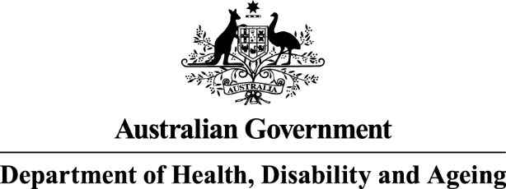

Antimicrobial prescribing practice in Australian hospitals




Results of the 2023 Hospital National Antimicrobial Prescribing Survey

Published by the Australian Government Department of Health, Disability and Ageing For issues regarding the content of the report:
Email: support@naps.org.au
Website: https://www.naps.org.au ISBN: 978-1-74186-104-4
© Australian Government Department of Health, Disability and Ageing
All material and work produced by the Department of Health, Disability and Ageing is protected by copyright.
The Department reserves the right to set out the terms and conditions for the use of such material.
Enquiries about the licence and any use of this publication are welcome and can be sent to AMR@health.gov.au
Preferred citation
Royal Melbourne Hospital and the National Centre for Antimicrobial Stewardship. Antimicrobial prescribing practice in Australian hospitals. Results of the 2023 Hospital National Antimicrobial Prescribing Survey. Canberra: Department of Health, Disability and Ageing; 2025.
Disclaimer
This document is not intended to provide guidance on particular healthcare choices. You should contact your healthcare provider for advice on particular healthcare choices.
This document includes the views or recommendations of its authors and third parties. Royal Melbourne Hospital, the National Centre for Antimicrobial Stewardship and the Australian Government Department of Health, Disability and Ageing do not accept any legal liability for any injury, loss or damage incurred by the use of, or reliance on, this document.

Table of Contents
Acknowledgements 4
Contributing facilities 4
Abbreviations 4
Summary 5
Results of key indicators 5
Implications for clinical practice 6
1. Introduction 7
2. Results 8
2.1 Participation 8
2.1 Key indicators 9
Documentation of review or stop date 10
Surgical prophylaxis greater than 24 hours 10
Compliance with guidelines 10
Appropriateness 11
Reasons for inappropriateness 11
2.2 Most commonly prescribed antimicrobials 12
2.4. Most common indications for antimicrobial prescribing and appropriateness 13
Compliance with guidelines 13
3. Conclusion 15
Appendix 16
References 20

Preface
This report is best interpreted when read in conjunction with the National Antimicrobial Prescribing Survey: technical supplement 2023.⁵

Acknowledgements

Contributing facilities
On behalf of the National Centre for Antimicrobial Stewardship and the Royal Melbourne Hospital Guidance Group, we would like to thank all contributing facilities and auditors for their time and effort in collecting and entering the data, in contributing data to this report, to the Antimicrobial Use and Resistance in Australia (AURA) surveillance program, and for their continued commitment to improving safety and quality across the Australian healthcare system.
National Centre for Antimicrobial Stewardship and the Royal Melbourne Hospital Guidance Group Professor Karin Thursky
Dr Rodney James
Dr Courtney Ierano
Ms Caroline Chen
Ms Josephine Wen
Associate Professor Noleen Bennett
Professor Lisa Hall
Mr Pramode Varghese
Mr Logesh Palani
Mr Abukari Yakubu
Mr Simon Burrell

Abbreviations
Abbreviation | Term
AIHW | Australian Institute of Health and Welfare
AMS | Antimicrobial stewardship
AURA | Antimicrobial Use and Resistance in Australia
EMM | Electronic medication management
GEM | Geriatric evaluation and management
NAPS | National Antimicrobial Prescribing Survey

Summary
The Hospital National Antimicrobial Prescribing Survey (Hospital NAPS) continues to support hospital antimicrobial stewardship (AMS) programs by providing a standardised tool to measure the key quality
metrics of antimicrobial prescribing. It is a key contributor to Australia’s National Antimicrobial Resistance Strategy1 and the Antimicrobial Use and Resistance in Australia (AURA) surveillance program.2
The Hospital NAPS program continues to be a widely adopted and valued tool to assess the quality of antimicrobial prescribing across Australian hospitals. Its focus on providing meaningful data for action with clear data visualisation for contributing hospitals has led to the continued high participation
from Australian hospitals, representing a wide variety of funding types, peer groups and remoteness classifications.
A total of 420 hospitals participated in the 2023 survey – a number which has remained consistent for
the last few years. Approximately three-quarters were public hospitals and one-quarter were private hospitals. This participation rate represented 43.5% of all eligible Australian hospitals.

Results of key indicators
- Documentation of indication was present for 86.5% of prescriptions. Hospitals with an electronic medication management (EMM) system had substantially higher rates of documentation (92.3%) compared with non-EMM hospitals (79.8%).
- Documentation of review and stop date was present for 56.0% of prescriptions. While documentation was better in EMM hospitals (59.1%) compared with non-EMM hospitals (52.4%), this is still well below the expected best-practice target of 95%.
- Of those audited prescriptions that were for surgical prophylaxis, 25.9% extended beyond 24 hours.
- There was a continued improvement in the rate of noncompliance with prescribing guidelines, with 24.0% of prescriptions deemed as noncompliant. Indications with the highest rates of guideline noncompliance were surgical prophylaxis, non-surgical wound infections, and cystitis.
- Approximately three-quarters of all prescriptions were deemed to be appropriate. As a national aggregate, this metric has had minimal changes over the years. Surgical prophylaxis remains an area with the poorest rates of appropriateness.

Implications for clinical practice
There have been encouraging signs of continued antimicrobial prescribing improvement, in line with
the growth and expansion of hospital AMS programs. Nonetheless, the Hospital NAPS highlights several opportunities for quality improvement in the following areas:
- Indication should be documented to ensure that all clinicians treating the patient clearly understand
the reasons for the antimicrobial. With increasing adoption of EMM systems in Australian hospitals,
this metric is likely to improve over time.
- Review or stop date should be documented, as past results have been well below best target recommendations. This is an important AMS measure to ensure the timely review of antimicrobials prescribed, maximise efficacy and reduce unnecessary treatment.
- Prescribing and guideline compliance should be improved, particularly in the following areas: surgical prophylaxis, management of non-surgical wound infections, and cystitis.
- Despite the existence of clear national guidelines, these data suggest there is still considerable work
to be done to support and educate prescribers in making informed and best-practice prescribing choices for indications requiring antimicrobial therapy.

Introduction
Australia’s National Antimicrobial Resistance Strategy – 2020 and beyond has recommended the adoption of antimicrobial stewardship (AMS) programs, with the aim of enhancing patient healthcare outcomes while reducing the emergence and spread of antimicrobial resistance.¹
For 11 years, the Hospital National Antimicrobial Prescribing Survey (Hospital NAPS) has continued to support hospital AMS programs, allowing the meaningful measurement, reporting and benchmarking of the quality of antimicrobial prescribing. Hospital NAPS program staff also continue to provide clinical program support and training for participants. Internationally, it remains the only tool to measure appropriateness of antimicrobial prescribing.
Furthermore, participation in the Hospital NAPS assists health service organisations to demonstrate
that they meet the AMS action requirements of the National Safety and Quality Health Service Standards and the Antimicrobial Stewardship Clinical Care Standard.^{3, 4}
The Australian Government Department of Health, Disability and Ageing provides funding for the Royal Melbourne Hospital Guidance Group and the National Centre for Antimicrobial Stewardship to conduct the Hospital NAPS and contribute data to the AURA surveillance program.²
For details on definitions, survey methodology, analyses methodology and considerations for data interpretation, please refer to the National Antimicrobial Prescribing Survey: technical supplement 2023.⁵

Results

2.1 Participation
The Hospital NAPS remains a voluntary program. Despite this, there has been consistent participation by hospitals across all Australian states and territories, with representation across all Remoteness Areas7,
funding types and peer groups6 since the program’s initiation.
This report analyses the data submitted by 420 hospitals (298 public and 122 private) that met the Hospital NAPS inclusion criteria. Participation has remained steady the last few years, with 414 hospitals (300 public and 114 private) in 2022 and 412 hospitals (296 public, 116 private) in 2021.
Overall, 43.5% of all eligible Australian hospitals participated in the survey, with slightly higher participation
from public hospitals (44.0%, 298 of 678) compared with private hospitals (42.4%, 122 of 288). All Australian states and territories were represented (Figure 1).
Figure 1. Representative participation of hospitals that contributed to the Hospital National Antimicrobial Prescribing Survey by state and territory, 2023*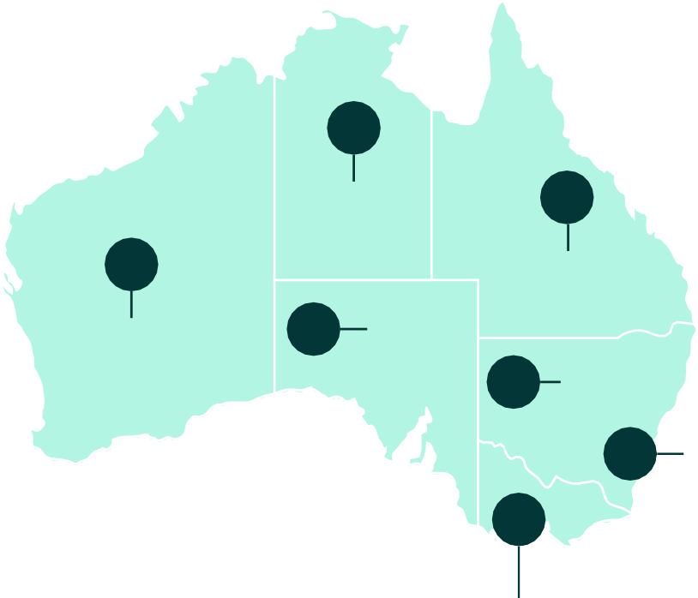
NT

100%
(6 of 6)
Qld
Total representative participation:
43.5%
(420 of 966 hospitals)

WA
30.9%
(56 of 181)
33.9%
(38 of 112)
SA
50.0%
(53 of 106)
NSW
46.1%
(141 of 306)
ACT
83.3%
(5 of 6)
Vic
51.8%
(114 of 220)
Tas
24.1%
(7 of 29)
* Total number of hospitals in each state and territory represent all eligible hospitals in the Australian Institute of Health and Welfare reporting groups for public and private, states and territories, and remoteness classifications.6, 7
ACT = Australian Capital Territory; NSW = New South Wales; NT = Northern Territory; Qld = Queensland; SA = South Australia; Tas = Tasmania;
Vic= Victoria; WA = Western Australia.

Data from 24,009 patients were submitted, generating 34,239 prescriptions for analysis. The majority of prescriptions were gathered from Victorian and New South Wales facilities which, together, represented 60.1% of all prescriptions submitted. The majority of auditing was performed in August, September and October, given the benchmark closing was brought forward to 31 October 2023 (previous years had a December close date). The benchmark closing date was brought forward to encourage dissemination of results during World Antimicrobial Resistance Awareness Week in November.

Key indicators
Results of the key indicators are summarised below (Table 1). The vast majority of antimicrobial prescriptions had an indication documented in the patient medical history. This measure has continued to improve, from 71.9% in 2015 to 86.5% in 2023.
Indication documentation was higher in public hospitals (89.7%) compared with private hospitals (73.2%) and amongst hospitals with an electronic medication management (EMM) system (92.3%) compared with those without an EMM system (79.8%). This is not surprising given that most EMM systems require indication as a mandatory field before the antimicrobial prescription can be confirmed.
Table 1. Hospital National Antimicrobial Prescribing Survey key indicators, for assessable prescriptions, 2023
Key indicator | Result
Indication documented  Best-practice target >95% | 86.5%
Review or stop date documented  Best-practice target >95% | 56.0%
Surgical prophylaxis >24 hours* | 25.9%
Compliance with guidelines^ | 70.2%
Appropriate# | 77.9%
Note: Refer to National Antimicrobial Prescribing Survey: technical supplement 2023 for definitions.5
* Where surgical prophylaxis was selected as the indication (n=4,122).
^ Prescriptions for which compliance was assessable (n=27,624). Excludes prescriptions for which guidelines were not available, as well as prescriptions that were ‘directed therapy’ or ‘not assessable’.
# Prescriptions for which appropriateness was assessable (n=32,686). Excludes prescriptions deemed to be ‘not assessable’.
For a full breakdown of Hospital NAPS key indicators by funding type, state and territory, peer group and remoteness classification, refer to the Appendix, tables 1A and 1B.

Documentation of review or stop date
Encouragingly, the documentation of antimicrobial review or stop date has continued to improve over the years since this measure was initially introduced (29.7%, 2015) to 56.0% in 2023. Private hospitals performed better than public hospitals (59.9% compared with 55.1%). Hospitals with EMM systems performed better than non-EMM hospitals (59.1% compared with 52.4%); however, these results are still well below the expected best-practice target of above 95%.

Surgical prophylaxis greater than 24 hours
The point prevalence nature of the Hospital NAPS methodology limits the meaningful interpretation of surgical prophylaxis results.5 This is because post-operative antimicrobial prophylaxis is not required in the majority of procedures and hence these patients do not meet the inclusion criteria for Hospital NAPS.
Nonetheless, of those audited prescriptions that were for surgical prophylaxis, 25.9% extended beyond 24 hours. This remains a major concern, as post-procedural prophylaxis is rarely required and should be less than 24 hours when prescribed.8
The Surgical National Antimicrobial Prescribing Survey (Surgical NAPS) has a more accurate methodology for capturing surgical antimicrobial prophylaxis data. Further in-depth analyses of the types and durations of post-operative surgical prophylaxis procedures can be found in the 2023 Surgical NAPS report.9

Compliance with guidelines
The rate of noncompliance with prescribing guidelines for the last few years has continued to decline (Figure 2) - slightly better in public hospitals compared with private hospitals (22.9% compared with 28.9%). Overall, nearly a quarter of prescriptions were noncompliant with guidelines despite existence of national guidelines, highlighting the need for further interventions to promote guideline concordance (Appendix, Table 1B).
Figure 2. Noncompliance with guidelines for all prescriptions in the Hospital National Antimicrobial Prescribing Survey, 2015-2023*
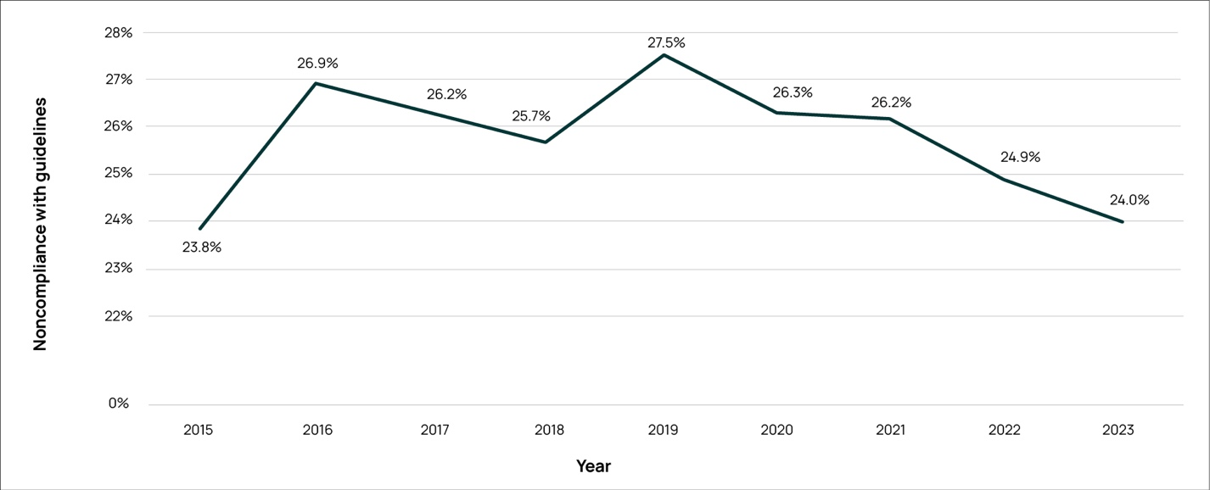
* There may be small differences in results compared with the previously published National Antimicrobial Prescribing Survey reports.
This is because participants are free to amend their data at any time and the historical data are reanalysed each year.
Please note axis is broken.

Appropriateness
Definitions of appropriateness are summarised in the National Antimicrobial Prescribing Survey: technical supplement 2023.5 The percentage of prescriptions deemed to be appropriate in 2023 was 74.4%, for
all prescriptions. Despite minor fluctuations, this metric has remained largely unchanged over many
years (Figure 3). Appropriateness was generally higher amongst public hospitals compared with private hospitals (75.8% compared with 68.6%).
Figure 3. Appropriateness for all prescriptions in the Hospital National Antimicrobial Prescribing Survey, 2015-2023*
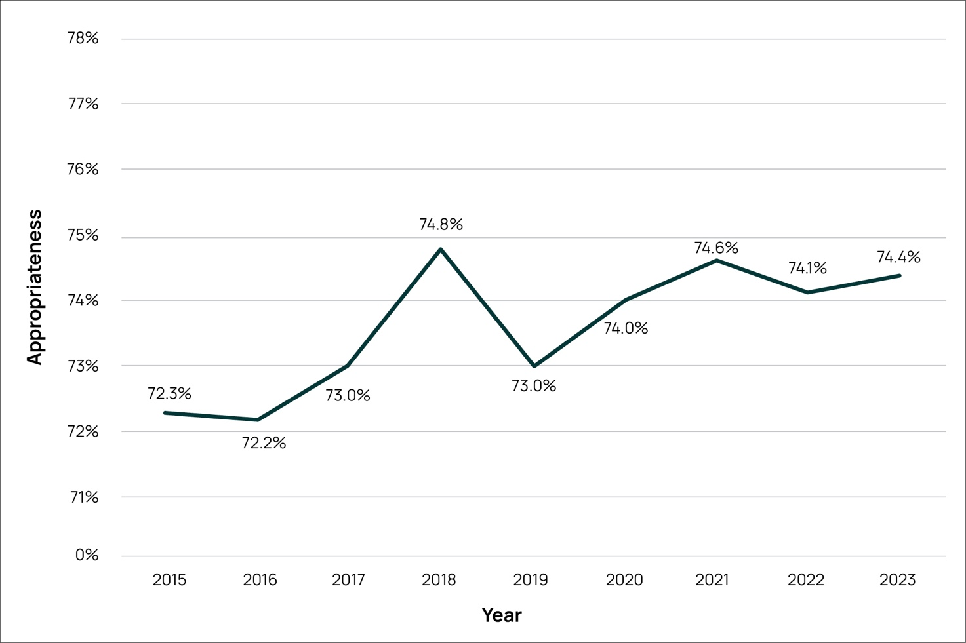
* There may be small differences in results compared with the previously published National Antimicrobial Prescribing Survey reports. This is because participants are free to amend their data at any time and the historical data are reanalysed each year.
Please note axis is broken.

Reasons for inappropriateness
The percentage of prescriptions deemed to be inappropriate in 2023 was 21.0% (the remaining 4.6%
of prescriptions were not assessable). Nearly one-quarter of inappropriate prescriptions (21.6%) were for conditions that do not require any antimicrobial therapy. The remaining reasons for inappropriateness (Table 2) were primarily due to the antimicrobial spectrum being too broad, incorrect dose or frequency,
and incorrect duration.

Table 2. Reasons for inappropriateness for all prescriptions assessed as being inappropriate* in the Hospital National Antimicrobial Prescribing Survey, 2023
Reason for inappropriateness |  | Number of prescriptions*
Microbiology mismatch |  | 468 (6.5%)
Allergy mismatch |  | 79 (1.1%)
Indication does not require any antimicrobials |  | 1,561 (21.6%)
Indication does require antimicrobials | Spectrum too broad | 1,895 (26.3%)
Indication does require antimicrobials | Incorrect dose/frequency | 1,604 (22.2%)
Indication does require antimicrobials | Incorrect duration | 1,548 (21.5%)
Indication does require antimicrobials | Spectrum too narrow | 601 (8.3%)
Indication does require antimicrobials | Incorrect route | 419 (5.8%)
*Each prescription is assessed against each quality indicator and thus can be represented in more than one category. There was a total of 7,215 inappropriate prescriptions (comprising of 8,175 reasons for inappropriateness).

Most commonly prescribed antimicrobials
The 10 most commonly prescribed antimicrobials and their corresponding appropriateness assessment
are summarised in Figure 4. Of these antimicrobials, cefazolin, ceftriaxone, amoxicillin—clavulanic acid, cefalexin and piperacillin—tazobactam also had amongst the highest rates of inappropriateness. This distribution of antimicrobials has remained relatively consistent with previous Hospital NAPS results.
Figure 4. The 10 most commonly prescribed antimicrobials and associated appropriateness assessment, Hospital National Antimicrobial Prescribing Survey, 2023
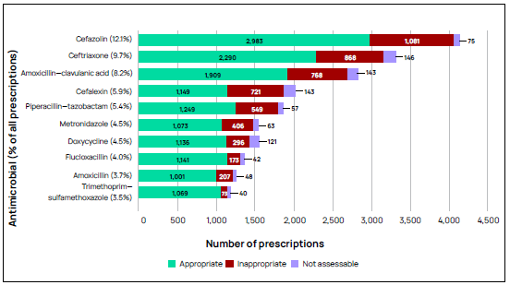

Most common indications for antimicrobial prescribing and appropriateness
Figure 5 shows the 10 most common indications for antimicrobial prescribing in Australian hospitals. The indication with the most inappropriate prescribing continues to be surgical prophylaxis, despite availability of nationally endorsed guidelines and a substantial revision to the antimicrobial recommendations in the Therapeutic guidelines: antibiotic⁸ in 2018.
Figure 5. The 10 most common indications for antimicrobial prescribing and their associated appropriateness assessment, Hospital National Antimicrobial Prescribing Survey, 2023
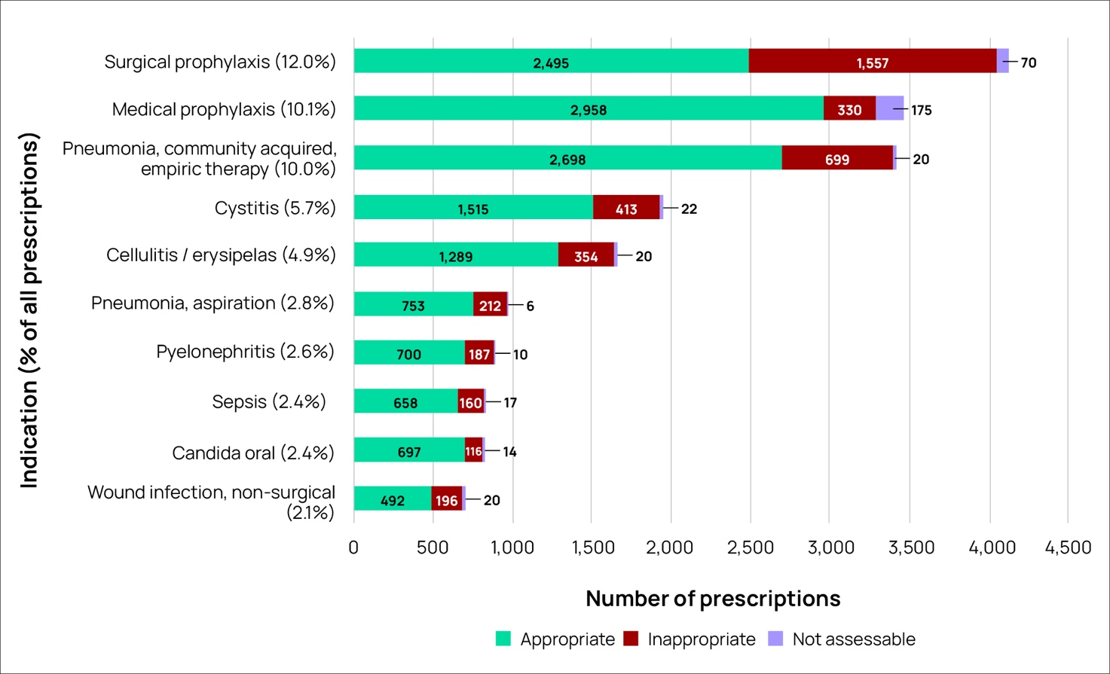

Compliance with guidelines
Indications with the highest rates of guideline noncompliance were surgical prophylaxis, wound
(non-surgical) infections and cystitis (Figure 6). Unsurprisingly, these indications are also associated with high rates of inappropriateness (Figure 5). Considerable work from a multi-level approach needs to be done to support and educate prescribers who are prescribing in these clinical areas.
Figure 6. Compliance with guidelines^ for the 10 indications* most commonly requiring antimicrobials in Hospital National Antimicrobial Prescribing Survey contributors, 2023
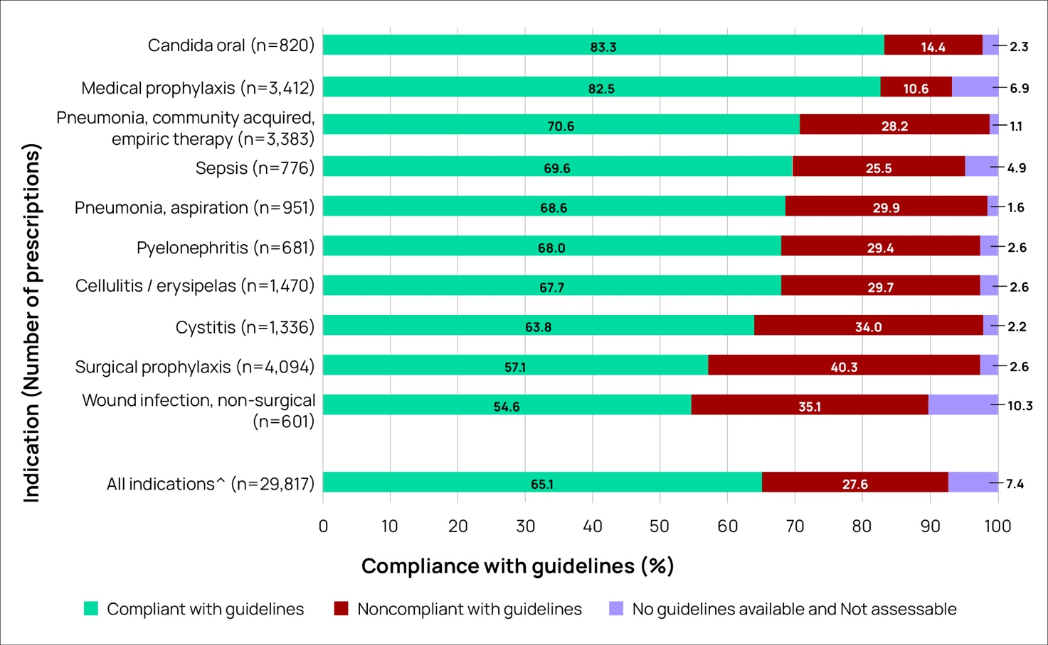
^ Excludes prescriptions marked as ‘Directed therapy’ (n=4,422).
* Excludes prescriptions where the indication for prescribing was unknown (n=995).

Conclusion
Overall, the Hospital NAPS has consistently demonstrated strong uptake from hospitals from around Australia. Encouragingly, there have been notable improvements in documentation of indication and
review and stop dates. Additionally, rates of noncompliance with guidelines and inappropriateness have continued to decline over recent years. Despite this, the Hospital NAPS reveals some key areas requiring improvement, such as antimicrobial use in surgical prophylaxis, managing non-surgical wound infections, and cystitis.
Rectifying these issues will require purposeful, large-scale interventions to improve the quality of prescribing. Further in-depth analysis of the Hospital NAPS dataset, and education of target areas
for practice improvement, will be incorporated into upcoming clinical circulars10 for specific clinical conditions.

Appendix
Table 1A. Results of key indicators in Hospital National Antimicrobial Prescribing Survey contributors, by state and territory, Remoteness Area,^ AIHW peer group^^ and funding type, 2023
Number of participating hospitals (n) |  |  |  |  | Percentage of participating hospitals (%) |  | Number of prescriptions (n) |  | Percentage of prescriptions (%) |  | Indication documented (%) |  | Review or stop date documented (%) |  | Surgical prophylaxis  >24 hours (%)*
State or territory |  | ACT |  | 5 | 1.2 |  | 655 |  | 1.9 |  | 92.4 |  | 51.6 |  | 40.9
 |  | NSW |  | 141 | 33.6 |  | 11,573 |  | 33.8 |  | 89.7 |  | 48.0 |  | 32.9
 |  | NT |  | 6 | 1.4 |  | 759 |  | 2.2 |  | 98.2 |  | 81.0 |  | 47.4
 |  | Qld |  | 56 | 13.3 |  | 4,845 |  | 14.2 |  | 84.7 |  | 36.1 |  | 24.5
 |  | SA |  | 53 | 12.6 |  | 3,213 |  | 9.4 |  | 81.7 |  | 49.0 |  | 15.4
 |  | Tas |  | 7 | 1.7 |  | 456 |  | 1.3 |  | 71.7 |  | 15.1 |  | 22.1
 |  | Vic |  | 114 | 27.1 |  | 9,004 |  | 26.3 |  | 85.3 |  | 44.1 |  | 23.3
 |  | WA |  | 38 | 9.0 |  | 3,734 |  | 10.9 |  | 84.7 |  | 36.3 |  | 18.0
Remoteness Area |  | Major Cities |  | 195 | 46.4 |  | 22,767 |  | 66.5 |  | 86.3 |  | 58.3 |  | 27.0
 |  | Inner Regional |  | 116 | 27.6 |  | 6,025 |  | 17.6 |  | 89.1 |  | 52.5 |  | 20.8
 |  | Outer Regional |  | 86 | 20.5 |  | 4,466 |  | 13.0 |  | 82.5 |  | 49.6 |  | 22.7
 |  | Remote |  | 17 | 4.0 |  | 694 |  | 2.0 |  | 92.2 |  | 51.3 |  | n/a
 |  | Very Remote |  | 6 | 1.4 |  | 287 |  | 0.8 |  | 95.5 |  | 58.2 |  | n/a
Public hospital peer group |  | Principal referral |  | 28 | 6.7 |  | 9,827 |  | 28.7 |  | 91.2 |  | 54.2 |  | 41.5
 |  | Public Acute Group A hospitals |  | 56 | 13.3 |  | 6,983 |  | 20.4 |  | 90.8 |  | 57.9 |  | 28.8
 |  | Public Acute Group B hospitals |  | 36 | 8.6 |  | 2,194 |  | 6.4 |  | 87.1 |  | 47.1 |  | 30.0
 |  | Public Acute Group C hospitals |  | 81 | 19.3 |  | 4,970 |  | 14.5 |  | 84.4 |  | 50.4 |  | 14.2
 |  | Public Acute Group D hospitals |  | 54 | 12.9 |  | 1,576 |  | 4.6 |  | 91.3 |  | 52.4 |  | n/a
 |  | Other acute specialised hospitals |  | 1 | 0.2 |  | 135 |  | 0.4 |  | 88.1 |  | 77.0 |  | n/a
 |  | Children’s hospitals |  | 3 | 0.7 |  | 434 |  | 1.3 |  | 93.1 |  | 68.4 |  | n/a
 |  | Women’s and children’s hospitals |  | 1 | 0.2 |  | 113 |  | 0.3 |  | 98.2 |  | 39.8 |  | n/a
 |  | Women’s hospitals |  | 4 | 1.0 |  | 248 |  | 0.7 |  | 95.2 |  | 83.5 |  | 12.5
 |  | Mixed subacute and non-acute hospitals |  | 8 | 1.9 |  | 270 |  | 0.8 |  | 92.6 |  | 87.0 |  | n/a
 |  | Rehabilitation and GEM hospitals |  | 7 | 1.7 |  | 238 |  | 0.7 |  | 89.5 |  | 62.6 |  | n/a
 |  | Very small hospitals |  | 16 | 3.8 |  | 277 |  | 0.8 |  | 91.3 |  | 52.7 |  | n/a
 |  | Psychiatric hospitals |  | 2 | 0.5 |  | 333 |  | 1.0 |  | 98.5 |  | 88.0 |  | n/a
 |  | Unpeered |  | 1 | 0.2 |  | 48 |  | 0.1 |  | 81.3 |  | 58.3 |  | n/a
 | Private hospital peer group |  | Private Acute Group A hospitals | 18 |  | 4.3 |  | 2,042 |  | 6.0 |  | 73.0 |  | 47.5 |  | 26.9
 |  |  | Private Acute Group B hospitals | 29 |  | 6.9 |  | 1,703 |  | 5.0 |  | 71.6 |  | 63.2 |  | 23.2
 |  |  | Private Acute Group C hospitals | 36 |  | 8.6 |  | 1,355 |  | 4.0 |  | 70.1 |  | 62.2 |  | 21.7
 |  |  | Private Acute Group D hospitals | 19 |  | 4.5 |  | 811 |  | 2.4 |  | 74.0 |  | 70.4 |  | 16.8
 |  |  | Other acute specialised hospitals | 2 |  | 0.5 |  | 233 |  | 0.7 |  | 82.8 |  | 83.3 |  | 8.7
 |  |  | Private rehabilitation hospitals | 14 |  | 3.3 |  | 366 |  | 1.1 |  | 79.2 |  | 60.9 |  | n/a
 |  |  | Private acute psychiatric hospitals | 3 |  | 0.7 |  | 77 |  | 0.2 |  | 83.1 |  | 68.8 |  | n/a
 |  |  | Women’s hospitals | 1 |  | 0.2 |  | 16 |  | 0.05 |  | n/a |  | n/a |  | n/a
 | Funding type |  | Public | 298 |  | 71.0 |  | 27,646 |  | 80.7 |  | 89.7 |  | 55.1 |  | 21.8
 |  |  | Private | 122 |  | 29.0 |  | 6,593 |  | 19.3 |  | 73.2 |  | 59.9 |  | 32.1
 | Combined national result |  |  | 420 |  | 100.0 |  | 34,239 |  | 100.0 |  | 86.5 |  | 56.0 |  | 25.9
^ Remoteness category as per the Australian Bureau of Statistics.7
^^ Australian Institute of Health and Welfare peer groups.6
* Where surgical prophylaxis was selected as the indication (n=4,122).
ACT = Australian Capital Territory; AIHW = Australian Institute of Health and Welfare; GEM = geriatric evaluation and management; n/a = not applicable, as there are fewer than 30 prescriptions; NSW = New South Wales; NT = Northern Territory; Qld = Queensland; SA = South Australia; Tas = Tasmania; Vic = Victoria; WA = Western Australia.

Table 1B. Compliance with guidelines and prescription appropriateness in Hospital National Antimicrobial Prescribing Survey contributors, by state and territory, Remoteness Area,^ AIHW peer group^^ and funding type, 2023
 |  | % Compliance with guidelines |  |  |  |  |  | % Appropriateness
 |  | Therapeutic Guideline8 compliant | Local Guideline compliant | Noncompliant | Directed therapy | Not available | Not assessable | Appropriate | Inappropriate | Not assessable
State or territory | ACT | 41.2 | 10.5 | 28.5 | 17.4 | 1.8 | 0.5 | 73.4 | 25.8 | 0.8
State or territory | NSW | 47.3 | 7.0 | 26.5 | 14.6 | 1.6 | 3.1 | 73.1 | 23.4 | 3.4
State or territory | NT | 44.0 | 20.2 | 11.3 | 24.0 | 0.3 | 0.3 | 84.5 | 15.0 | 0.5
State or territory | Qld | 46.7 | 7.4 | 25.2 | 13.6 | 3.2 | 3.9 | 72.5 | 23.0 | 4.6
State or territory | SA | 50.7 | 9.4 | 22.2 | 11.9 | 2.4 | 3.4 | 79.8 | 16.3 | 3.9
State or territory | Tas | 50.2 | 7.9 | 22.6 | 10.3 | 2.6 | 6.4 | 72.8 | 19.7 | 7.5
State or territory | Vic | 51.1 | 8.7 | 21.2 | 9.5 | 2.9 | 6.7 | 73.8 | 18.9 | 7.3
State or territory | WA | 42.6 | 13.6 | 25.2 | 13.2 | 2.9 | 2.4 | 75.8 | 21.3 | 2.9
Remoteness Area | Major Cities | 45.1 | 10.6 | 23.9 | 14.3 | 2.8 | 3.4 | 74.9 | 21.2 | 3.9
Remoteness Area | Inner Regional | 53.4 | 5.2 | 26.1 | 9.9 | 1.6 | 3.8 | 73.9 | 21.8 | 4.3
Remoteness Area | Outer Regional | 54.3 | 3.4 | 22.0 | 10.1 | 1.8 | 8.3 | 71.9 | 19.3 | 8.8
Remoteness Area | Remote | 45.2 | 13.3 | 27.5 | 11.7 | 0.7 | 1.6 | 74.9 | 23.1 | 2.0
Remoteness Area | Very Remote | 58.2 | 14.3 | 15.3 | 11.5 | 0.0 | 0.7 | 79.4 | 19.5 | 1.0
Public hospital peer group | Principal referral | 40.3 | 13.1 | 22.6 | 18.1 | 3.2 | 2.7 | 76.1 | 21.0 | 2.9
Public hospital peer group | Public Acute Group A hospitals | 47.1 | 8.1 | 25.2 | 13.9 | 2.9 | 2.7 | 74.6 | 22.2 | 3.2
Public hospital peer group | Public Acute Group B hospitals | 46.4 | 6.9 | 27.3 | 11.9 | 2.9 | 4.6 | 72.2 | 22.8 | 5.0
Public hospital peer group | Public Acute Group C hospitals | 58.1 | 5.3 | 20.0 | 7.9 | 1.0 | 7.8 | 75.7 | 16.2 | 8.1
Public hospital peer group | Public Acute Group D hospitals | 56.5 | 2.5 | 28.2 | 10.0 | 0.9 | 2.0 | 71.8 | 25.3 | 2.9
Public hospital peer group | Other acute specialised hospitals | 68.9 | 6.7 | 12.6 | 6.7 | 4.4 | 0.7 | 90.4 | 8.9 | 0.7
Public hospital peer group | Children’s hospitals | 13.6 | 55.5 | 9.2 | 13.4 | 5.3 | 3.0 | 87.3 | 10.4 | 2.3
Public hospital peer group | Women’s and children’s hospitals | 36.3 | 24.8 | 14.2 | 12.4 | 10.6 | 1.8 | 81.4 | 15.9 | 2.7
Public hospital peer group | Women’s hospitals | 41.9 | 43.5 | 7.3 | 4.4 | 2.8 | 0.0 | 91.1 | 8.5 | 0.4
Public hospital peer group | Mixed subacute and non-acute hospitals | 55.9 | 4.8 | 15.2 | 16.3 | 3.3 | 4.4 | 84.8 | 9.3 | 5.9
Public hospital peer group | Rehabilitation and GEM hospitals | 52.9 | 7.1 | 18.1 | 15.1 | 3.8 | 2.9 | 80.3 | 16.4 | 3.4
Public hospital peer group | Very small hospitals | 57.0 | 2.9 | 26.7 | 9.4 | 0.4 | 3.6 | 75.8 | 19.9 | 4.3
Public hospital peer group | Psychiatric hospitals | 58.3 | 1.5 | 11.4 | 26.4 | 1.2 | 1.2 | 90.4 | 7.8 | 1.8
Public hospital peer group | Unpeered | 54.2 | 2.1 | 29.2 | 10.4 | 4.2 | 0.0 | 75.0 | 25.0 | 0.0
Private hospital peer group | Private Acute Group A hospitals | 45.3 | 4.9 | 31.5 | 11.2 | 1.6 | 5.4 | 67.4 | 26.3 | 6.3
Private hospital peer group | Private Acute Group B hospitals | 53.1 | 4.8 | 26.4 | 9.6 | 1.6 | 4.5 | 71.4 | 23.5 | 5.1
Private hospital peer group | Private Acute Group C hospitals | 48.9 | 4.1 | 33.3 | 5.5 | 1.4 | 6.7 | 61.5 | 30.3 | 8.1
Private hospital peer group | Private Acute Group D hospitals | 54.7 | 2.1 | 29.8 | 5.4 | 1.2 | 6.7 | 65.5 | 26.4 | 8.1
Private hospital peer group | Other acute specialised hospitals | 80.7 | 7.2 | 10.3 | 0.0 | 0.0 | 1.8 | 88.3 | 9.9 | 1.8
Private hospital peer group | Private rehabilitation hospitals | 55.2 | 0.8 | 22.7 | 16.1 | 0.5 | 4.6 | 79.2 | 13.9 | 6.8
Private hospital peer group | Private acute psychiatric hospitals | 80.5 | 0.0 | 15.6 | 0.0 | 1.3 | 2.6 | 84.4 | 11.7 | 3.9
Private hospital peer group | Women’s hospitals | n/a | n/a | n/a | n/a | n/a | n/a | n/a | n/a | n/a
Private hospital peer group | Mixed subacute and non-acute hospitals | n/a | n/a | n/a | n/a | n/a | n/a | n/a | n/a | n/a
Funding type | Public | 47.0 | 9.9 | 22.9 | 13.9 | 2.6 | 3.7 | 75.8 | 20.1 | 4.1
Funding type | Private | 51.4 | 4.1 | 28.9 | 8.6 | 1.4 | 5.4 | 68.6 | 25.0 | 6.5
Combined national result |  | 47.9 | 8.8 | 24.0 | 12.9 | 2.4 | 4.0 | 74.4 | 21.1 | 4.5
^ Remoteness category as per the Australian Bureau of Statistics.7
^^ Australian Institute of Health and Welfare peer groups.6
ACT = Australian Capital Territory; AIHW = Australian Institute of Health and Welfare; GEM = geriatric evaluation and management; n/a = not applicable, as there were fewer than 30 prescriptions; NSW = New South Wales; NT = Northern Territory; Qld = Queensland; SA = South Australia; Tas = Tasmania; Vic = Victoria; WA = Western Australia.

References
- Australian Government Department of Health and Aged Care, Australian Government Department
of Agriculture, Fisheries and Forestry. Australia’s National Antimicrobial Resistance Strategy–2020 and beyond. Canberra: Australian Government; 2020.
- Australian Government Department of Health and Aged Care, Australian Government Department
of Agriculture, Fisheries and Forestry. Surveillance of antimicrobial use and resistance in human health. [Internet] Canberra: Australian Government; 2023 [cited May 2024]. Available from
- https: /www.amr.gov.au/australias-response/objective-5-integrated-surveillance-and-response- resistance-and-usage/surveillance-antimicrobial-use-and-resistance-human-health
- Australian Commission on Safety and Quality in Health Care. National safety and quality health service standards. 2nd ed - version 2. Sydney (Australia); 2021.
- Australian Commission on Safety and Quality in Health Care. Antimicrobial stewardship clinical care standard. 2nd ed. Sydney (Australia); 2020.
- Royal Melbourne Hospital and the National Centre for Antimicrobial Stewardship. National Antimicrobial Prescribing Survey: technical supplement 2023. Canberra: Department of Health, Disability and Ageing; 2025.
- Australian Institute of Health and Welfare. Hospital resources 2020-21: Australian hospital statistics. [Internet] Canberra: AIHW; 2021 [cited May 2024]. Available from: https: /www.aihw.gov. au/getmedia/e0e946d9-3d84-48b3-954a-e97f96814c0a/Hospital-resources-tables-2020-21.xls.aspx.
- Australian Bureau of Statistics. 1270.0.55.005 - Australian Statistical Geography Standard. Canberra (Australia); 2016.
- Antibiotic Expert Group. Therapeutic guidelines: antibiotic. Version 16. Melbourne: Therapeutic Guidelines Ltd; 2019. Available from: https: /www.tg.org.au/.
- Royal Melbourne Hospital and the National Centre for Antimicrobial Stewardship. Surgical prophylaxis prescribing in Australian hospitals. Results of the 2023 Surgical National Antimicrobial Prescribing Survey. Canberra: Department of Health, Disability and Ageing; 2025.
- Royal Melbourne Hospital and the National Centre for Antimicrobial Stewardship. 2024. National Antimicrobial Prescribing Survey Circulars: ISSN2982-0014. Available from: https: /www.ncas- australia.org/circulars
20 Results of the 2023 Hospital National Antimicrobial Prescribing Survey

All information in this publication is correct as at January 2025.
amr.gov.au

